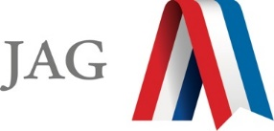

2020-21 Flex PBL
PBL Title: | The L.O.V.E. Project – Lifting Our Voices for Equity
Duration: | Varies | Release Date: | October 7, 2020
HELP? | e-mail ragan.ross@ijag.org | Pages: | 10
Before you begin:
- The intent of this project is to create a space for JAG participants to reflect on inequities impacting youth in communities across America and identify solutions to make positive change.
- InterContinental Hotels Group (IHG) is supporting this work by sponsoring grants to Career Associations in the amount of $500 as seed money to implement projects. Up to 75 grants will be awarded. The application deadline is November 1, 2020.
Click this link for details: https://jag.org/jag_L.O.V.E._project/
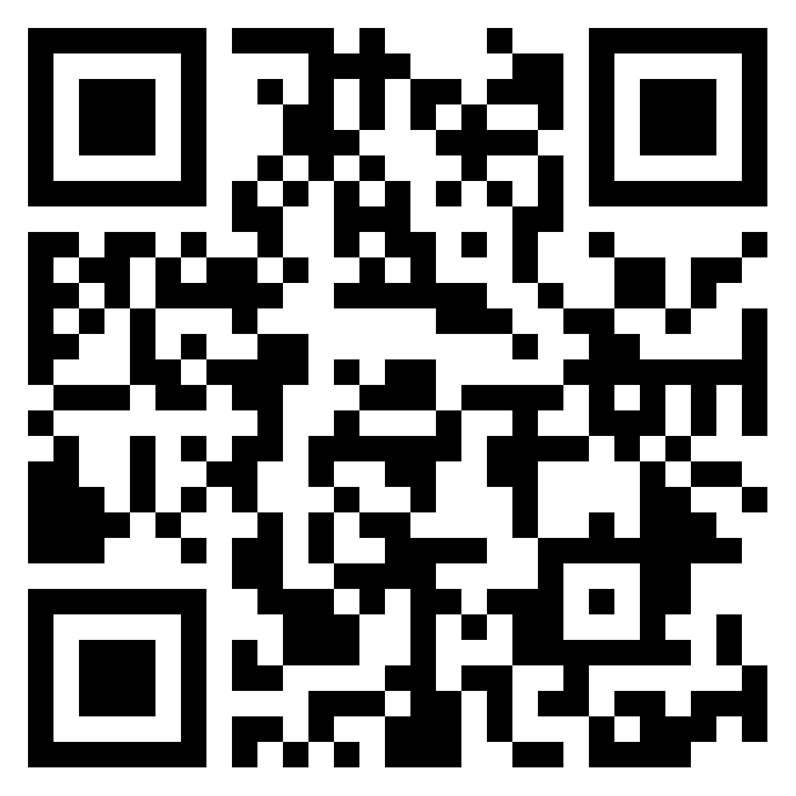
- To satisfy the terms of the grant, students should document their progress and share periodically with JAG National through submitting videos on the JAG webpage portal (https://jag.org/jag_L.O.V.E._project/), sharing on social media using the hashtag #JAGL.O.V.E.Project., and/or uploading progress to the L.O.V.E. Project PADLET.
QR Code: https://padlet.com/jageniussocial/shr7aq9qxprzm6nh
Padlet “How To” - https://padlet.com/gallery/tips
- This FLEX PBL is an outline with getting started and to offer helpful resources; however, each individual project should be unique, based on what is most important/relevant to participants.
- This project is intended to be delivered 1-2 days per week over several weeks as a Career Association activity. The overall length of this project, whether two weeks, four weeks, three months or an entire semester should be at the discretion of the CA with your support.
- The Specialist role in this project is a facilitator/Advisor, allow your CA Officers to drive the content and results of this project. Ongoing Specialist supports include a weekly PSA (released each Monday on the Genius) and monthly webinars (conducted each month at 5:00 p.m. EDT/4:00 p.m. CDT). Links can be found on the Genius for upcoming session dates:

    - October 21
    - November 18
    - December 16
    - January 20
    - February 17
    - March 17

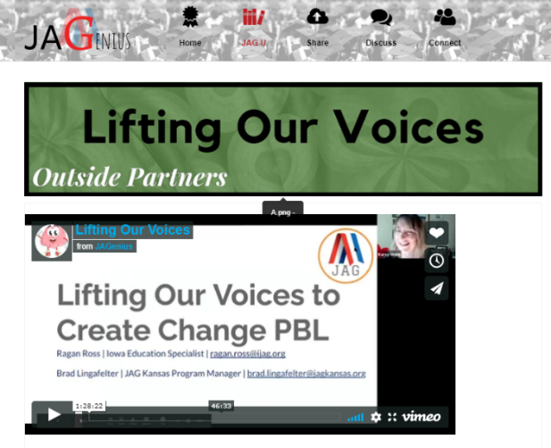
Unsure of where or how to begin the conversation?

Watch the L.O.V.E. Project webinar during VNTS:
(Found JAGU>VNTS>Day 3>TIC Track>Lifting Our Voices
https://jag-genius.wisetail.com/eco_player.php?id=8d24bdea-cc5b-11ea-ba08-0a2e53c8b7f5&pid=ff1e940e-aa9e-11ea-a320-12bcb1b01635&token=

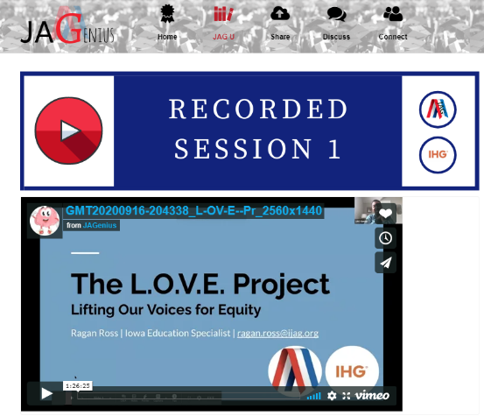
Session 1 of the L.O.V.E. Project webinar series
(Found JAGU>L.O.V.E. Project Webinars>L.O.V.E. Project Session 1
https://jag-genius.wisetail.com/eco_player.php?id=1e6a8c2c-fe7e-11ea-8981-0a9b92160139&pid=db43e1ec-fe7c-11ea-8ca5-125cc1816a6f&token=

Project Summary
JAG has always believed in the power of youth voice. This project was developed in response to the social unrest across the nation that sparked a request by Specialists and students to “do something” to create a collective impact across the JAG National Network.
This FLEX PBL is designed as more of an outline of options for you to implement, rather than a specific scope and sequence. Several resources will be shared for to you implement based on student interest. Follow the activities as you have time and as they are relevant to the project you are implementing.
Upon completion of this project, students will be able to:
- Establish respectful communication guidelines in your classroom
- Think critically about topics that impact your community
- Navigate and resolve conflict
- Have a shared definition of equity, equality, diversity, inclusion and identify examples of inequities in their community
- Develop a public product to highlight the work completed and share with JAG National and the InterContinental Hotels Group (IHG)

Competency Attainment
JAG Competencies should be set based on the Specialists discretion.

Notes for Specialist
- A Flex PBL can be administered in a variety of instructional modalities. Here are three of the most common options:
  - Traditional; full time, in-person instruction – walk through the steps in showing videos and leading discussions as a typical class unit.
  - Hybrid, blended or a flipped classroom – identify and pull out the pieces that can be asked of students to perform outside of in-person class time (i.e. to watch videos, journal, etc.) and reserve team building, discussions and/or problem solving for in-person opportunities.
  - Completely online model – this Flex PBL can also be administered in a completely online format, by using any means of delivery that is being directed or offered by your school district.
- In addition to Genius resources, the JAG National Staff is available for steps on the practical application of this Flex PBL.
- Specialists are responsible for how grading/allocation of points are determined based on your program expectations.

Flex PBL – Lifting Our Voices for Equity Project

Driving Question
“Where do inequities show up in our community and what can you do to create positive change?”
Entry Event
Show a video* about social, racial inequality, health disparities, gun control, homelessness, immigration, food instability, voter suppression, etc. and hold a class discussion afterwards asking thought provoking questions.

Follow Up Questions:
- How did this video make you feel?
- Is this something that your community struggles with?

*Suggestions to Video Link Resources: (You are welcome to use these or find your own)
- Why is Jason in the Hospital?
  - https://www.youtube.com/watch?v=vFXSYCJHPUg&feature=youtu.be
- Immigration
  - My Story of Immigration | Miriam Martinez | TEDxCarverMilitaryAcademy
  - Logic - One Day ft. Ryan Tedder (Official Video)
- Spoken Word about America Unequal
  - https://www.youtube.com/watch?v=GZDNUGMMxLk
- The Unequal Opportunity Race:
  - https://www.youtube.com/watch?v=vX_Vzl-r8NY
  - What were some of the themes that you noticed? (Slavery, voting rights, Generational wealth, housing instability, underemployment/unemployment, school to prison pipeline, standardized tests, health disparities, gender inequality, etc.)
  - How might experiencing any of these life experiences impact an individual?
Public Product
The public product should reflect the focus of this project based on your student’s response to the driving question. Below are ideas/suggestions of public products:
- Students will create a video documentary or Public Service Announcement highlighting a project of their choice promoting the inequalities identified as the focus of this project. In the video, answer the following questions:
    - What inequities are present in your community?
    - What does your JAG Career Association hope to do to create a positive impact in your community?
    - How will your work make a positive change in the future?
    - What are the root causes of the inequities that you studied?
    - What did you learn from this project?
    - What do you want us to know?

- Students will write and perform a skit/performance consisting of authentic experience surrounding inequities, racism, discrimination, etc. and present the performance to a live audience. Record and share with JAG National.
- Students will organize a town hall or community event that brings together stakeholders in the community (Mayor, Police Department, School Administrators, Parents, elected officials, etc.) to promote peace and work towards healing relationships.
- Students create a kindness campaign, highlighting opportunities to encourage “Random Acts of Kindness” in their community and document the process and impact.

Follow the examples of projects below or CREATE YOUR OWN!

Here is a sample rubric to help guide student’s work on the L.O.V.E. Project Public Product: https://www.tolerance.org/sites/default/files/2017-07/6-12DS_Listen%20Up%21%20Rubric.pdf
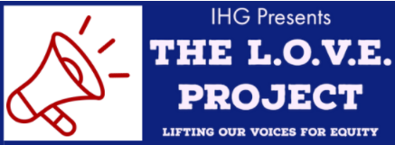
REMEMBER: JAG National is encouraging programs to apply for the $500 microgrant on the JAG National website. The deadline is November 1, 2020 and only 75 programs will be selected.
As part of stipulations of the grant, it is encouraged to upload photo or video footage of students working throughout this project or post on social media using #JAGL.O.V.E.Project.
L.O.V.E. Project grant application can be found here: https://jag.org/jag-L.O.V.E.-project_application/

Setting up the L.O.V.E. Project

Before you “launch” the L.O.V.E. Project, you will want to establish a strong classroom culture of mutual respect. If you have not done this already, take the time to build rapport and set the tone to create respectful communication guidelines. It is recommended that you ease into the conversation through participating in icebreakers and learning activities before the formal introduction to the L.O.V.E. Project and partnership with IHG. Here are some tips below:

Creating Classroom Culture

Example Activity #1: Safe Zone

It will be important for you to create a safe/brave space for all students to learn and express themselves in your classroom. If you have not created “Respectful Communication Guidelines”, a “Safe Zone” or classroom expectations, now is the time to do so.

“What needs to happen in this classroom in order to make this
a safe space for everyone to learn?”

In person, write the responses on a piece of flip chart paper. Virtually, ask participants to type into the chat, or text their responses to a Poll Everywhere word cloud. If cell phones are allowed in your classroom, use the Poll Everywhere app to collect responses in-person as well.

Create your classroom “commitment” using their words and phrases and confirm them with the Respectful Communication Guidelines below. Continue to refer to their “commitment” as necessary.

- R – take Responsibility for what you say and feel without blaming others
- E – use Empathetic listening
- S – be Sensitive to differences in communication/cultural styles
- P – ponder what you hear and feel before you speak
- E – examine your own assumptions and perceptions
- C – keep Confidentiality
- T – tolerate ambiguity because we are not here to debate. There are no “winners” or “losers.”
Example Activity #2: What do YOU Think?
Using Poll Everywhere, create a Google Slides presentation using Poll Everywhere for a five-slide presentation. This activity can be done in person or virtual.

- Do you L.O.V.E. your parents?
      - Yes, No (Multiple Choice)
      - Class discussion based on responses
- Do you believe that everyone deserves a fair chance?
      - Yes, no, sometimes (Multiple Choice)
      - Class discussion based on responses
- Do you think that everyone is given a fair chance?
      - Yes, no, sometimes
      - Class discussion based on responses
- Do you think the world we live in is just?
      - Yes, no, sometimes (Multiple choice)
      - Class discussion based on responses
- Have you ever not been given a fair chance?
      - Yes, no (Multiple choice)
      - Class Discussion based on responses)
*Bonus question if necessary

Example Activity #3: Social Justice Activist Video Introduction

  - Stepping Up: The Social Justice Activist https://youtu.be/mcbAr3QCPs0 (3 minutes)
  - Reflect on the video, how did you connect to what she was saying? What surprised you? How were you able to relate, or not relate with what she was saying?

Example Activity #4: Character Check

  - Has someone ever lied about you or falsified your character? How did that make you feel? Were you mad, sad, irritated? Did you try to correct that person or just let it be?
  - Think about today's world. If you don't speak up for yourself who will? If no one spoke up what kind of world would we live in today??

Potential L.O.V.E. Project Icebreakers
When facilitating icebreakers, the power is in the facilitation of the activity and the DISCUSSION about what was learned. Debriefing is an art, not a science, and it is often the difference between a good experiential learning activity and a great one.
- Encourage the group to review both the task, as well as the process (most groups tend to focus on the task).
- Clarify and focus the comments of the group and provide helpful information.
- Assist the group in discovering what they have experienced. Resist the temptation to tell them what they have experienced and learned.
- Allow quiet time between your question and their response.
- Your ability to become an effective experiential learning activity facilitator will rest on your ability to ask great questions.
Discussion questions: http://www.toobeez.com/teambuilding-book/Appendix-A-Debrief.html

Icebreaker Suggestions:

- Diversity Activities and Ice-Breakers: http://www.nwlink.com/~donclark/leader/diverse2.html
- Awareness Activities: http://www.edchange.org/multicultural/activityarch.html
- Diversity & Inclusion Activities: https://www.uh.edu/cdi/diversity_education/resources/activities/pdf/Inclusion_Activities_Book.pdf
Resources for the L.O.V.E. Project

To complete this project, it is recommended that you work alongside a supported text or project outline offered from school district or community expert, text/research from the Teaching Tolerance/other professional website, or this virtual “course” from the Robert Wood Johnson Foundation’s program called Understand and Identify Root Causes of Inequities.

Below are a couple resources focused on Tolerance that will help deliver this project:

  - https://www.tolerance.org/professional-development/social-justice-standards-understanding-justice
  - https://www.tolerance.org/classroom-resources/student-tasks/do-something/be-the-change

PROJECT EXAMPLES: If you are having difficulty structuring a project, use these resources to help you get started!

- Understand and Identify Root Causes of Inequities
https://www.countyhealthrankings.org/take-action-to-improve-health/learning-guides/understand-and-identify-root-causes-of-inequities#/

Project Summary
In healthy communities, everyone has opportunities to thrive. This means everyone having access to quality schools, good paying jobs, healthy foods, quality healthcare, affordable housing, and safe neighborhoods. However, in some communities, not everyone has access to these opportunities.

This guide focuses on understanding how inequities in communities impact health. While some of these issues are easy to see, others are less clear. These deeper, underlying factors are referred to as root causes. Once you can identify these root causes that impact health, you can begin to develop strategies to address them so that everyone in your community is afforded a fair and just opportunity for good health.

https://www.countyhealthrankings.org/sites/default/files/UnderstandandIdentifyRootCauses_Worksheet.pdf (worksheet)

Marking History, Making History
https://my.pblworks.org/project/marking-history-making-history

Project Summary
History is a process of interpretation and perspective-taking. In this project, students research the history of their home community or region and use primary source materials to learn about the experiences and perspectives of multiple community members (e.g., indigenous people, immigrants, colonists, enslaved people, people of different class backgrounds) in relation to particular events. Students use what they learn to document and share the multiple (and sometimes conflicting) histories that coexist in their local community.

Changing the World One Poem at a Time
https://my.pblworks.org/project/changing-world-one-poem-time

Project Summary
In this project, students create video montages of social justice poetry. Each student chooses a social justice poem and analyzes the elements of content and craft that make it powerful and effective. Students find or create accompanying images that enhance their selected poem’s meaning and record an expressive oral performance of the poem.
Teams collaborate to storyboard and produce a montage video that ties the poems together around a common theme. Students also create a response poem or social justice poem of their own inspired by one of their classmates’ selected poems. Finally, students work together as a class to create a community exhibition featuring their video montages as well as their original poems paired with images and the mentor texts that inspired them.

- Be the Change
https://www.tolerance.org/classroom-resources/student-tasks/do-something/be-the-change

Project Summary
Service learning allows students to identify a problem within their community and apply academic, social and personal skills to garner real results. When students are empowered to think about their communities through a social justice lens, they may spot areas of need that they hadn’t before considered. Service learning promotes positive group interactions, problem-solving skills and conflict resolution and encourages students to consider their roles in society. Connecting service learning to a theme or issue, like those found in Perspectives central texts, is shown to have a larger impact on youth than service learning conducted in isolation or when context is not provided.

- Act Up! Drama for Justice
https://www.tolerance.org/classroom-resources/student-tasks/do-something/act-up-drama-for-justice

Project Summary
Drama can be a powerful tool for social change. It allows students to call attention to injustice and to envision a scene in which injustice is overcome. Using dialogue, students can change the very language associated with the injustice. With drama, students can re-imagine moments of historical courage. Drama is hands on, creative and fun for students.

- Community Arts Showcase
https://www.tolerance.org/classroom-resources/student-tasks/do-something/community-arts-showcase

Project Summary
Arts encourage deeper levels of thinking, exploration, discovery, creativity, choice and engagement. Diverse learners and students of all ability levels can communicate expressively via the arts. In addition to skills learned and practiced through the creation of the artwork, students also gain valuable collaborative and leadership skills planning the event.

- Film Festival:
https://www.tolerance.org/classroom-resources/student-tasks/do-something/film-festival

Project Summary
Students explore social justice themes through a popular and familiar medium. Via the genre of documentary films, students will increase media awareness and hone persuasive writing techniques.

- Inventing a Better World
https://www.tolerance.org/classroom-resources/student-tasks/do-something/inventing-a-better-world

Project Summary
Problem solving challenges students to use critical thinking and creativity to imagine an alternative to the current reality. This task requires students to apply their academic analyses to a real-world situation.

- Journalism for Justice
https://www.tolerance.org/classroom-resources/student-tasks/do-something/journalism-for-justice

Project Summary
Journalism creates awareness of issues, promotes critical thinking and allows students to work collaboratively and integrate visual arts, design and writing. This task is for all students, not only those in a journalism class or club.

- Listen Up! PSA for Change
https://www.tolerance.org/classroom-resources/student-tasks/do-something/listen-up-psa-for-change

Project Summary
Quality technology use in the classroom, focused on social justice and active learning, engages students and promotes academic achievement. PSA for Change allows students to explore social justice ideas and themes using familiar technology they enjoy.

- My Voice, My Voter’s Guide
https://www.tolerance.org/classroom-resources/student-tasks/do-something/my-voice-my-voters-guide

Project Summary
One of the ways young students become invested in the democratic process is by become empowered advocates for civic participation in their local communities. When younger students understand they have the power to use their voices in politics, they are more likely to be involved and register to vote when they are eligible.

- Teaching About Race, Racism and Police Violence:
https://www.tolerance.org/moment/racism-and-police-violence

Project Summary
In 2014, the deaths of Michael Brown in Ferguson, Eric Garner in New York City, Tamir Rice in Cleveland and too many others caused waves of nationwide protest and appeals for stronger protections against police brutality.
These events—along with the lack of accountability for the police officers who shot and killed these unarmed victims—also prompted educators to seek resources on how to address these subjects in the classroom.
The resources below can help spur much-needed discussion around implicit bias and systemic racism, but they can also empower your students to enact the changes that will create a more just society.

Additional Resources:

  - Southern Poverty Law Center
https://www.splcenter.org/our-issues/immigrant-justice/southeast-immigrant-freedom-initiative-0
  - How to be an Anti-Racist Educator
http://www.ascd.org/publications/newsletters/education-update/oct19/vol61/num10/How-to-Be-an-Antiracist-Educator.aspx
  - 21-Day Racial Equity Habit Building Challenge
https://www.eddiemoorejr.com/21daychallenge

Check out the JAG PBL Support Pinterest page for ideas!
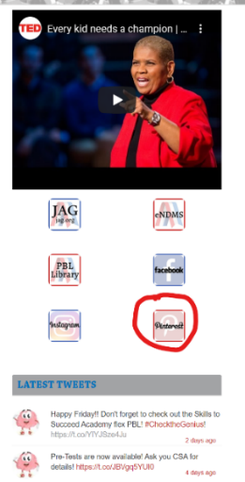
https://www.pinterest.com/pbljag/boards/



Reminder, don’t forget to apply for the L.O.V.E. Project microgrant, and submit photos videos of your work: https://jag.org/jag_L.O.V.E._project/

At the conclusion of the L.O.V.E. Project, please complete the survey below:
- Specialists – https://forms.gle/YChjUQ5cW3ZCqQDF6
- Students - https://forms.gle/diKX1icJndCqnrnZ7

