2020-21 Flex PBL

| PBL Title: | *Skills to Succeed Academy:* | You and Your Career |  |
| --- | --- | --- | --- |
| Duration: | 4 weeks | Release Date: | September 9, 2020 |
| HELP? | e-mail jenn.beal@jag.org | Pages: | 10 |

Project Summary

This Flex PBL is intended to be in the second wave of projects student engage with as they return to school for the 2020-2021 academic year.

Using the free, highly interactive online training program provided by *Skills to Succeed Academy (S2SA)*, this project focuses on one module per week with the final week working on this project’s Public Product. Each module helps learners build the skills and confidence they need to make smart career choices and find and succeed in employment. The four *S2SA* modules being used from the You and Your Career section are:

1. Career Pursuit
2. What Makes You Tick?
3. Why Do You Want To Be A…?

*Skills to Succeed Academy* is a proud sponsor of the JAG organization and strives to support JAG students in completing modules as a way to boost their employability skills. Each year *S2SA* seeks to connect youth with their valuable courses; however, this year their resources are needed more than ever. *S2SA* modules can be administered in variety of ways:

* Assigned for students to complete outside of school in an asynchronous manner
* Streamed to groups or classrooms of students via a video conferencing service
* Facilitated in-person through a classroom overhead projector

Competency Attainment

**Level 1:**, A.4-Develop a career path for a selected occupation, B.7-Construct a resume, C.14-Demonstrate appropriate appearance, D.21-Comprehend verbal communications, D.24-Communicate verbally, F.33-Base decisions on values and goals

**Level 2:** A.1-Identify occupational interest, aptitudes and abilities, A.2-Relate interests, aptitudes and abilities to appropriate occupations, A.3-Identify desired life style and relate to selected occupation, A.5-Select an immediate job goal, C.18-Follow directions, D. 22-Comprehend written communications

**Level 3:**

JAG Competencies should be set based on the Specialists discretion.

The above stated are merely suggestions based on the project structure.

Notes for Specialist

* **This Flex PBL encourages Specialists to set-up a Flipgrid account and establish a classroom code to share with your students. Here is a helpful tutorial video of Flipgrid:** [**https://www.youtube.com/watch?v=aLzX13jw7bw**](https://www.youtube.com/watch?v=aLzX13jw7bw)
* Flex PBL are designed with two intended purposes:
  1. to meet the ever-changing instructional needs of JAG Specialists across the JAG National network and
  2. to provide relief with competency attainment and project design to allow Specialists the space to devote a majority of their time in meeting the immediate needs of students.
* A Flex PBL can be administered in a variety of instructional modalities. Here are three of the most common options:
  + **Traditional; full time, in-person instruction** – walk through the steps in showing videos and leading discussions as a typical class unit.
  + **Hybrid, blended or a flipped classroom** – identify and pull out the pieces that can be asked of students to perform outside of in-person class time (i.e. to watch videos, journal, etc.) and reserve team building, discussions and/or problem solving for in-person opportunities.
  + **Completely online model** – this Flex PBL can also be administered in a completely online format, by using any means of delivery that is being directed or offered by your school district.
* The format of this Flex PBL was aimed to be easily manipulated for Specialists to deliver the project within a classroom. They can print, copy and paste into an e-mail, text, social media or a learning management system (i.e. Google Classroom, Canvas, etc).
* The intentional design of this Flex PBL is to allow a logical and manageable flow for students to work in a self-guided way.
* A series of webinars are available on the Genius for each of these three options. The topic area shifts from week to week, but the three group offerings remain consistent to accommodate your needs as they may change throughout the 2020-2021 academic year.
* In addition to Genius resources, the JAG National Staff is available for steps on the practical application of this Flex PBL.
* 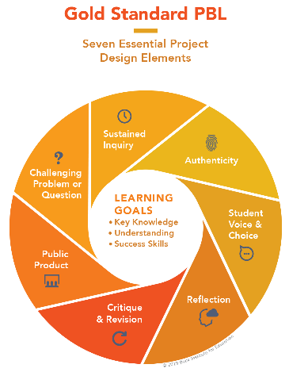The yellow highlighted sections need Specialist attention, as they are notes that require an action of the Specialist.
* Remember that each student responsibility can be adjusted to fit the needs of your students, especially when it comes to the expected time spent on this project. **You are encouraged to add, remove or change out any elements within this Flex PBL to make this project suitable for your JAG students**. Just remembering that a strong PBL (regardless of delivery method) has seven essential gold standard elements.
* Please complete this **JAG** **Specialist** survey at the completion of the project: <https://forms.gle/kA8GjnVo8XW6RXcG6>
* Finally, Specialists are responsible for how grading/allocation of points are determined based on your program expectations.

Flex PBL – *S2SA*: You and Your Career

**Driving Question**

What am I passionate about and how can I combine my skills and strengths in selecting the perfect career for me?

**Entry Event**

**Watch this video** – (TedTalk) 2 questions to uncover your passion—and turn it into a career

<https://www.youtube.com/watch?v=y3emv9DIEkE> (11 minutes)

**Visit** – the Kyusa website <https://kyusa.weebly.com/blog> (5 minutes)

**Journaling Time** -- Individually answer the following questions: (10 minutes)

* What does the word “passion” mean to you?
* If you had all the money in the world, what would you spend your time doing?
* What makes you happy or gives you the deepest level of fulfillment?

**Create Flipgrid Account** -- <https://info.flipgrid.com/> (3 minutes)

What is Flipgrid? A simple, free and accessible video discussion experience for everyone!



Use this Join Code to have students get connected with each other ______________

**Post Welcome Video** – within your Flipgrid account, find the Entry Event Welcome Video assignment and post a short 30 second intro. Here is a video on how students can use Flipgrid: <https://www.youtube.com/watch?v=C0QV3Yfv7UY> (10 minutes)

* This exercise will help you become familiar with the Flipgrid site, as this will be a tool used several times throughout this project.
* This video will also help your classmates get to know you a little better.
* Share your name, something fun/interesting about you and share one or two items from your journaling time above.

**Public Product**

At the end of this project, students will create a one and half minute video explaining the ideal career for them based on their skills, interests, strengths and passions. Students will post their video to Flipgrid for their classmates and Specialist to review and offer advice for improvements. The student can then update their video and share on their Tallo profile, LinkedIn as well as other social media sites. A video resume has become a popular way to get to know candidates, so students may also choose to use this video in a digital job application packet.

Here is a rubric to help guide student’s work on this Flex PBLs Public Product: (insert link, picture or attachment)

Here is an few examples of video project rubrics to help you in the creation of your grading metrics for this Flex PBL Public Product: <https://www.pinterest.com/pin/44262008811170049/>

Week 1 of 4

JAG Student Week One Responsibilities

* Specialist will record and share a link here or do an in-person overview of the Skills to Succeed Academy. A nice touch would be to share this video using Flipgrid if you are up for it! 😊 JAG Specialists can share information about how the *Skills to Succeed Academy* supports the overall JAG organization by providing their resources for free to JAG participants. Express how *S2SA* offers a variety of online modules focused on finding and maintaining employment. If you need additional information about the Skills to Succeed Academy, refer to their page on the JAGenius! (Approx. 5 minutes)

**You will also find a special promotion just for JAG Specialists!**

**During the month of September 2020, if a Specialist completes the**

***S2SA* onboarding module and then completes the post-module survey—they will be entered to win one of ten $100 eGift Cards!**

* Entry Event -- Implement the Entry Event activities found on page three of this Flex PBL.
  + Watch TedTalk Video
  + Visit Kyusa website
  + Journaling time
  + Create Flipgrid account
  + Post welcome video
* Log into the *Skills to Succeed Academy* – <http://s2sacademy.org> (5 minutes)

**Not registered yet?**

1. Go to [http://s2sacademy.org](http://s2sacademy.org/)
2. Click on <Learner > Registration
3. Fill in the registration form and use Access Code <fill in learner access code here. This information can be found on the JAGenius. >

* Take a moment to explore the site once you are logged into the *Skills to Succeed Academy*. You will notice a purple menu bar across the top that helps with: (5 minutes)



* + Search
  + Courses
  + Progress
  + Ref.Zone

* When you are familiar with the site and are ready to start your module/online lesson for this week, you may click on “Courses” in the purple menu bar at the top of the page. Then scroll down until you see three purple boxes with the title “Our courses”. Select the left-hand section called “Choose a Career”. When you open this page, you will see six modules. The focus on this week will be the option called “Career Pursuit”. By clicking [here](https://s2sacademy.org/course/non_replay/usa/yyc_02/), you will be taken directly to this module if you are already logged into the *S2SA*.

You will see that this module is 25 minutes; however you will not need to complete this all in one setting. Click the purple bar that says “START” when you are ready to begin the course.

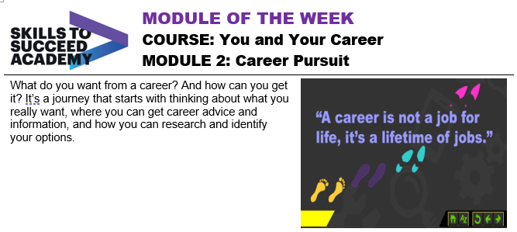

* When you are in the “Career Pursuit” module and ready to begin, on screen 1/21 you will click the play button on the small video. This is an introduction video to this module. Once the video intro is finished, you will be able to click the green arrow button in the bottom right-hand corner to advance to the next page. Remember, you can stop this module at any time and pick-up where you left off. Your progress is automatically saved, so when you log in next time—you can start on the page you last were on. (1 minute)
* On page 2 of 21, you will see what you’re going to do in this module, as well as what your intended targets are at the completion of this week’s course. See below.

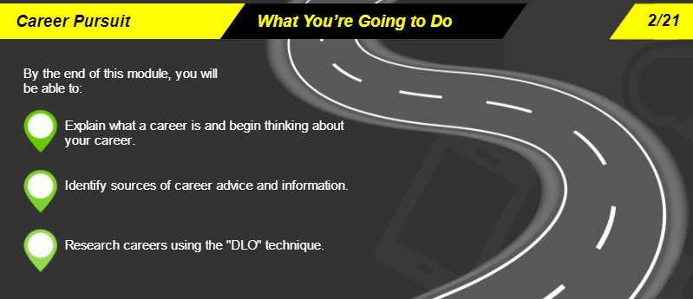

* After hearing about the goals of this module, click the green arrow to advance. Follow the directions that are spoken to you and that you are able to read on the screen. For example, on this screen (3/21) you will click the play button on the video to hear from several different people what a career means to them. (1 minute)
* Pause & Think -- What does a career mean to you? (2 minutes)
* Check-in with your Specialist. The indicator word is banana. Share with your Specialist how the process was for logging in and accessing the *S2SA* content. Also share how you answered the question in the step above – what does a career mean to you? (5 minutes)
* Advance through the remainder of the module at your own pace; however, be aware of the goal to have this module completed before the start of next week. We have walked through the steps for the first few screens, so you should be familiar with how to interact with the *S2SA* platform.

Remember, you can pause, stop and/or go back at any point in the module.

* Screen 4/21 – quote about careers
* Screen 5/21 - click on each of the images to learn how careers have changed over time
* Screen 6/21 – career basics
* Screen 7/21 – who can help you?
* Screen 8/21 – career planning
* Screen 9/21 – doing research
* Screen 10/21 – define it
* Screen 11/21 - locate
* Screen 12/21 - organize
* Screen 13/21 – meet the characters
* Screen 14/21 – meet Lila
* Screen 15/21 – meet Bryan
* Screen 16/21 – meet Luis
* Screen 17/21 – meet Lila’s grandma
* Screen 18/21 – almost there…
* Screen 19/21 – Module 2 Quiz
  + Track your score, so you can share with your Specialist later! 😊
* Screen 20/21 – Module Survey
* Screen 21/21 - Activity
* When you click on the green “Activity” button, you will be taken to a new window that has helpful activities for you to complete after having viewed this module. Browse this document and save for a later date.
* Check-in with your Specialist. The indicator word is roller coaster. Share with your Specialist that you have completed the “Career Pursuit” module on the Skills to Succeed Academy. Your Specialist will work with you to identify sections within the activity pack that would be helpful for you to continue the important work focus on your career. (5 minutes)

**Specialists: here is a direct link to the student activity pack, so you can review and identify sections that would be helpful for students to complete.**

<https://s2sacademy.org/cms/usa/activity_packs_files/YAYC%20Mod%202%20Career%20Pursuit.pdf>

Week 2 of 4

JAG Student Week Two Responsibilities

* Specialist will pose a question to all students by making a video in Flipgrid. Specialists will ask students to answer their question with a video response using Flipgrid. The question should focus on: **WHAT career do you want?** Allow for the question just to be WHAT the career is for now and at the end of the week, students will develop the WHY they want that particular career after participating in this week’s *Skills to Succeed Academy* module.
* 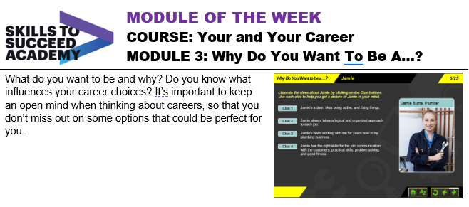Log into your *Skills to Succeed Academy* and access the “Why Do You Want To Be A…?” module. You may find the module by searching, checking under “Courses” or by clicking on this direct [link](https://s2sacademy.org/course/non_replay/usa/yyc_03/). (2 minutes)
* Click on the play button on the video introduction and then advance through the screens by using the green arrow button in the bottom right-hand corner.

Remember: you can pause/stop the module at any time and resume where you left off at a later time.

There are 25 screens of this module and the estimated time to complete is 40 minutes.

* Check-in with your Specialist. The indicator word is oak tree. Share with your Specialist how the second *Skills to Succeed Academy* module went. Highlight one thing you learned and at least one thing you still have a question about. Specialist will work with you to identify sections within the activity pack that would be helpful for you to continue the important work focus on your career. (5 minutes)

**Specialists: here is a direct link to the student activity pack, so you can review and identify sections that would be helpful for students to complete.** <https://s2sacademy.org/cms/usa/activity_packs_files/YAYC%20Mod%203%20Why%20Do%20You%20Want%20To%20Be%20A.pdf>

* Spend some time journaling about the topic of: “Why do I want to be a ________________?
* Specialist will ask students to follow-up to the question they answered earlier in the week with another Flipgrid assignment. Students will answer WHY they want the career they do in 2-3 sentences. (10 minutes)

Week 3 of 4

JAG Student Week Three Responsibilities

* Specialists will set up this week’s module by encouraging students to revisit their skills and strengths they explored in an earlier Flex PBL or previous project. Let students know that this will be the last *Skills to Succeed* module for this project and that next week is all focused on students working on their Public Product.  (Approx. 5 minutes)
* Log into your *Skills to Succeed Academy* and access the “What Makes You Tick?” module. You may find the module by searching, checking under “Courses” or by clicking on this direct [link](https://s2sacademy.org/course/non_replay/usa/yyc_04/). (2 minutes)

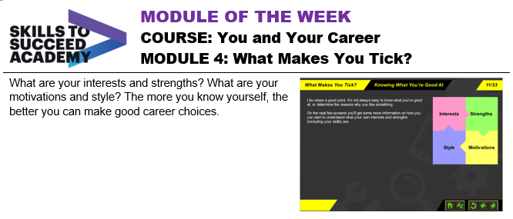

* Click on the play button on the video introduction and then advance through the pages by using the green arrow button in the bottom right-hand corner.

Remember: you can pause/stop the module at any time and resume where you left off at a later time.

There are 31 screens of this module and the estimated time to complete is 30 minutes.

* Take some time and consider what makes your “tick”. Think about the things discussed within the module to help guide the things that are important to you. (10 minutes)
* Check-in with your Specialist. The indicator word is iced coffee. Share with your Specialist what makes your tick. Explain what you learned about yourself by watching the online module and thinking about the things that are important to you. (5 minutes)
* E-mail your progress on the *Skills to Succeed Academy* to your Specialist. You can view your progress page by logging into your *S2SA* profile and clicking on “Progress” in the purple bar at the top of the page. You may take a picture of this progress page or you may click on the “E-mail Progress” button and send the information to your Specialist this way.

**Specialists: here is a direct link to the student activity pack, so you can review and identify sections that would be helpful for students to complete.** <https://s2sacademy.org/cms/usa/activity_packs_files/YAYC%20Mod%204%20What%20Makes%20You%20Tick.pdf>

Week 4 of 4

JAG Student Week Four Responsibilities

* This week is completely dedicated to working on your Public Product for this project. As a reminder, here is an overview of the Public Product details: (30 minutes)
  + At the end of this project, students will create a one and half minute video explaining the ideal career for them based on their skills, interests, strengths and passions.
  + Students will post their video to Flipgrid for their classmates and Specialist to review and offer advice for improvements.
  + The student can then update their video and share on their Tallo profile, LinkedIn as well as other social media sites. A video resume has become a popular way to get to know candidates, so students may also choose to use this video in a digital job application packet.

Start by completing this chart below to help you organize your thoughts on what might be best to be included in your video.

|  |  |
| --- | --- |
| About Me |  |
| Skills |  |
| Interest |  |
| Strengths |  |
| Passion |  |
| Work Experience |  |
| Leadership |  |
| Career Desire |  |

* Watch some student video examples to gain inspiration. If you like something someone says, make a note of it and consider where it might best fit within your video. (15 minutes)
  + <https://www.youtube.com/watch?v=Jd-UVxtwMlo>
  + <https://www.youtube.com/watch?v=c_PZTAW5piQ>
  + <https://www.youtube.com/watch?v=wS5gR0_4BM8>
  + <https://www.youtube.com/watch?v=lskgM0CxYUo>
  + Do your own searching to find videos that you are interested in.
* Review the rubric to help guide your work on this Flex PBLs Public Product: (insert link, picture or attachment) (5 minutes)

Here is an few examples of video project rubrics to help you in the creation of your grading metrics for this Flex PBL Public Product: <https://www.pinterest.com/pin/44262008811170049/>

* Check-in with your Specialist. The indicator word is video. Use this time to ask questions of your Specialists before you dive into creating your Public Product for this project. (5 minutes)
* Create your Public Product: (Times will vary)
  + Draft your script.
  + Make decisions about your attire, background, props, etc.
  + Practice.
  + Set-up your phone/camera or ask a friend to film.
  + Do a practice recording/dress rehearsal. Listen and watch for things you would like to improve.
  + Do your REAL video recording! Good luck! 😊
  + When you are satisfied with your video intro, post it on Flipgrid under the Public Product assignment.
* As you wait for peers to review and offer feedback on your video, go check out a minimum of three other videos from your classmates. Comment on their video using this framework:
  + I like…
  + I wonder…
  + Have you thought about...
* Remember the Driving Question for this Flex PBL: **What am I passionate about and how can I combine my skills and strengths in selecting the perfect career for me?** If you believe you have adequately answered this question and feel confident in the final Public Product you have—consider posting this video within your Tallo profile, LinkedIn, other social media sites and/or including it in your digital application packet!
* Wrap up this project by doing the these three things:
  1. E-mail your progress from Skills to Succeed Academy to your Specialist.
  2. Share with your Specialist how you used your video from this project in other ways.
  3. Complete this JAG National student survey to gather feedback about this Flex PBL: <https://forms.gle/nTHEJ6AE2NbQasS78>