
2020-21 Flex PBL
PBL Title: | Take Off with Technology!
Duration: | 3 weeks | Release Date: | February 5, 2021
HELP? | e-mail jenn.beal@jag.org | Pages: | 10
Project Summary
This Flex PBL is intended to help students expand their skills using basic computer operations, email, and other valuable forms of college and career technology. “Technology” is so much more than being on a device for many hours a day. The capabilities and skills are far reaching and extremely important to our future.
Career Research has a valuable article to demonstrate the importance of technology and careers: http://career.iresearchnet.com/career-development/technology-and-careers/

Article Summary: Technology has had a dramatic impact on the nature of work itself, individual applicants and employees, employers, and career counselors. It has changed the nature of work and the types of jobs that people do today. It has altered the knowledge and skills individuals need to be effective workers. It has transformed how employers recruit, select, and train applicants and employees. It has also changed how individuals gather occupational information and how career counselors work with their clients. As a result, individuals, employers, and career counselors will need to keep pace with advancing technology and be adaptable and responsive to change in order to continue to be successful to meet the challenges of the 21st century.

Competency Attainment
Level 1: C.15-Understand what employers expect of employees, C.16-Identify problems of new employees, C.17-Demonstrate time management, C.18-Follow directions, D.21-Comprehend verbal communications, D.24-Communicate verbally, G.40-Conduct a job analysis, G.42-Demonstrate effective study skills, G.45-Understand the essential elements of high performing work teams, H.62-Demonstrate how to work effectively with others, H.63-Demonstrate an attitude that attracts the attention of management, H.66-Demonstrate an ability to follow and give directions
Level 2: D. 22-Comprehend written communications, E.28-Deliver presentations to a group, G.47-Demonstrate techniques for building commitment by others, G.53-Exhibit work ethics and behaviors essential to success, H.74-Demonstrate an eagerness to learn new responsibilities or improve current responsibilities, H.75-Demonstrate an understanding of the work to be accomplished
Level 3: G.43-Demonstrate how to use group dynamics techniques, H.76-Demonstrate familiarity with a variety of technologies, H.78-Demonstrate basic computer operation skills, H.80-Demonstrate an ability to send, receive and organize e-mail messages, H.81-Demonstrate an ability to search for information on the Internet
JAG Competencies should be set based on the Specialists discretion.
The above stated are merely suggestions based on the project structure.

Flex PBL Notes for Specialist

- Flex PBL are designed with two intended purposes:
  - to meet the ever-changing instructional needs of JAG Specialists across the JAG National network and
  - to provide relief with competency attainment and project design to allow Specialists the space to devote a majority of their time in meeting the immediate needs of students.

- A Flex PBL can be administered in a variety of instructional modalities. Here are three of the most common options:
  - Traditional; full time, in-person instruction – walk through the steps in showing videos and leading discussions as a typical class unit.
  - Hybrid, blended or a flipped classroom – identify and pull out the pieces that can be asked of students to perform outside of in-person class time (i.e. to watch videos, journal, etc.) and reserve team building, discussions and/or problem solving for in-person opportunities.
  - Completely online model – this Flex PBL can also be administered in a completely online format, by using any means of delivery that is being directed or offered by your school district.
- The format of this Flex PBL was aimed to be easily manipulated for Specialists to deliver the project within a classroom. They can print, copy and paste into an e-mail, text, social media or a learning management system (i.e. Google Classroom, Canvas, etc).
- The intentional design of this Flex PBL is to allow a logical and manageable flow for students to work in a self-guided way.
- A series of webinars are available on the Genius for each of these three options. The topic area shifts from week to week, but the three group offerings remain consistent to accommodate your needs as they may change throughout the 2020-2021 academic year.
- In addition to Genius resources, the JAG National Staff is available for steps on the practical application of this Flex PBL.
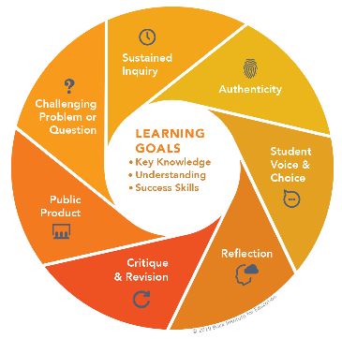
- The yellow highlighted sections need Specialist attention, as they are notes that require an action of the Specialist.
- Remember that each student responsibility can be adjusted to fit the needs of your students, especially when it comes to the expected time spent on this project. You are encouraged to add, remove or change out any elements within this Flex PBL to make this project suitable for your JAG students. Just remembering that a strong PBL (regardless of delivery method) has seven essential gold standard elements.
- Please complete this JAG Specialist survey at the completion of the project: https://forms.gle/xWNL8YmK1hjcJ95v7
- Finally, Specialists are responsible for how grading/allocation of points are determined based on your program expectations.

Flex PBL – Take Off with Technology!

Driving Question
How can I improve my basic computer skills and expand my experiences with technology to help me gain success in college and/or my future career?
Entry Event
- Begin by having students complete the pre-project self-placement questionnaire worksheet (page 9 of this Flex PBL packet). Based on their responses, and on your observations of their strengths and weaknesses in your classroom, assign student small groups of 3-4. The goal to group students who find technology to be a weakness with students who feel confident using various forms of technology.

Watch the video: Technology – Its impact on your world of work (3 minutes)

https://www.youtube.com/watch?v=oQQbPhfsASI

(although made for the UK, it applies to the US as well)
- Answer the following questions: (5 minutes)
- How do you use technology?
- What do you want to learn more about when it comes to technology?
- How do you envision using technology in your future career?

Public Product
Students will work in small groups, either virtually or in person, to create a project using at least three different types of technology about one of the following technology topics:
- History of technology
- Future of technology
- Careers in technology
- Pros and cons of technology
- Student’s choice (needs to be approved by your Specialist)

For example, a project could include a video, podcast, and an Excel chart over one of the topics above.

Here is a list of other technologies that may be interested to explore:

- Globster
- Pixton
- Animoto
- Canva
- Powtoon
- Padlet
- Ipiccy
- Thinglink
- Easel.ly
- Infogr.am
- BigHugeLabs
- Sign Generator
- WeVideo
- Flipgrid
- Zoom

These are just a few of the many tools available for students online!

Week 1 of 3
JAG Student Week One Responsibilities
Focus on the Internet
- Review the Driving Question for the Flex PBL.
Driving Question: How can I improve my basic computer skills and expand my experiences with technology to help me gain success in college and/or my future career?
- Perform the Entry Event activities
- Begin by having students complete the pre-project self-placement questionnaire (page 9 of this Flex PBL packet). Based on their responses, and on your observations of their strengths and weaknesses in your classroom, assign student small groups of 3-4. The goal to group students who find technology to be a weakness with students who feel confident using various forms of technology.

Watch the video: Technology – Its impact on your world of work (3 minutes)

https://www.youtube.com/watch?v=oQQbPhfsASI

(although made for the UK, it applies to the US as well)
- Answer the following questions: (5 minutes)
- How do you use technology?
- What do you want to learn more about when it comes to technology?
- How do you envision using technology in your future career?

- Review the Public Product details
Students will work in small groups, either virtually or in person, to create a project using at least three different types of technology about one of the following technology topics:
- History of technology
- Future of technology
- Careers in technology
- Pros and cons of technology
- Student’s choice (needs to be approved by your Specialist)

For example, a project could include a video, podcast, and an Excel chart over one of the topics above.

Here is a list of other technologies that may be interested to explore:

- Globster
- Pixton
- Animoto
- Canva
- Powtoon
- Padlet
- Ipiccy
- Thinglink
- Easel.ly
- Infogr.am
- BigHugeLabs
- Sign Generator
- WeVideo
- Flipgrid
- Zoom

These are just a few of the many tools available for students online!
Pro Tip: There are many other great resources online to assist you with creating your PBL if you need assistance and/or ideas!
Here are some websites to get you started:

Best Tech Creation Tools - https://www.commonsense.org/education/top-picks/best-tech-creation-tools

75 digital tools and apps teachers can use to support formative assessment in the classroom - https://www.nwea.org/blog/2019/75-digital-tools-apps-teachers-use-to-support-classroom-formative-assessment/

- Before beginning group work, review How to Write a Proper Email (10 minutes)
https://www.grammarly.com/blog/email-writing-tips/?&utm_source=google&utm_medium=cpc&utm_campaign=searchusaemailwriting&utm_targetid=aud-834333299696:dsa-875896953090&gclid=Cj0KCQiA9P__BRC0ARIsAEZ6irgiAlJbBfImv-XZzzcb964CjzNYM8464BhjsEH4P6ebaLWrXPlTyP8aAh5XEALw_wcB&gclsrc=aw.ds

- Send an email introducing yourself to your group members and cc your Specialist using proper business format. (10 minutes)
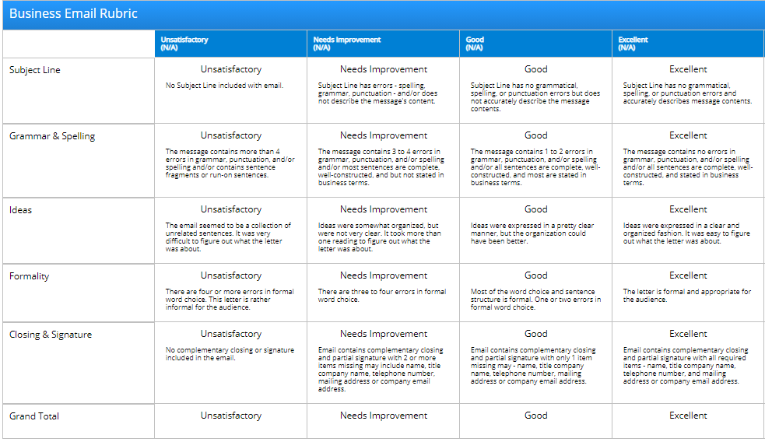

- As a group… (30-40 minutes)

  - Visit this website: https://edu.gcfglobal.org/en/internetbasics/l
  - Read through the information and discuss it.
  - Have each group member take the quiz at the end and screenshot their score.
  - Submit an outline of the information to your Specialist, including quiz scores for each team member.

- Begin planning your team project (time varies)

- Decide on a topic.
- Begin researching facts for your project using reliable sites.
  - This website will help you decide if you are viewing reliable information: https://sites.umgc.edu/library/libhow/credibility.cfm
- Explore different types of technology that can be used to present your project.
- Practice with them and try to find unique and creative tools.
- Refer to Take off with Technology rubric (on page 10) as a guide.

- Check in with your Specialist and discuss your group’s planning and any questions you have before you begin writing your project plan. (5 minutes)

- Create a project plan. (25-45 minutes)
Project Plan
What is our project about?
Who is the audience?
Describe the project.
How will we begin my project?
How will our project demonstrate all of the required elements?
How will we end our project?
What will we show or do to make our project interesting?

Week 2 of 3
JAG Student Week Two Responsibilities
Basic Computing Skills
- Watch this video: Funny Tech Support (6 minutes)
https://www.youtube.com/watch?v=Wp-uKlhXvmo
- Visit this website: https://support.microsoft.com/en-us/training and read through the information on the following topics: (time will vary)
  - Word
  - PowerPoint
  - Excel
  - Learn the Basics
  - Quick Starts
  - Save Time with Tips

NOTE: You may view more than these six if you wish.

- Practice using these Microsoft tools individually. (time will vary)

- Discuss and draft a summary of the Microsoft tools with your group members and develop a summary of what was learned. (time will vary)

- Submit a group summary of the information on the Microsoft Tools to your Specialist.
- Continue working on your group Public Product for this project: (time will vary)
Remember the Driving Question for this Flex PBL: How can I improve my basic computer skills and expand my experiences with technology to help me gain success in college and/or my future career?
Pro Tips:
  - Decide what types of technology will be used in your project. Consider how they will work together to present your research.
  - Make an outline.
  - What facts will you include? How will you cite your sources?
  - Will you be on camera? Doing a voiceover? Will your attire need to be planned?
  - Will you need to prepare background, props, etc.?
  - Practice to listen and watch for things you would like to improve.
  - What details could be added to enhance your project?
  - Make sure you are using the rubric on page 10 as a guide.

- Check-in with your Specialist. Share your plans for the group presentation. (10 minutes)

Week 3 of 3
JAG Student Week Three Responsibilities
Finish and Polish
- Read this article: Improving Group Dynamics (10 minutes)
https://www.mindtools.com/pages/article/improving-group-dynamics.htm
- Continue working on your Public Product for this project. (time will vary)
- Consult with at least one other group for feedback on your project so far. Ask them to use the following framework: (20 minutes)
  - I like…
  - I wonder…
  - Have you thought about...

- Finish the Public Product for this project and be sure to review the rubric outlining the expectations.
- Wrap up this project by doing these three things:
  - Present your project.
  - Complete these self-reflection questions:

    - What did you learn from doing this project?

    - Were you satisfied with your final product?

    - What, if anything, would you change?

    - Did this project increase your knowledge of technology? Why or why not?

    - Did this project increase your skills in using technology? Why or why not?

  - Complete this JAG National student survey to gather feedback about this Flex PBL: https://forms.gle/eKwZqd854r5pXywD7

Name______________________________

Pre-Project Self-Placement Questionnaire

Below are six numbered paragraphs, each of which describes a computer user/learner. Read all six paragraphs and select the number of the paragraph that comes closest to describing you. Write that number in the space provided at the bottom of this page.

- Has never or rarely used a computer or the Internet. Is very worried and uncomfortable about having to use a computer or the Internet.

- Uses a computer or the Internet occasionally. Can turn a computer on and access the Internet, but understands little else. Needs considerable direction and support to handle even the most fundamental tasks.

- Uses a computer competently in a structured work situation, but is still uncomfortable with unfamiliar applications. Can follow clear step-by-step directions, but cannot use the computer as a tool. Does not fully understand how programs and data differ and how they are organized, stored, and accessed. Can use the Internet with assistance.

- Has some experience using the computer or the Internet as a tool. Can use word processing and other programs. Can learn additional programs with training. Is able to experiment and try different things out on the computer or the Internet. Understands the basic structure of the computer and the difference between programs and data. Comfortable using the Internet, including using search engines such as Google.

- Experienced and confident using the computer as a tool. Able to do troubleshooting to solve problems. Comfortable using help systems and manuals to learn how to use software or Internet tools. Able to determine the appropriate software or Internet tool to use to accomplish a task. Able to locate and use appropriate web sites or tools to access information or accomplish a task.

- Frequently helps others with their computer and Internet problems. Can clearly explain to others computer and Internet capabilities and functions. Can evaluate web sites, software, and hardware. Tests new software and Internet based tools and creatively uses them to improve productivity and quality.

Self-Placement # ______________

© 2016 Kenneth Tamarkin

Take Off with Technology! Project Rubric

CATEGORY | (4) Excellent | (3) Good | (2) Almost | (1) Not Yet
Project Design/Appearance | Project is professional, attention-grabbing, and informational | Appearance is appealing and informational | Project appeal is fair | Project appeal needs improvement
Content | Content is exceptionally detailed and informative | Content is adequately detailed and informative | Content is informative, but lacks details | Content lacks information and details
Mechanics and Grammar | No errors in grammar, usage, or mechanics | 1-2 errors that do not detract from the project | There are noticeable errors in that may detract from the project | Multiple errors in mechanics, usage, and/or grammar
Use of Technology | Exceptional use of 3 types of technology, enhancing the overall effects of the project | Competent use of 3 types of technology that add to the project | Fair use of technology, but one type is not fully used or does not add to the project | Poor use of technology, 3 types are not fully used or fail to the project
Research of Technology Topic | Use of three or more reliable sources, Detailed and factual information is accurate and cited throughout the presentation with a works cited included at the end. | Use of three or more reliable sources, Factual information is accurate and cited in the presentation with a works cited included at the end. | Only 2 reliable sources and or missing some citations | Credible research is not evident

Raw Rubric Score/Total | Percentage
20 | 100%
19 | 97%
18 | 95%
17 | 92%
16 | 90%
15 | 87%
14 | 84%
13 | 82%
12 | 79%
11 | 77%
10 | 74%
9 | 71%
8 | 69%

