Alpha max

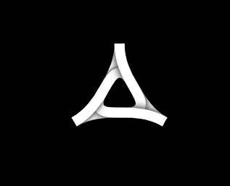

January 22nd, 2019

Executive Summary

Our company Alpha Max produces armored vehicles and helicopters for the U.S. Military. In Somerset County 3% of the population has moved in search of better opportunities. Our goal is to bring these opportunities back to Madison providing a variety of jobs from engineers to janitors. Currently, people travel from all across Maine to Bath Iron Works for work. Our company will put Madison on the map as a workforce center.

Market Research

In the last 10 years Somerset County's population decline is up 3% that's huge. Also the unemployment rate is the highest in Maine (4.4%). With Alpha Max we’re looking to fix this problem. We are also looking forward to help supply the military with more and better products; helicopters, hummvee, ripsaw, and more. By supplying more vehicles to our government we are looking to help protect our troops from death and other fatal injuries with our products. Our competition is limited to AM General, that produce military humvees; and Sikorsky Aircraft Corporation, producers of the famous Blackhawk and Pave hawk helicopters. With our new company (Alpha Max) we will be making faster, more mobile, and better protected humvees.. Since 2010 there has been approximately 3400 injured and 280 dead soldiers from road ieds alone. We see that as a problem so we are making a humvee that will protect our soldiers and bring down that number significantly. Making humvees and helicopters are not the only line of business we are going to be doing. We will be making trucks and other motor vehicles that are big and mean. These will be showed in showrooms and will be the only product sold to the public.
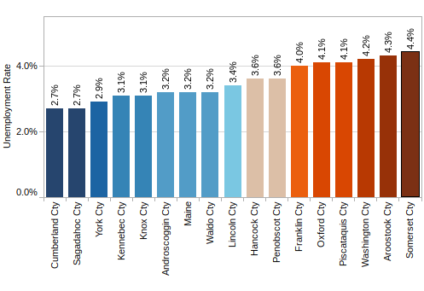

Market Strategy

Our product will be contracted with the United States Government. Our target audience for our public products will be people living in areas where off-roading is available especially in rural parts of the United States. We will advertise online through our website and social media for our public products only. Our government contracts are confidential and will not be advertised.

Financial Plan

Funding Strategy:
Our funding strategy is to apply for STEM Grants through the Maine Technology Institute and receiving funding through a government contract.
Similar companies to ours have received contracts which resulted in $40 Million profit annually through the government. Our goal is to obtain a similar contract.
Our Humvees sold for $30,000

Cost Structure:

Start-up Cost:
Building (Mill)- 2.5 Million
Runway Strip- 2 Million
Total Start Up Cost: $4.5 Million

Development and Manufacturing Cost:
Annual Cost: $10 Million

Employees Cost:
Engineers- $100/hr @ 40 hrs a week x 10 Employees= $40000 x 4= $160,000
Manufacturers- $25/hr @ 40 hrs a week x 100 Employees= $100,000 x 4= $400,00
Total per Month: $560,000
Annual Cost: $6,720,000

Total First Year Cost: $21,220,000

