Email Etiquette Tips

Do Pay Attention to The Subject Line
Write a clear, concise subject line that reflects the body of the email. Avoid subject lines with general words like, “Hi,” “Touching Base,” or “FYI,” and do not leave the subject line blank.

Do Use a Proper Salutation
“Hi” and “Hey” communicate a lack of professionalism and maturity. Begin your email with phrases such as “Good morning,” “Good afternoon,” “Good evening,” or “Hello.” “Good day” or “Greetings” are other phrases used frequently in the international arena.

Do Use an Introduction
In cultures like the U.S., the best practice is for the sender to introduce themselves by first and last name with some background information in the first few lines. For example, “Dear Ms. Mandell: My name is Sharon Schweitzer, a student with the Limon High School JAG program. I was referred to you by . . .”

Don’t Use Inappropriate Email Address
Avoid using emails with inappropriate, vulgar, and unprofessional email addresses. For example: bigbootyjudy@aol.com or maryjane420@gmail.com. Simple emails using a first and last name, or a birthday or best.

Don’t Include Humor and Sarcasm
Emails can easily be misinterpreted through text without context. Humor is culture-specific. Avoid both humor and sarcasm in emails as the recipient may be confused, or worse, offended.

Don’t Hit “Reply All”
Avoid using “Reply All” unless everyone needs to know. Why make others delete your email if it wasn’t intended for them? Reply All is a function for ongoing deliberations on a particular subject.

Do Reply Expediently
Replying within 24 is common courtesy. Leave someone hanging for any longer and you are not only perceived as rude—it could cost you business in the long run. If you’ve unintentionally kept someone waiting longer than 24 hours or extenuating circumstances arose, politely explain the situation and express your apologies.

Don’t Use Emojis
Those little winking, smiling icons are for text messages. They are inappropriate and unprofessional in a business email.

Do Proofread
Check and recheck for spelling and grammatical errors. These errors make you seem unprofessional and will reduce the likelihood that the email will be taken seriously. Email software comes with many professional tools such as spell check—use them.

Don’t Forget the Conversation Closer
Close with “Thank you again,” “See you Tuesday”, “Please let me know if I may be of further assistance.” End your email with a closing such as “Best,” “Best Regards,” “Sincerely,” or another appropriate phrase.

Email Examples
Bad Email
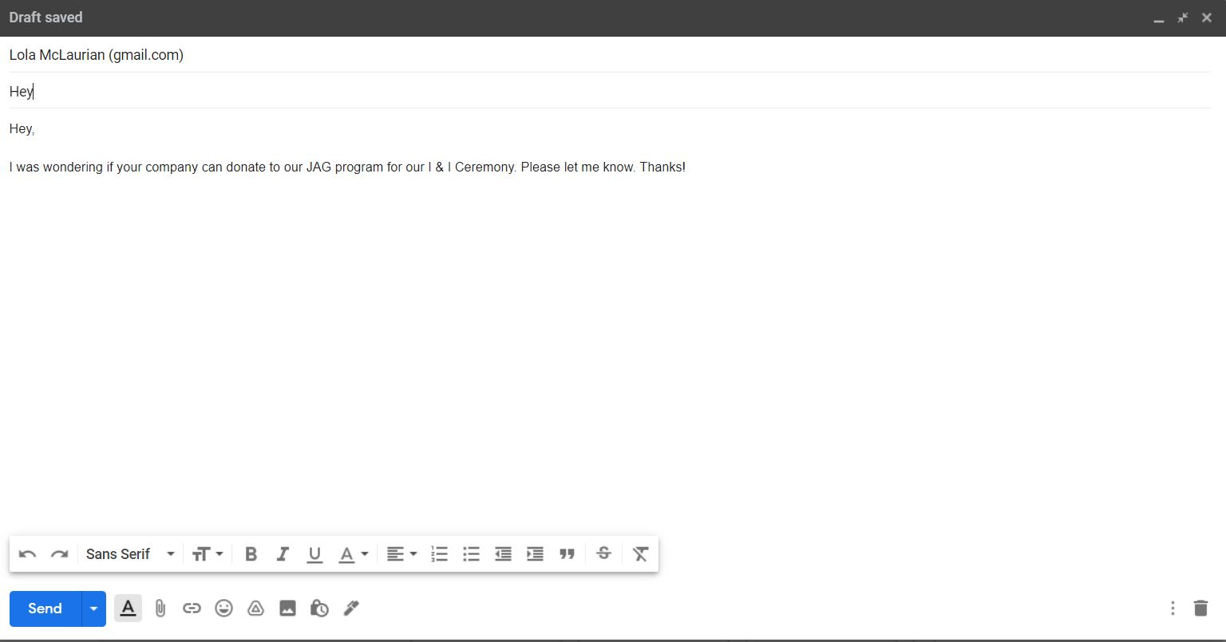
Good Email
