

2020-21 Flex PBL
PBL Title: | Resiliency in Uncertain Times
Duration: | 4 weeks | Release Date: | August 3, 2020
HELP? | e-mail jenn.beal@jag.org | Pages: | 13
Project Summary
This Flex PBL is intended to be one of the first projects student engage with as they return to school for the 2020-2021 academic year.
The scaffolding of the project will utilize a free Coursera course called “Resilience Skills in a Time of Uncertainty”. The course is taught by Dr. Karen Reivich, Director of Resilience Training Services at the University of Pennsylvania. Penn is an Ivy League institution and the fourth-oldest college in the United States.
About the Coursera course: https://www.Coursera.org/learn/resilience-uncertainty?#about
We are all facing different and difficult challenges as we confront the COVID-19 pandemic. In order to support you in this time of uncertainty, the University of Pennsylvania is sharing this free and unique version of Dr. Karen Reivich’s “Resilience Skills” course from the Specialization Foundations of Positive Psychology.

Learn how to incorporate resilience interventions into your personal and professional life with Dr. Karen Reivich. In this course, you are exposed to the foundational research in resilience, including protective factors such as mental agility and optimism. Several types of resilience interventions are explored including cognitive strategies; strategies to manage anxiety and increase positive emotions such as gratitude; and a critical relationship enhancement skill. Throughout the course, you will hear examples of individuals using resilience skills in their personal and professional lives.

Competency Attainment
Level 1: C.15–Identify expectations that employers have of employees, C.17–Demonstrate time management, C.19-Practice effective human relations, D.21-Comprehend verbal communications, D.22-Comprehend written communications, D.24-Communicate verbally, E.29-Deliver presentations to a group, F.32-Identify self-value system and how it affects life, F.33-Base decisions on values and goals, F. 35-Demonstrate ability to assume responsibility for actions and decisions, F.36-Demonstrate a positive attitude, F.37-Develop healthy self-concept for home, school and work.
Level 2:
Level 3:
JAG Competencies should be set based on the Specialists discretion.
The above stated are merely suggestions based on the project structure.

Notes for Specialist
- This Flex PBL was designed with two intended purposes:
  - to meet the ever-changing instructional needs of JAG Specialists across the JAG National network and
  - to provide relief with competency attainment and project design to allow Specialists the space to devote a majority of their time in meeting the immediate needs of students.
- A Flex PBL can be administered in a variety of instructional modalities. Here are three of the most common options:
  - Traditional; full time, in-person instruction – walk through the steps in showing videos and leading discussions as a typical class unit.
  - Hybrid, blended or a flipped classroom – identify and pull out the pieces that can be asked of students to perform outside of in-person class time (i.e. to watch videos, journal, etc.) and reserve team building, discussions and/or problem solving for in-person opportunities.
  - Completely online model – this Flex PBL can also be administered in a completely online format, by using any means of delivery that is being directed or offered by your school district.
- The format of this Flex PBL was aimed to be easily manipulated for Specialists to deliver the project within a classroom. They can print, copy and paste into an e-mail, text, social media or a learning management system (i.e. Google Classroom, Canvas, etc).
- The intentional design of this Flex PBL is to allow a logical and manageable flow for students to work in a self-guided way.
- A series of webinars are available on the Genius for each of these three options. The topic area shifts from week to week, but the three group offerings remain consistent to accommodate your needs as they may change throughout the 2020-2021 academic year.
- In addition to Genius resources, the JAG National Staff is available for steps on the practical application of this Flex PBL.
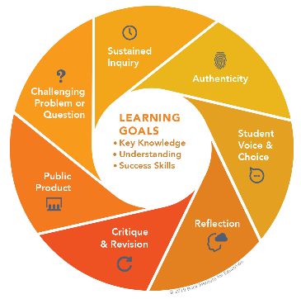
- The yellow highlighted sections need Specialist attention, as they are notes that require an action of the Specialist.
- Remember that each student responsibility can be adjusted to fit the needs of your students, especially when it comes to the expected time spent on this project. You are encouraged to add, remove or change out any elements within this Flex PBL to make this project suitable for your JAG students. Just remembering that a strong PBL (regardless of delivery method) has seven essential gold standard elements.
- Please complete this JAG Specialist survey at the completion of the project: https://forms.gle/tLbtrXzKhAXKa8vP9
- Finally, Specialists are responsible for how grading/allocation of points are determined based on your program expectations.

Flex PBL – Resiliency in Uncertain Times

Driving Question
How can I face the difficult challenges that confront me now to be resilient in times of uncertainty?

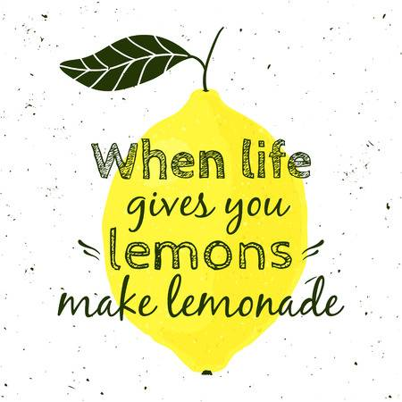
Entry Event
Propose the phrase “When life gives you lemons, make lemonade”.
Share with students the purpose behind this commonly used phrase to express making something good out of a bad situation. Allow for some dialogue.
Students would then view this music video: https://www.youtube.com/watch?v=xS0uS8Tfyt4
Allow for further discussion.

Then, ask for students to come up with their own version of this phrase that is more applicable to their life. For example; 1) when life gives you lemons, do a sour challenge or 2) when life gives you a pandemic, focus your view on the panoramic.
Students can share their Lemon ideas on a Padlet; either by uploading it themselves or working with you to post it within the classroom. Below is a link and to the right is a QR Code for students to add their work to an existing JAG National Padlet for this entry event. You may certainly make your own Padlet or other platform in which students can share their individual ideas. https://padlet.com/jageniussocial/5zhi72cy280r9m1b

Public Product
At the end of this project, students will have a baseline understanding of how to incorporate resilience interventions into their own personal lives. Students will have the tools to manage anxiety and increase their positive emotions. As a result of the work students do in this project to explore their personal resiliency, they will then outwardly share this information forward focusing on optimism and gratitude.
Students will put together a way to express to others how 1) they themselves are making lemonade out of lemons and 2) assist others in doing the same. The mode of delivery is up to the student or group of students (verbal presentation, written communication and/or a visual representation).
Here is a rubric to help guide student’s work on this Flex PBLs Public Product: (insert link, picture or attachment)
A PBLWorks rubric link is provided below as an example. Adjustments can and should be made to fit the delivery method you or the students select for this Public Product.
https://my.pblworks.org/resource/document/9_12_presentation_rubric_non_ccss?_ga=2.202124241.1541406188.1596114595-70278534.1592403584

Week 1 of 4
JAG Student Week One Responsibilities
- Specialist will record and share a link here or do an in-person overview of the online platform Coursera and how a FREE class is being offered to all JAG students for the purposes of this PBL. Here is a link to information about this online learning platform: https://blog.Coursera.org/about/#:~:text=It%20is%20now%20a%20leading,learn%20skills%20of%20the%20future.&text=Coursera%20for%20Campus%20empowers%20any,alumni%2C%20faculty%2C%20and%20staff. (Approx. 5 minutes)
- Watch this video: 7 Pro Tips for Using Coursera (4 minutes)
https://www.youtube.com/watch?v=RZ8FEEpXSUI
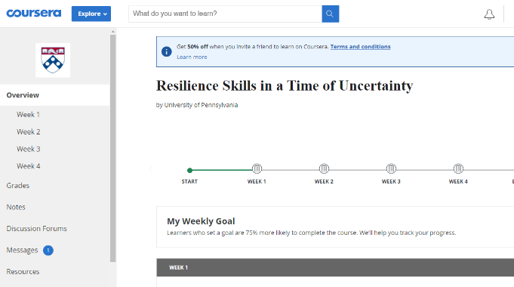
- Visit https://www.Coursera.org/ and create a FREE account/profile by clicking “Join for Free” in the top-right corner. Then search “Resilience Skills in a Time of Uncertainty” or you may click on this direct link to the course to enroll for free. Register for this course and save your username and password. When you are all set, you will see the image to the right on your screen.
Explore this page which provides an overview of the four weeks’ worth of content in this online course. You can see the sections on the left-hand side of your screen for grades, notes, discussion forums, messages, resources and more. (5 minutes)
- (Optional) For help along the way with the Coursera website, visit https://learner.Coursera.help/hc/en-us
- When ready to start the Week 1 content, log into your account and click on to follow the prompts. This is what your screen will look like:
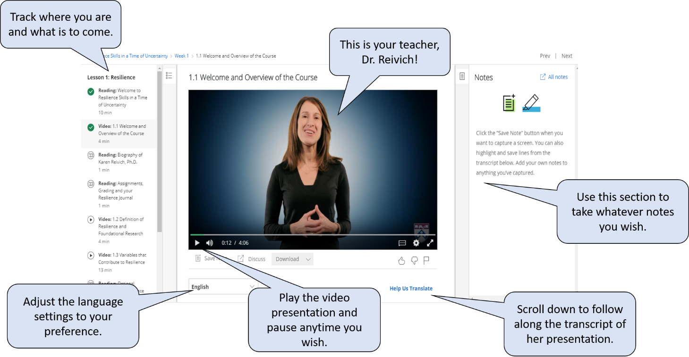

- Start Lesson 1: Resilience (TOTAL 10 minutes)
- Watch Video 1.1 - Welcome & Overview (4 minutes)
- Read about assignments, grading and your resilience journal (1 minute)
  - Remind students that they do not have to complete this Coursera course as part of this Flex PBL. Pieces will be selected out for students to complete and other pieces will be skipped. However, this is a great opportunity to allow students to take a chance to review a one-minute video to see how this particular Coursera course grades. The “Resilience Skills in a Time of Uncertainty” is not a Coursera course for credit for a certificate; yet thousands of other options are. Future Flex PBLs will be providing a completion certificate and students are always encouraged to use Coursera as a resources for their own personal development and exploration. The indicator word will be key for students to share with you when they get to a particular checkpoint in which they are being directed to connect with their Specialist. The indicator word allows the Specialist to know where the student is with the weekly responsibilities. (Approx. 5 minutes)
- Watch Video 1.2 - Definition of Resilience and Foundational Research (4 minutes)

- At this point, check-in with your Specialist. The indicator word is alligator. (2-5 minutes)
  - Share any challenges you may be having with the website Coursera and/or the content so far in the “Resilience Skills in a Time of Uncertainty” course.
- Continue working on Lesson 1: Resilience (TOTAL 18 minutes)
- Watch Video 1.3 – Variables that Contribute to Resilience (13 minutes)
- Take the Optimism Questionnaire (5 minutes)

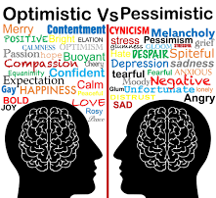
- Think about your scores on the Questionnaire. (5 minutes)
  - Good Events: The score range is 0 to 8. If your score is 7 or 8, you are very optimistic about the likelihood of good events continuing; 6, moderately optimistic; 4 or 5, average; 3, moderately pessimistic; and 0, 1, or 2, very pessimistic.
  - Bad Events: The score range is 0 to 8. If your score is 0-1, you are very optimistic on this dimension; 2 or 3, moderately optimistic; 4 average, 5 or 6 quite pessimistic; and if you got a 7 or 8 you are very pessimistic.

- Watch this video: How to be more Optimistic (1 minute)
https://www.youtube.com/watch?v=WqmTcjtnl9k

- Write a response to your Specialist: (5 minutes)
  - Share your Optimism Questionnaire results.
  - How did your scores surprise you or not?
  - Are you currently more Optimistic or Pessimistic?
- Specialist will record and share a link here or lead an in-person discussion on the differences between a Pessimistic and an Optimistic viewpoint. Reminding folks of the entry event and then also highlighting the phrase of the glass being half full could go a long way in emphasizing this point. Discuss with students how optimism affects ones resiliency and overall happiness. Here is a video with some good content that you may wish to include. https://www.youtube.com/watch?v=bIfvDJ0S6ME&t=89s (Approx. 5 minutes)

Week 2 of 4
JAG Student Week Two Responsibilities
- Specialist will pose a question to all students that asks them to post to an online discussion board or poll question. The key is that each member of the class or program are able to see all of the other responses (Options might include: PollEverywhere, Microsoft Teams, Google Classroom discussion board). The question should focus on: What do you hope to learn in Lesson 2 of your course on Optimism? (Approx. 5 minutes)
- Watch this video: Growth Mindset by Carol Dweck (7 minutes)
https://www.youtube.com/watch?v=EyIF5VUOJc0

- Take a mental break and do something you enjoy! This can be spending time on an app on your phone, reading, drawing, etc. Remember as you are doing this, that at one point in time—you likely didn’t know how to do that particular activity. When things are new or different, it can be confusing and/or frustrating; however, it is important to remind yourself that new does not equal bad. New just equals new and with a growth mindset focused on optimism—you can accomplish anything! (15 minutes)



NOTE: try your best to remain positive as you start Lesson 2. If you are not in the right headspace, take a break and revisit the course when you are ready to absorb new content that may be very different from anything you have heard before.

- Start Lesson 2: Optimism (TOTAL 33 minutes)
- Watch Video 1.6 – Intro to Optimism (8 minutes)
- Pause. Take some notes on the things you didn’t fully understand or wish you knew more about.
- Watch Video 1.7 – Benefits of Optimism (13 minutes)
- Pause. Take some notes of things that stood out to you as interesting or wish you knew more about.
- Watch Video 1.8 – What Optimists Do Differently (12 minutes)
- Read this article: The Power of Positive Thinking (5 minutes) https://www.hopkinsmedicine.org/health/wellness-and-prevention/the-power-of-positive-thinking

- Check-in with your Specialist. The indicator word is watermelon. (2-5 minutes)
  - Share any challenges you may be having with the content of the course.
- Continue working on Lesson 2: Optimism
- Consider the Discussion Prompt (5 minutes)
  - Think of a situation you’re struggling with or are frustrated with. Some possible situations:
    - You are dealing with changes due to the pandemic
    - You have a lot of competing assignments and are feeling overwhelmed
    - You and your friend/ are fighting more than usual
Make a note of what aspects of the situation you can control or influence. Then note which aspects you can’t control and need to accept. Finally, list what purposeful action you can take to make the situation better.
- After you have thought about the Discussion prompt above, draft your response that is one paragraph or 3-4 sentences. (10 minutes)
- When you feel confident in your Discussion response, share it with 3-5 trusted classmates and/or friends. Ask them for their feedback as you may not be able to see all the aspects of the situation that is or isn’t within your control. (10-20 minutes)
- Incorporate your peer review feedback and finalized your discussion post; then, post it to the Discussion Board on the Coursera website. Review responses from other participants in the course. Keep in mind, those posting on this course’s discussion board are from all over the world! (5 minutes)
- Continue working on Lesson 2: Optimism
- Watch Video 1.12 –Personal Highlight: Lucy Hone (7 minutes)
  - Note: If you are uncomfortable with Lucy’s personal story of grieving the loss of her daughter, you may skip this section.


- Re-framing exercise (7 minutes)
  - Take out a piece of paper and draw a diagram similar to what you see below. Set a time for 7 minutes and challenge yourself to write as many things as you can in the spaces below. Take a picture to save this for yourself!
Things I
CANNOT control
Things I
CAN control

- Continue working on Lesson 2: Optimism (TOTAL 7 minutes)
- Watch Video 1.13 –Summary (2 minutes)
- Complete the Quiz for Module 1 (5 questions)
  - Coursera Honor Code states that all learners should:
    - Submit their own original work
    - Avoid sharing answers with others
    - Report suspected violations
NOTE: you may take the quiz as many times as you need!

- Specialist will record and share a link here or lead an in-person discussion on the finalization of the first section of the Coursera course. Reminding students that the week break downs within the course may not align with the pace in which the JAG class is working on the content and that is ok. Provide motivation for those who are not on pace and keeping those engaged that are wishing to move ahead. This would be also a great reminder that this is NOT the only course on Coursera and to allow students an opportunity to explore all of the available options.

Week 3 of 4

JAG Student Week Three Responsibilities
- Begin taking a look at the time for each of the course elements and set a pace that is best for you to complete the following responsibilities. Remember to take time in between sections for a mental break, to take notes, chat with your Specialists and/or engage in conversation with your classmates. Set reasonable deadlines for yourself, but understand that it is perfectly fine to make adjustments to anything you set for yourself, as the most important thing is that you are getting something out of your Coursera course and this Flex PBL.
- Lesson 1: Thinking Traps (TOTAL 45 minutes)
- Watch Video 2.1 – Thinking Traps Intro (7 minutes)
- Watch Video 2.2 – Definition and Demonstration of Thinking Traps (20 minutes)
- Watch Video 2.3 – Detecting Patters in Yourself, Activity: Trying Thinking Traps on for Size (2 minutes)
- Discussion Prompt (15 minutes)
  - Choose one of the following scenarios or one of your own:
    - You have a fight with a friend
    - You get negative feedback on an assignment
    - You saw a text of someone speaking poorly of you
    - You receive a text from a family member that they need to speak with you soon
For each of the five thinking traps, generate thoughts that illustrate each of the thinking traps for this scenario.
- Mind-reading
- Me
- Them
- Catastrophizing
- Helplessness
Then, identify how you would feel, what your reactions would be and how each thinking trap would affect your physiology.
Note: you may wish to follow the steps for your previous Discussion Board; however, you are able to do whatever process you wish in publishing your post.
- SKIP Video 2.4 and Reading that follows…this is an old married couple example. Instead, watch this video: https://www.youtube.com/watch?v=pTT5Z3ZEMMc (1 minute)

- Check-in with your Specialist. The indicator word is theater. (2-5 minutes)
  - Share how you are progressing or not progressing throughout assigned responsibilities. Ask for help in setting or adjusting your desired deadlines. If you could share ONE of your best takeaways from the last section—that would be awesome!
- Lesson 2: Real-Time Resilience (TOTAL 28 minutes)
- Watch Video 2.5 – Changing non-resilient thinking: Realtime Resilience (14 minutes)
- Watch Video 2.6 – Real-time Resilience Activity (7 minutes)
- Consider the Discussion Prompt (10 minutes)
  - Make a list of 5 counterproductive thoughts you might have in a given situation. For each counterproductive thought, use one of the strategies listed to generate a Real-time Resilience response. The sentence starters can help you to formulate the response. They are:
    - Evidence: That’s not true because…..
    - Reframe: A more helpful way to see this is……
    - Plan: If x happens, I will y…….
  - (Optional) you may post on this Discussion Board if you wish or you may simply proceed just by considering the questions being presented to you.
- Watch Video 2.8 – Summary of Module 2 and Intro to Module 3 (1 minute)
- Complete the Quiz for Module 2 (6 questions)
  - Coursera Honor Code states that all learners should:
    - Submit their own original work
    - Avoid sharing answers with others
    - Report suspected violations
NOTE: you may take the quiz as many times as you need!

Week 4 of 4
JAG Student Week Four Responsibilities
- Lesson 1: Managing Anxiety (TOTAL 22 minutes)
- Watch Video 3.1 – Intro Catastrophizing the Relationship of Anxiety to Resilience (6 minutes)
- Watch Video 3.2 – Dr. Baime: Effects on Anxiety on Our Bodies (4 minutes)
- Watch Video 3.5 – Introduction of three Different Ways to Manage Anxiety (12 minutes)

- Check-in with your Specialist. The indicator word is welder. (2-5 minutes)
  - Share TWO of your best takeaways from the last section.

- Lesson 2: Increasing Positive Emotion (TOTAL 12 minutes)
- Watch Video 3.6 – Dr. Park: Deliberate Breathing to Manage Anxiety (5 minutes)
- Watch Video 3.7 – Dr. Baime: A Mindful Approach to Anxiety (7 minutes)

- Watch this video: Attitude of Gratitude Spongebob Squarepants: https://www.youtube.com/watch?v=A1PmNHOzwA4 (1 minute)
- The fourth week of the Coursera course focuses on your personal strengths and how your character guides your resilience and ability to overcome challenges. Use this time to click through the content available and view sections of videos that are of interest to you.
- Lesson 2: Strengthening Relationships (2 minutes)
- Watch Video 4.9 – Course Summary
- List 3-5 topics within the “Resilience Skills in a Time of Uncertainty” Coursera course that you found particularly interesting. Now of this list, are there one or two items that you wish you could learn more about? Circle that topics on your list and spend some time taking a deeper dive as Dr. Reivich suggested. (5 minutes)
- Check-in with your Specialist. The indicator word is pencil. (2-5 minutes)
  - Let your Specialist know which topic you are going to move forward exploring more about and if needed, ask for assistance with ways you can find credible resources.
- Spend some time taking a deeper dive, which means you create experiences in which you can learn more. This can mean searching the internet for articles, stories, videos, etc. Growing in your knowledge of this topic may also include reaching out to a professional in this area to learn more than what Dr. Reivich provided in the Coursera course. Another great way to expand your knowledge of the topic you selected is to chat with friends and family members. If the are unfamiliar with the topic, briefly explain and ask them how they have used resilience in their personal experiences. (45 minutes)

- Remember the Driving Question for this Flex PBL: How can I face the difficult challenges that confront me now to be resilient in times of uncertainty? Begin to take all that you have learned from the Coursera course and your outside research to begin to answer this question for yourself. Spend some time writing in a journal, typing into a private blog and/or using a voice reminder recording. (20 minutes)
- Put together this project’s Public Product!
  - Express to others
    - 1) how you are making lemonade out of lemons and
    - 2) how you can assist others to do the same based on the tools you discovered during this project.
  - The mode of delivery is up to the student or group of students (verbal presentation, written communication and/or a visual representation).
  - Connect with your Specialist if you are wanting help with how or what to do for this project’s Public Product.
  - You may also refer to this link for the project rubric, which outlines the expectations: (insert rubric link here—remember you can find an example at the beginning of this document).
  - This Flex PBL is titled Resilience in Uncertain Times—try to focus a portion of your final Public Product on the current situation.
  - Before you are ready to present or perform your final piece to this project: a) walk through your Public Product idea for feedback from peers and b) practice.
  - If you lose motivation, remember this project is all about resilience. Use tools you’ve learned over your lifetime, and maybe some new ones as well, to get yourself on track.

- Complete a JAG National student survey over this Flex PBL: https://forms.gle/E86aNqwgrsjV5Cej9

