
2020-21 Flex PBL
PBL Title: | Soft Skills with LinkedIn
Duration: | 4 weeks | Release Date: | December 15, 2020
HELP? | e-mail jenn.beal@jag.org | Pages: | 15
Project Summary
This Flex PBL is intended to help students gain soft skills in the following seven domains and showcase their skills by creating a professional LinkedIn profile.:

  - Time Management
  - Following Directions
  - Teamwork (linked to Career Association)
  - Maturity/Emotional Intelligence
  - Decision-Making/Judgement
  - Critical Thinking
  - Online Professional Presence/LinkedIn


Using the free, highly interactive online training program provided by Skills to Succeed Academy (S2SA), this project includes two modules that are relevant to this project. The two S2SA modules being used from the Getting a Job section are:
- Identify your Skills
- Online Professional Presence

Skills to Succeed Academy is a proud sponsor of the JAG organization and strives to support JAG students in completing modules as a way to boost their employability skills. Each year S2SA seeks to connect youth with their valuable courses; however, this year their resources are needed more than ever.
Competency Attainment
Level 1: A.1-Identify occupational interest, aptitudes and abilities, A.4-Develop a career path for a selected occupation, B.7-Construct a resume, D.21-Comprehend verbal communications, D.24-Communicate verbally, F.36-Demonstrate a positive attitude, G.58-Identify ways to build mutual trust and respect, H.77-Demonstrate ability to self-evaluate and develop a continuous improvement (career development) plan, H.78-Demonstrate basic computer operation skills
Level 2: C.15-Understand what employers expect of employees, C.19-Practice effective human relations,
D. 22-Comprehend written communications, F.31-Understand types of maturity, F.33-Base decisions on values and goals, G.45-Understand the essential elements of high performing work teams, G.46-Describe how to work and communicate with diverse people at work and in the community to satisfy their expectations, G.53-Exhibit work ethics and behaviors essential to success, H.62-Demonstrate how to work effectively with others, H.72-Demonstrate an ability to prioritize and manage time effectively in the workplace
Level 3: C.17-Demonstrate time management, C.18-Follow directions, D.23-Communicate in writing, F.34-Identify process of decision-making, G.39-Identify how best to achieve marketable occupation skills for an entry level job, G.41-Apply critical thinking skills, G.54-Set and prioritize goals and establish a timeline for achieving them, H.65-Demonstrate listening skills which result in gaining a clear understanding of information being conveyed, H.66-Demonstrate an ability to follow and give directions, H.67-Demonstrate good reasoning skills which results in thinking first, then taking action, H.76-Demonstrate familiarity with a variety of technologies
JAG Competencies should be set based on the Specialists discretion.
The above stated are merely suggestions based on the project structure.
Notes for Specialist

- Flex PBL are designed with two intended purposes:
  - to meet the ever-changing instructional needs of JAG Specialists across the JAG National network and
  - to provide relief with competency attainment and project design to allow Specialists the space to devote a majority of their time in meeting the immediate needs of students.

- A Flex PBL can be administered in a variety of instructional modalities. Here are three of the most common options:
  - Traditional; full time, in-person instruction – walk through the steps in showing videos and leading discussions as a typical class unit.
  - Hybrid, blended or a flipped classroom – identify and pull out the pieces that can be asked of students to perform outside of in-person class time (i.e. to watch videos, journal, etc.) and reserve team building, discussions and/or problem solving for in-person opportunities.
  - Completely online model – this Flex PBL can also be administered in a completely online format, by using any means of delivery that is being directed or offered by your school district.
- The format of this Flex PBL was aimed to be easily manipulated for Specialists to deliver the project within a classroom. They can print, copy and paste into an e-mail, text, social media or a learning management system (i.e. Google Classroom, Canvas, etc).
- The intentional design of this Flex PBL is to allow a logical and manageable flow for students to work in a self-guided way.
- A series of webinars are available on the Genius for each of these three options. The topic area shifts from week to week, but the three group offerings remain consistent to accommodate your needs as they may change throughout the 2020-2021 academic year.
- In addition to Genius resources, the JAG National Staff is available for steps on the practical application of this Flex PBL.
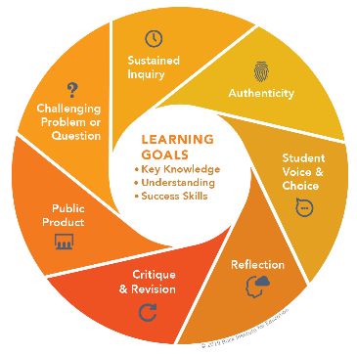
- The yellow highlighted sections need Specialist attention, as they are notes that require an action of the Specialist.
- Remember that each student responsibility can be adjusted to fit the needs of your students, especially when it comes to the expected time spent on this project. You are encouraged to add, remove or change out any elements within this Flex PBL to make this project suitable for your JAG students. Just remembering that a strong PBL (regardless of delivery method) has seven essential gold standard elements.
- Please complete this JAG Specialist survey at the completion of the project: https://forms.gle/BnJvPSPdEFPmGKmU6
- Finally, Specialists are responsible for how grading/allocation of points are determined based on your program expectations.

Flex PBL – Soft Skills with LinkedIn

Driving Question
When it comes to soft skills, what are my strengths and weaknesses, and how can I develop them further to ensure my future success?
Entry Event
- Watch this video: Employability skills – have you got them? (2 minutes)
https://www.youtube.com/watch?v=tKKPUYfOkvw
- Read this Article: (20 minutes)
https://www.indeed.com/career-advice/resumes-cover-letters/soft-skills
Then answer the following questions:
- What soft skills are your strengths?
- What soft skills are your weaknesses?
- How could you further develop your soft skills help you in your future career?

Public Product
Students will create a Professional LinkedIn profile.
Please see the University of Illinois LinkedIn rubric to help guide student’s work on this Flex PBL, located on pages 16-17 of this document.
If students have not previously used the Skills to Succeed Academy, JAG Specialists should share information about how the Skills to Succeed Academy supports the overall JAG organization by providing their resources for free to JAG participants. Express how S2SA offers a variety of online modules focused on finding and maintaining employment. If you need additional information about the Skills to Succeed Academy, refer to their page on the JAGenius!
Specialists may want to have students share their LinkedIn profile with your employer partners for feedback as well!

Free Soft Skills Training is available at:

https://www.open.edu/openlearn/money-business/soft-skills-training
https://www.edx.org/learn/soft-skills
https://www.trainingcoursematerial.com/free-training-articles
https://learndigital.withgoogle.com/digitalgarage/course/soft-skills-training

Week 1 of 4
JAG Student Week One Responsibilities
Getting the Soft Skills to Succeed
- State Driving Question
When it comes to soft skills, what are my strengths and weaknesses, and how can I develop them further to ensure my future success?

- Perform Entry Event Activities (TOTAL 22 minutes)
  - Watch this video: Employability skills – have you got them? (2 minutes)
https://www.youtube.com/watch?v=tKKPUYfOkvw
  - Read this Article: (20 minutes)
https://www.indeed.com/career-advice/resumes-cover-letters/soft-skills
Then answer the following questions:
- What soft skills are your strengths?
- What soft skills are your weaknesses?
- How could you further develop your soft skills help you in your future career?

- Review Details of this Project’s Public Product (3-5 minutes)
At the end of this project you will create a multimedia presentation that describes hard skills and/or certifications you would like to obtain, explain why these things would be beneficial to your future career, and construct a plan to build hard skills and pursue certifications.
A multimedia presentation presents information with slides, video, and/or digital representations that includes sound which might be a narrative, music, or the use of sound effects.
Tip: There are several great resources online to assist you with creating multimedia presentations if you need assistance and/or ideas!
Remember: these presentations are intended to showcase your learning, but to also help other students learn from you. Refer to the rubric for assistance.
- Log into the Skills to Succeed Academy – http://s2sacademy.org (3-5 minutes)

Not registered yet?
- Go to http://s2sacademy.org
- Click on <Learner > Registration
- Fill in the registration form and use Access Code <fill in learner access code here. This information can be found on the JAGenius. >

- Take a moment to explore the site once you are logged into the Skills to Succeed Academy. You will notice a purple menu bar across the top that helps with: (5 minutes)



  - Search
  - Courses
  - Progress
  - Ref.Zone

- Click on “Courses” in the purple menu bar at the top of the page. Then scroll down until you see three purple boxes with the title “Our courses.” (TOTAL 65 minutes)

Select the left-hand section called “Choose a Career.” When you open this page, you will see nine modules.

The focus on this week will be the options called:
- “Identify your Skills” (25 minutes)
- “Online Professional Presence” (40 minutes)
Click the purple bar that says “START” when you are ready to begin the courses.
Advance through the modules at your own pace; however, be aware of the goal to have these modules completed before the start of next week. Remember, you can pause, stop and/or go back at any point in the module.
- E-mail your progress on the Skills to Succeed Academy to your Specialist once you have completed both modules. You can view your progress page by logging into your S2SA profile and clicking on “Progress” in the purple bar at the top of the page. You may take a picture of this progress page or you may click on the “E-mail Progress” button and send the information to your Specialist this way. This check-in with your Specialist will focus on the activity packs that would be helpful for you to continue the important work focus on your career. (5 minutes)
Specialists: here is a direct link to the student activity pack, so you can review and identify sections that would be helpful for students to complete.
Identify your Skills: https://s2sacademy.org/cms/usa/activity_packs_files/GAJ%20Mod%205%20Identify%20Your%20Skills.pdf
Online Professional Presence
https://s2sacademy.org/cms/usa/activity_packs_files/GAJ%20Mod%2020%20Online%20Professional%20Presence.pdf

- With any remaining time this week, begin working on your presentation for this project.

Week 2 of 4
JAG Student Week Two Responsibilities
Time Management, Following Directions, and Teamwork
- Watch this video: Soft Skills by the Department of Labor (14 minutes) https://www.youtube.com/watch?v=31mfgrZpLus
- Watch this video: Effective Time Management (3:32 minutes) https://www.youtube.com/watch?v=31mfgrZpLus
- Create a List (10 minutes)
Include 20 things you need to accomplish in the next week. These things can be as simple as brushing your teeth or as big as taking a test, going to work, or a celebration.

- Watch this video: 7 Big Rocks (3:53 minutes)
https://www.youtube.com/watch?v=fmV0gXpXwDU
- Now, take the list you made earlier and prioritize the 20 activities from least important to most important. (10 minutes)
- Watch this video: Following Directions with Goofy (7:31 minutes) https://www.youtube.com/watch?v=Yruu2nKJBvY
- Following Directions Activity (20-30 minutes)
For this activity you will need a partner, either virtually or in person. One of you will draw a picture. Without telling the other person what the picture is, provide them with instructions to draw it. For example, “half way down the page, draw a straight horizontal line…” After explaining it, hold both pictures up where you can both see them and compare. Now do it again, reversing roles.

- Teamwork Activity: SURVIVAL--A Simulation Game (20-30 minutes)
Do this activity in small groups of 3-4 people.
- You and your companions have just survived the crash of a small plane. Both the pilot and co-pilot were killed in the crash. It is mid-January, and you are in Northern Canada. The daily temperature is 25 below zero, and the night time temperature is 40 below zero. There is snow on the ground, and the countryside is wooded with several creeks crisscrossing the area. The nearest town is 20 miles away. You are all dressed in city clothes appropriate for a business meeting. Your group of survivors managed to salvage the following items:

  - A ball of steel wool
  - A small ax A loaded
  - .45-caliber pistol
  - Can of Crisco shortening
  - Newspapers (one per person)
  - Cigarette lighter (without fluid)
  - Extra shirt and pants for each survivor
  - 20 x 20 ft. piece of heavy-duty canvas
  - A sectional air map made of plastic
  - One quart of 100-proof whiskey
  - A compass
  - Family-size chocolate bars (one per person)

- Your task as a group is to list the above 12 items in order of importance for your survival. List the uses for each. You MUST come to agreement as a group. Once you come to an agreement, give your list to your Specialist, who will then provide you with the suggested rankings for comparison.
Specialists: Once your student groups turn in their lists, provide them with the solution to the activity found at the end of this project or also at the following link: https://www.whiteman.af.mil/Portals/53/documents/AFD-130408-063.pdf.
- Answer the following questions: (10 minutes)
  - Why is it important to be a team player at school?
  - Why is it important to be a team player in the workplace?
  - Name 2 people you consider to be excellent team players and explain why.
- Check-in with your Specialist to discuss your learning so far and to get feedback on your plans for your LinkedIn Profile. (10 minutes)
- With any remaining time this week, continue working on your presentation for this project.

Week 3 of 4
JAG Student Week Three Responsibilities
Critical Thinking, Decision Making, and Emotional Intelligence

- Watch the Video: How to Improve Decision Making Skills (8 minutes)
https://www.youtube.com/watch?v=2tCYy66CyuQ

- Ethical Decision Making Activity (45-60 minutes)
- Find a group of two or three.
- Discuss the following:
  - How do you make decisions?
  - Is decision-making a skill that was taught to you?
  - Do you have personal rules for decision-making?
  - If you have rules, do these rules change if you are making decisions at home, at school, with friends, or at work?
- Discuss ethics. What are ethics?
  - Ethics on the job often deal with a code of conduct or a set of principles for BOTH the employer and the employee. What are some examples of workplace ethics from both the EMPLOYER and the EMPLOYEE?
  - For example
    - A list of work ethics for an employer or a company might be:
• To provide a safe work environment for staff and employees
• To treat employees with dignity and respect
• To provide a fair wage for the services rendered
• To handle all business transactions with integrity and honesty
    - A list of work ethics for an employee might include:
• To show up on time
• To tend to company business for the whole time while at work
• To treat the company’s resources, equipment, and products with care
• To give respect to the company; that means honesty and integrity
What types of ethical issues might come up at work?
- Review the Four-Step Process for Making Ethical Decisions at Work:
    - Define the problem (or ethical situation).
    - List the facts that appear to be most significant to the decision (and consider who is affected).
    - List two or three possible solutions (and how these solutions could impact each person).
    - Decide on a plan of action.
- Case Study
  - Still working in small groups, analyze the following case studies.
  - Assume you are employed by a large computer company, with approximately 1,000 employees. The company is located in your town. Read each case study and follow the four steps for making ethical decisions. Record your analysis and submit to your specialist as follows:
      - Identify the problem
      - List the facts
      - List 2-3 potential solutions
      - Decide the plan of action

Case 1: LaKeisha is an administrative assistant in the Human Resources Department. Her good friend Michael is applying for a job with the company and has agreed to be a reference for him. Michael asks for advice on preparing for the interview. LaKeisha has the actual interview questions asked of all applicants and considers making him a copy of the list so he can prepare.

Case 2: Emily works in the Quality Control Department. Once a year, her supervisor gives away the company’s used computers to the local elementary school. The company does not keep records of these computer donations. Emily really needs a computer. Her supervisor asks her to deliver 12 computers to the school.

Case 3: Marvin is an assistant in the Building Services Department. He has just received a new work computer and is excited to try it out. His supervisor has a strict policy about computer usage (for business purposes only), but Marvin wants to learn the email software. He figures one good way to do this is to send emails to his friends and relatives until he gets the hang of it. He has finished all of his work for the day and has 30 minutes left until his shift is over. His supervisor left early.

Case 4: Jennie was recently hired to work as a receptionist for the front lobby. As receptionist, she is responsible for making copies for the people in her office. Her son, Jason, comes in and needs some copies for a school project. He brought his own paper and needs 300 copies for his class. If he doesn’t bring the copies with him, he will fail the project. The company copier does not require a security key, nor do they keep track of copies made by departments.

Case 5: Nonye works in the Customer Service Support Department and spends a lot of his day responding to email. One day he got a message from an email address he didn’t recognize. It said, “I’d like to get to know you better, outside of work.” Nonye had no idea who sent it, so he deleted it. A few days later, he received another message from the same source. Nonye ignored the message again, thinking they would stop. He mentioned these emails to one of his co-workers, who responded, “You’re lucky to have a fan.” The messages continue to come every few days and he’s feeling pretty weirded out.
- Watch this video: What is Emotional Intelligence? (10 minutes) https://www.youtube.com/watch?v=LgUCyWhJf6s

- Take the following Emotional Intelligence Test (15-20 minutes)
https://globalleadershipfoundation.com/geit/eitest.html

Examine the results and answer the following questions:

  - What did you score highest in?
  - What did you score lowest in?
  - Do you agree with the results?
- Read this article: Improving Emotional Intelligence (15-20 minutes) https://www.helpguide.org/articles/mental-health/emotional-intelligence-eq.htm
Answer the following questions:
  - Where do you feel you need to make improvements?
  - What areas do you feel are your strengths?
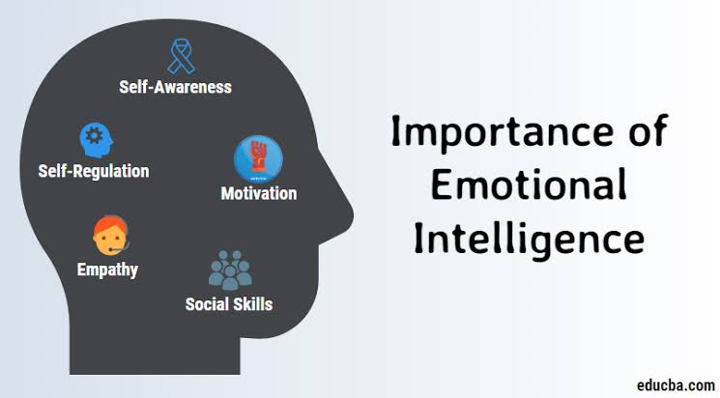
- Check-in with your Specialist. Discuss with your Specialist your answers to the previous two tasks, your progress on your LinkedIn Profile, and this week’s lessons. (10 minutes)
- Work on your LinkedIn Profile (Times will vary)
Remember: the Driving Question for this Flex PBL: When it comes to soft skills, what are my strengths and weaknesses, and how can I develop them further to ensure my future success?

Week 4 of 4
JAG Student Week Four Responsibilities
Putting it all Together

- This week is completely dedicated to working on your Public Product for this project, to create a Professional LinkedIn profile (Times Will Vary)
- Here are some suggested websites to assist you:
  - https://www.themuse.com/advice/the-31-best-linkedin-profile-tips-for-job-seekers
  - https://www.linkedin.com/help/linkedin/answer/112133/how-do-i-create-a-good-linkedin-profile-?lang=en
  - https://www.forbes.com/sites/williamarruda/2017/01/15/linkedin-101-how-to-craft-a-stellar-profile/?sh=2d2e23b45379
- Consult with at least two peers for feedback on your profile so far. Ask them to use the following framework: (20 minutes)
  - I like…
  - I wonder…
  - Have you thought about...

- Review the Rubric (10 minutes)
A rubric is provided below called “LinkedIn Profile Review Rubric for Undergraduates”

- Wrap up this project by doing these three things:
  - Share your LinkedIn profile with your Specialist.
*Insert how you wish for your participants to submit their work.

  - Complete the Self Reflection
SELF REFLECTION ON PROJECT WORK
    - What did you learn from doing this project?

    - Were you satisfied with your final product?

    - What, if anything, would you change?

    - Do you plan to begin working on your hard skills and/or towards a certification?

    - What resources will help you reach your goals for gaining those hard skills and/or certification?

  - Complete this JAG National student survey to gather feedback about this Flex PBL: https://forms.gle/Gquryg9Yvoa47VdbA

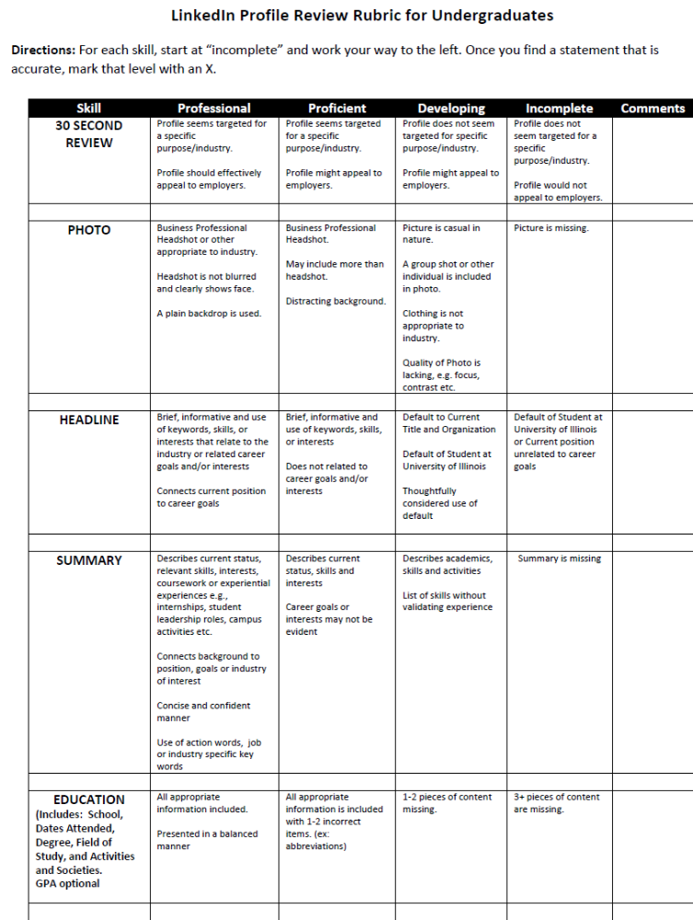
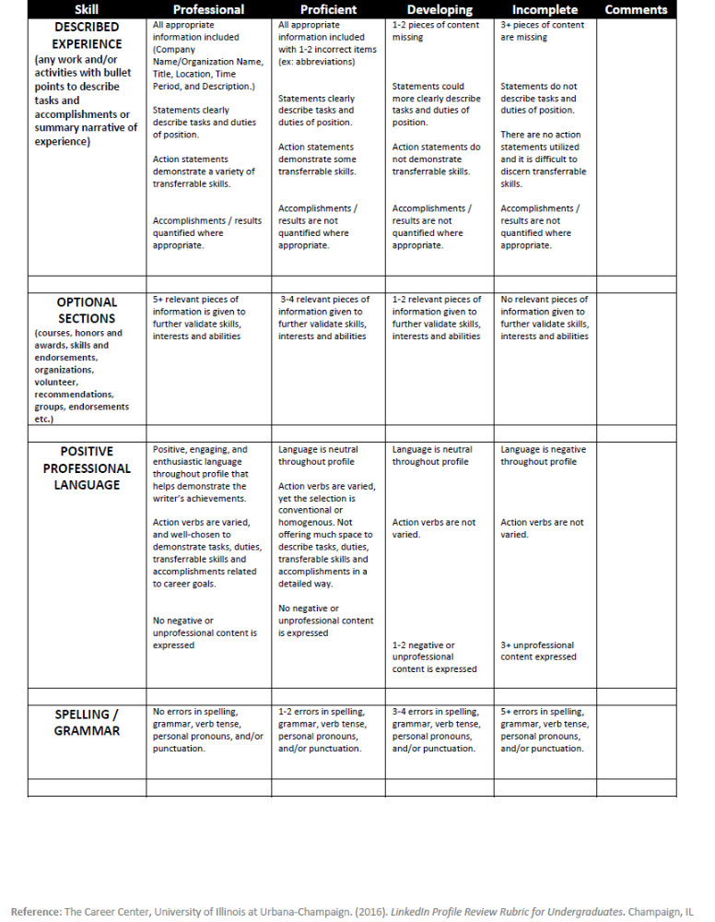

Teamwork Activity: SURVIVAL--A Simulation Game
Mid-January is the coldest time of year in Northern Canada. The first problem the survivors face is the preservation of body heat and the protection against its loss. This problem can be solved by building a fire, minimizing movement and exertion, using as much insulation as possible, and constructing a shelter.
The participants have just crash-landed. Many individuals tend to overlook the enormous shock reaction this has on the human body, and the deaths of the pilot and co-pilot increases the shock. Decision-making under such circumstances is extremely difficult. Such a situation requires a strong emphasis on the use of reasoning for making decisions and for reducing fear and panic. Shock would be shown in the survivors by feelings of helplessness, loneliness, hopelessness, and fear. These feelings have brought about more fatalities than perhaps any other cause in survival situations. Certainly the state of shock means the movement of the survivors should be at a minimum, and that an attempt to calm them should be made.
Before taking off, a pilot has to file a flight plan which contains vital information such as the course, speed, estimated time of arrival, type of aircraft, and number of passengers. Search-and rescue operations begin shortly after the failure of a plane to appear at its destination at the estimated time of arrival.
The 20 miles to the nearest town is a long walk under even ideal conditions, particularly if one is not used to walking such distances. In this situation, the walk is even more difficult due to shock, snow, dress, and water barriers. It would mean almost certain death from freezing and exhaustion. At temperatures of minus 25 to minus 40, the loss of body heat through exertion is a very serious matter.
Once the survivors have found ways to keep warm, their next task is to attract the attention of search planes. Thus, all the items the group has salvaged must be assessed for their value in signaling the group’s whereabouts.
The ranking of the survivors items was made by Mark Wanvig, a former instructor in survival training for the Reconnaissance School of the 101st Division of the U.S. Army. Mr. Wanvig currently conducts wilderness survival training programs in the Minneapolis, Minnesota area. This survival simulation game is used in military training classrooms.
https://www.whiteman.af.mil/Portals/53/documents/AFD-130408-063.pdf
How to score Each team should list its top 5 choices in order prior to seeing the answer sheet. To award points, look at the ranking numbers on this answer sheet. Award points to each team’s top choices according to the numbers here. For example, the map would earn 12 points, while the steel wool would earn 2 points. Lowest score wins (and survives).
RANKINGS
- 1. Cigarette lighter (without fluid) The gravest danger facing the group is exposure to cold. The greatest need is for a source of warmth and the second greatest need is for signaling devices. This makes building a fire the first order of business. Without matches, something is needed to produce sparks, and even without fluid, a cigarette lighter can do that.
- 2. Ball of steel wool To make a fire, the survivors need a means of catching he sparks made by the cigarette lighter. This is the best substance for catching a spark and supporting a flame, even if the steel wool is a little wet.
- 3. Extra shirt and pants for each survivor Besides adding warmth to the body, clothes can also be used for shelter, signaling, bedding, bandages, string (when unraveled), and fuel for the fire.
- 4. Can of Crisco shortening This has many uses. A mirror-like signaling device can be made from the lid. After shining the lid with steel wool, it will reflect sunlight and generate 5 to 7 million candlepower. This is bright enough to be seen beyond the horizon. While this could be limited somewhat by the trees, a member of the group could climb a tree and use the mirrored lid to signal search planes. If they had no other means of signaling than this, they would have a better than 80% chance of being rescued within the first day. There are other uses for this item. It can be rubbed on exposed skin for protection against the cold. When melted into an oil, the shortening is helpful as fuel. When soaked into a piece of cloth, melted shortening will act like a candle. The empty can is useful in melting snow for drinking water. It is much safer to drink warmed water than to eat snow, since warm water will help retain body heat. Water is important because dehydration will affect decision-making. The can is also useful as a cup.
- 5. 20 x 20 foot piece of canvas The cold makes shelter necessary, and canvas would protect against wind and snow (canvas is used in making tents). Spread on a frame made of trees, it could be used as a tent or a wind screen. It might also be used as a ground cover to keep the survivors dry. It’s shape, when contrasted with the surrounding terrain, makes it a signaling device.
- 6. Small ax Survivors need a constant supply of wood in order to maintain the fire. The ax could be used for this as well as for clearing a sheltered campsite, cutting tree branches for ground insulation, and constructing a frame for the canvas tent.
- 7. Family size chocolate bars (one per person) Chocolate will provide some food energy. Since it contains mostly carbohydrates, it supplies the energy without making digestive demands on the body.
- 8. Newspapers (one per person) These are useful in starting a fire. They can also be used as insulation under clothing when rolled up and placed around a person’s arms and legs. A newspaper can also be used as a verbal signaling device when rolled up in a megaphone-shape. It could also provide reading material for recreation.
- 9. Loaded .45-caliber pistol The pistol provides a sound-signaling device. (The international distress signal is 3 shots fired in rapid succession). There have been numerous cases of survivors going undetected because they were too weak to make a loud enough noise to attract attention. The butt of the pistol could be used as a hammer, and the powder from the shells will assist in fire building. By placing a small bit of cloth in a cartridge emptied of its bullet, one can start a fire by firing the gun at dry wood on the ground. The pistol also has some serious disadvantages. Anger, frustration, impatience, irritability, and lapses of rationality may increase as the group awaits rescue. The availability of a lethal weapon is a danger to the group under these conditions. Although a pistol could be used in hunting, it would take an expert marksman to kill an animal with it. Then the animal would have to be transported to the crash site, which could prove difficult to impossible depending on its size.
- 10. Quart of 100 proof whiskey The only uses of whiskey are as an aid in fire building and as a fuel for a torch (made by soaking a piece of clothing in the whiskey and attaching it to a tree branch). The empty bottle could be used for storing water. The danger of whiskey is that someone might drink it, thinking it would bring warmth. Alcohol takes on the temperature it is exposed to, and a drink of minus 30 degrees Fahrenheit whiskey would freeze a person’s esophagus and stomach. Alcohol also dilates the blood vessels in the skin, resulting in chilled blood belong carried back to the heart, resulting in a rapid loss of body heat. Thus, a drunk person is more likely to get hypothermia than a sober person is.
- 11. Compass Because a compass might encourage someone to try to walk to the nearest town, it is a dangerous item. It’s only redeeming feature is that it could be used as a reflector of sunlight (due to its glass top).
- 12. Sectional air map made of plastic This is also among the least desirable of the items because it will encourage individuals to try to walk to the nearest town. It’s only useful feature is as a ground cover to keep someone dry

