

2020-21 Flex PBL
PBL Title: | Leading Through Service
Duration: | 4 weeks | Release Date: | November 15, 2020
HELP? | e-mail jenn.beal@jag.org | Pages: | 12
Project Summary
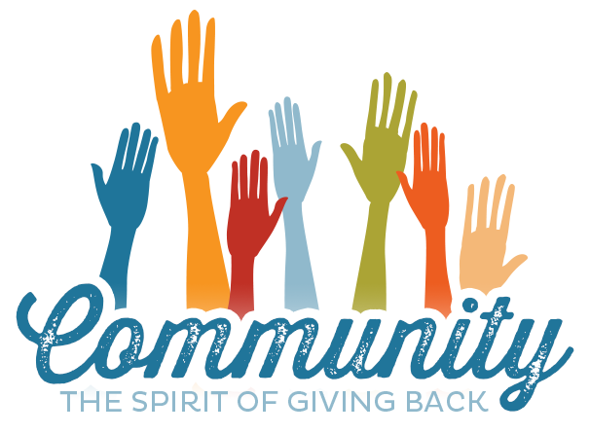
This Flex PBL, which asks students to conduct a service project that meets a need in their community, is intended to be implemented during the month of December for the 2020-2021 academic year, but could be implemented anytime you want to add in a service project.
Public Product
Student groups will collaborate to construct a community service project that benefits a need in the community. The project must include at least two promotional components designed to bring awareness to that need and inspire others to take action. The public product will be the execution of the community service project. The project concludes with an individual reflective essay.

Competency Attainment
Level 1:, D.21-Comprehend verbal communications, D.22-Comprehend written communications,
D.23-Communicate in writing, D.24-Communicate verbally, F.31-Understand types of maturity, F.32-Identify a self-value system and how it affects life, F.33-Base decisions on values and goals, F.35-Demonstrate ability to assume responsibility for actions and decisions, G.49-Provide constructive feedback, H.70-Demonstrate a commitment in completing work assignments accurately and in a timely fashion, H.71-Demonstrate an ability to satisfy the purposes of a delegated task, H.72-Demonstrate an ability to prioritize and manage time effectively in the workplace, H.73-Demonstrate enthusiasm for work, H.75 Demonstrate an understanding of the work to be accomplished.
Level 2: C.15-Understand what employers expect of employees, C.16-Identify problems of new employees, C.17-Demonstrate time management, C.18-Follow directions, C.19-Practice effective human relations, F.36-Demonstrate a positive attitude, F.37-Develop healthy self-concept for home, school and work, G.53-Exhibit work ethics and behaviors essential to success, G.58-Identify ways to build mutual trust and respect.
Level 3: G.47-Demonstrate techniques for building commitment by others, G.48-Demonstrate an openness to change, G.54-Set and prioritize goals and establish a timeline for achieving them, G.55-Apply the problem-solving process to complex problems, H.74-Demonstrate an eagerness to learn new responsibilities or improve current responsibilities.
JAG Competencies should be set based on the Specialists discretion.
The above stated are merely suggestions based on the project structure.

Notes for the Specialist
- Flex PBL are designed with two intended purposes:
  - to meet the ever-changing instructional needs of JAG Specialists across the JAG National network and
  - to provide relief with competency attainment and project design to allow Specialists the space to devote a majority of their time in meeting the immediate needs of students.

- With Flex PBL. Specialists are encouraged to meet with their students as recommended by their school district, whether face-to-face, hybrid, or virtual. Specialists should also use the technology recommended by their school district.

- A Flex PBL can be administered in a variety of instructional modalities. Here are three of the most common options:
  - Traditional; full time, in-person instruction – walk through the steps in showing videos and leading discussions as a typical class unit.
  - Hybrid, blended or a flipped classroom – identify and pull out the pieces that can be asked of students to perform outside of in-person class time (i.e. to watch videos, journal, etc.) and reserve team building, discussions and/or problem solving for in-person opportunities.
  - Completely online model – this Flex PBL can also be administered in a completely online format, by using any means of delivery that is being directed or offered by your school district.
- The format of this Flex PBL was aimed to be easily manipulated for Specialists to deliver the project within a classroom. They can print, copy and paste into an e-mail, text, social media or a learning management system (i.e. Google Classroom, Canvas, etc).
- The intentional design of this Flex PBL is to allow a logical and manageable flow for students to work in a self-guided way.
- A series of webinars are available on the Genius for each of these three options. The topic area shifts from week to week, but the three group offerings remain consistent to accommodate your needs as they may change throughout the 2020-2021 academic year.
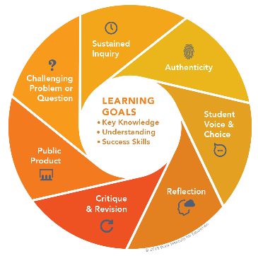
- In addition to Genius resources, the JAG National Staff is available for steps on the practical application of this Flex PBL.
- The yellow highlighted sections need Specialist attention, as they are notes that require an action of the Specialist.
- Remember that each student’s responsibilities can be adjusted to fit their needs, especially when it comes to the expected time spent on this project. You are encouraged to add, remove or change any elements within this Flex PBL to make this project suitable for your JAG students. Just remembering that a strong PBL (regardless of delivery method) has seven essential gold standard elements.
- Please complete this JAG Specialist survey at the completion of the project: https://forms.gle/yRW67aN5WuQfzobA9
- Finally, Specialists are responsible for how grading/allocation of points are determined based on your program expectations.

Flex PBL – A Community of Service

Driving Question
How can I make a positive difference in my community?

Entry Event
- Watch this video – Choose Life: https://www.globalgoals.org/ (1:58 minutes)

- Discussion Questions (10 minutes)
In small groups, have students define the following and then engage in a discussion:
- Civic Engagement
- Civic Awareness
- Civic Responsibility
- Civic Literacy
Suggestions: you may want to use free online discussion tools such as: Flipgrid, Kialo, NowComment, or Yo Teach!

- Create groups (time will vary)
Public Product
In teams, students will conduct a service project that meets a need in your community. Once your group selects their project, they will create a plan and create publicity, including at least two promotional components to bring awareness to that need and inspire others to take action. PSA video, print advertisement, website, audio recording, pamphlets, newsletter, etc. Students should first analyze needs within their community, then reach a consensus as a group to select their service project direction. Following the project, groups will reflect on their experience and celebrate! Let those who participate feel appreciated for their contribution.
*Rubric is available page11 of this Flex PBL.

Sites with community service ideas that include virtual options:

Points of Light: https://www.pointsoflight.org/virtual-volunteering-opportunities/

20 Online Community Service Ideas for High Schoolers
- https://blog.collegevine.com/online-community-service-for-high-schoolers/
- The World Volunteer Web is the hub for information and resources on the online, worldwide volunteer community.
- UNV Online Volunteering is a service by United Nations Volunteers that connects individual volunteers with organizations working for sustainable human development around the world.
- Volunteer Match links volunteers to virtual opportunities both in nearby communities and across the globe.
- Idealist.org is a great search tool for locating volunteer opportunities with a nonprofit focus—and you can search by location, focus area, schedule and more.
- DoSomething.org allows you to volunteer for any cause, from anywhere, at any time.
- 60 Ways to Better your Community: https://www.signupgenius.com/nonprofit/community-service-project-ideas.cfm
- https://lancaster.unl.edu/4h/communityserviceideas.pdf

Week 1 of 4
JAG Student Week One Responsibilities
Investigate and Prepare
- Entry Event -- Implement the Entry Event activities found on page three of this Flex PBL.

  - Watch YouTube Video
  - Answer Discussion Questions
    - Create online account for discussions, if necessary.
  - Create project groups

- Find a need in your community that your group wants to address. Perhaps it is a need you already know about, maybe something from the news. If you are not sure, you can interview others or even conduct a survey. One great resource is to choose from the United Nations 17 Global Goals for sustainable development, found at: https://www.globalgoals.org/. This website also has resources to assist you. https://www.un.org/sustainabledevelopment/sustainable-development-goals/ Your group should come to a consensus in selecting a community service project and then begin dividing the tasks. (30-60 minutes)
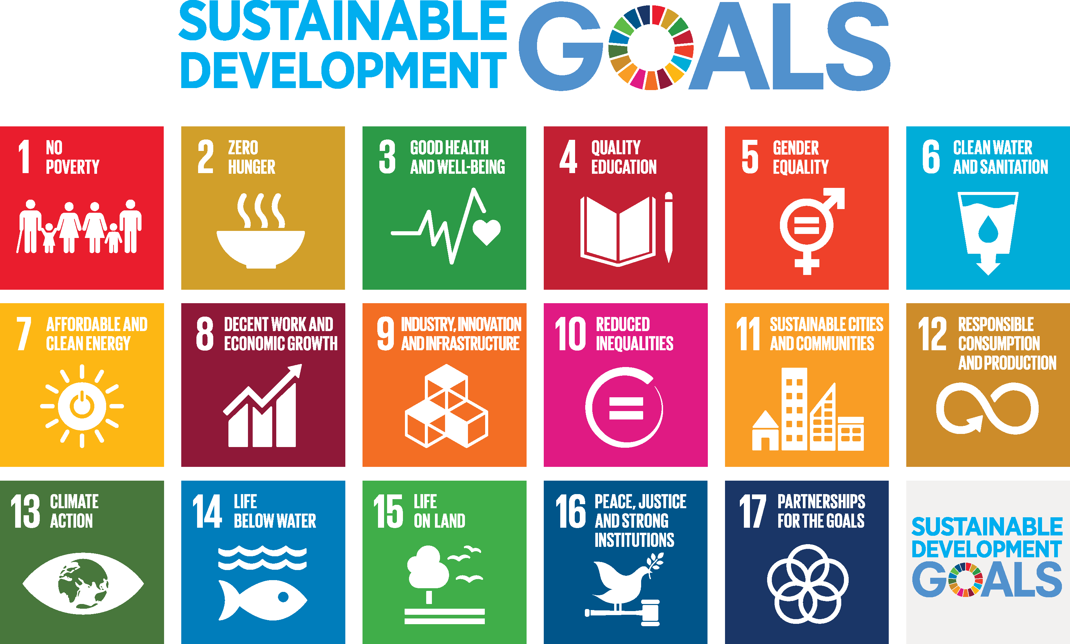

- Complete the Project Team Contract(attached). (20 minutes)
- Complete the Community Service Action Plan (attached). (20 minutes)
- Complete the Project Teamwork Plan (attached). (20 minutes)
- Group check-in with your Specialist for feedback on plans before proceeding. (15 minutes)
- Begin executing your project plan, it is especially important to start working on your promotional components early. Work together to obey your team contract and complete the plan. Consider the impact of this project in your community and allow that to drive your work. (Time will vary)
Week 2 of 4
JAG Student Week Two Responsibilities
Create and Build

- Watch the Video: “Why it is Important for Kids to Volunteer” (8:21 minutes)
This can be watched individually or as a group: https://www.youtube.com/watch?v=fDocxsO2tYA
- Read the article: (20 minutes)
“Youth Helping America: The Role of Social Institutions in Teen Volunteering” by the Corporation for National and Community Service.
https://www.nationalservice.gov/pdf/05_1130_LSA_YHA_SI_factsheet.pdf
According to this article, youth volunteer at nearly twice the rate of adults. From the information in this article, and with what you know already, please answer the following questions:
  - Why is it important for youth to volunteer?
  - How can young people have a positive impact on their communities?
  - Why do you think youth who volunteer perform better academically?

- Research tips for running a successful community service campaign. (20-30 minutes)
Here is a potentially helpful resource:
https://www.extension.iastate.edu/sites/www.extension.iastate.edu/files/desmoines/CommunityServiceProject.pdf
- Make sure you have all of the components to lead a successful project:
  - Meets a need in your community
  - Is credible and professional
  - Has a plan to collect the necessary resources to implement the project
  - Includes realistic goals
  - Plan includes a time and a location for the project to take place
  - Promotional components will inform others and inspire them to take action

- Groups will outline their projects in a document for a virtual or in-person gallery walk to receive “I like…,I wish…” feedback from their peers (20 minutes)
- Perform a Gallery Walk (30 minutes)
For assistance with virtual gallery walks, check here: https://topr.online.ucf.edu/digitalizing-gallery-walks-method-student-centered-feedback-engagement/
- Consider as a group the provided peer feedback. Make any necessary adjustments. (15 minutes)
- Check-in with your Specialist and provide them with an update on your project. (5 - 15 minutes)
- Continue work on your public product/project plan to deliver a service to your community. (Varies)

Week 3 of 4
JAG Student Week Three Responsibilities
Prepare and Practice
- Specialists: Remind students this is the final week to work on their public product.
- Watch the video: “Volunteering - the Beneficial Side Effects” (9:50 minutes)
This can be watched individually or as a group: https://www.youtube.com/watch?v=jbV1TDZQAFc
- Individually, perform the following tasks: (15 minutes)
  - Answer the following:
    - What could I gain or have I gained from participating in community service?
    - Describe a time you showed empathy or someone else demonstrated empathy towards you.
- Student groups should examine their project thus far and identify potential problems, then generate solutions to overcome as you progress in your project planning. (15 minutes)
Potential challenges may include:
  - Getting the message out to gain awareness and support—research advertising strategies.
  - Logistics or making the project plan actually happen – seek checklists and create a roadmap so everyone knows their role to ensure the project comes to life.
- Spend the rest of your time this week working on your public product: (Varies)
Just one more week until showtime! Please be sure to use the rubric to assist you. Work together and remember that your goal to help others through this project!
- Check-in with your Specialist for final feedback on your project. (15 minutes)

Week 4 of 4
JAG Student Week Four Responsibilities
Execute, Reflect, and Celebrate
- Perform your group Community Service Project! (Time will vary)
Reference the Community Service Project Group Rubric for how this project’s public product will be graded (attached).

- Complete a Reflection Essay. (1-1 ½ hours)
  - Reflective Essay: After full implementation of the community service project, individually construct a reflective essay that includes the following:
    - Describe the community service project and the feelings you experienced
    - Evaluate the experience - what was good/bad about it
    - Analyze the event- cause/effect, compare/contrast
    - What were the effects of your project? Did it cause change?
    - How did the project help you grow as an individual?
    - Would you do anything differently? Why or why not?

Reference the Reflective Essay Rubric for grading (attached).

- Complete this survey: https://forms.gle/aRnfC6teLSFewSsJ6 (2 minutes)
- Celebrate!




PROJECT TEAM CONTRACT

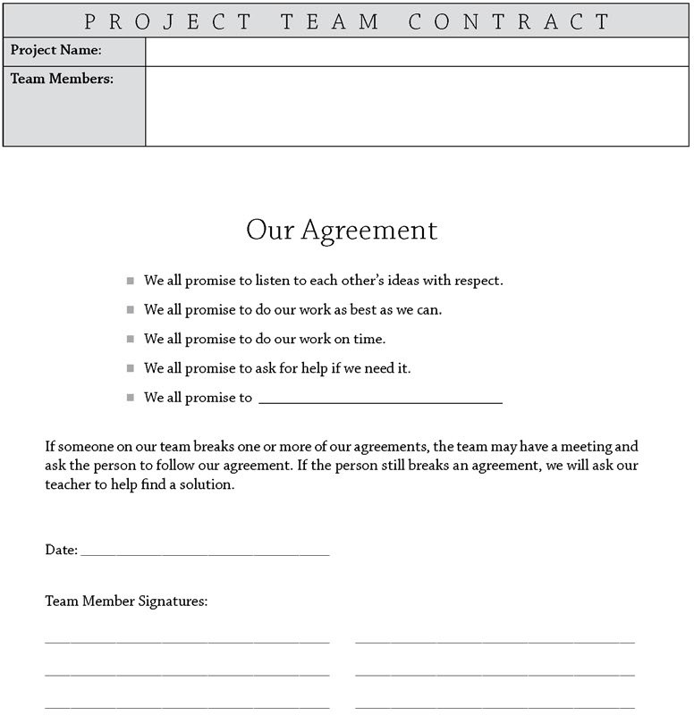

pblworks.org
© 2019 Buck Institute for Education

Community Service Action Plan

Identify the issue. What is a need in your community that you can address? ____________

______________________________________________________________________________

_____________________________________________________________________________

What makes this issue important to your group and the community?_____________________

______________________________________________________________________________

_______________________________________________________________________________

What do you want to accomplish? How will this make a difference?_____________________

______________________________________________________________________________

________________________________________________________________________________

What resources will you need and how will you get them?_____________________________

_________________________________________________________________________________

________________________________________________________________________________

What components will our plan include?_____________________________________________

_________________________________________________________________________________

_________________________________________________________________________________

When and where will our service take place?________________________________________

____________________________________________________________________________

How will we know we are ready to implement our plan?_________________________________

________________________________________________________________________________

________________________________________________________________________________

What are the roles and responsibilities of each group member?__________________________

________________________________________________________________________________

________________________________________________________________________________

________________________________________________________________________________

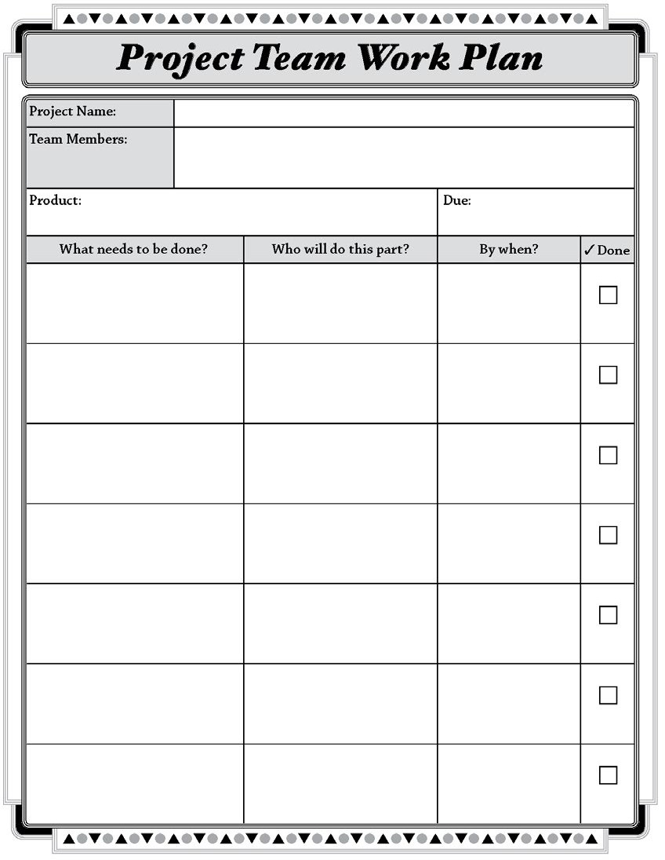
pblworks.org
© 2019 Buck Institute for Education

Community Service Project Group Rubric

SCORE | CONTENT/ DEVELOPMENT | ORGANIZATION/ MECHANICS | VOICE/ PERSUASION | FOCUS/ ORIGINALITY | PRESENTATION
4 | Presents a well-researched issue that is clearly defined and includes abundant information.  Fully develops the central idea with specific, relevant details. | All facets of the project are well-organized and appealing. Correct grammar and mechanics are used, adding credibility | The force of language, imagery, and argument is powerful, and invokes the emotions of the audience, making them want to take action. Strongly aware of audience and task; tone is consistent and appropriate | The project creatively presents the issue in a manner that is attention grabbing and gets the point across, while sustaining focus on central idea throughout the project | Innovative and professional presentation that portrays the issue with maximum integrity and reliability
3 | Presents a well-researched issue that is clearly defined and includes adequate information.  Fully develops the central idea with specific, relevant details. | Most facets of the project are well-organized and appealing, with minimal errors in grammar and mechanics. | The force of language, imagery, and argument would adequately move the audience to take action. Sufficiently aware of audience and task; tone is consistent and appropriate | The project productively presents the issue in a manner that is gets the point across, while adequately sustaining focus on central idea throughout the project | Satisfactory and professional presentation that portrays the issue with adequate credibility
2 | Presents the issue, but has insufficient research to back it up with facts. The central idea lacks specific, relevant details. | Some facets of the project are well-organized and appealing, with several errors in grammar and mechanics | The force of language, imagery, and argument is fair, but lacks the power to invoke the emotions of the audience. Somewhat aware of audience and task; tone may be inconsistent but is appropriate | The project mostly presents the issue in a manner that gets the point across, but the focus shifts throughout the project | Presentation lacks the high level of professionalism required to portray the issue with sufficient credibility
1 | Presents the issue in a haphazard manner, with no research to support the facts presented, and is missing the necessary information to generate awareness of the issue. | Few facets of the project are well-organized and appealing, with numerous errors in grammar and mechanics | The force of language, imagery, and argument is weak and would not move the audience to take action. Project lacks awareness of the audience and task; tone is inconsistent and/or inappropriate | The project presents the issue in an unoriginal or redundant matter that lacks focus and credibility | Presentation is unprofessional and lacks credibility

Raw Rubric Score/Total | Percentage
20 | 100%
19 | 97%
18 | 95%
17 | 92%
16 | 90%
15 | 87%
14 | 84%
13 | 82%
12 | 79%
11 | 77%
10 | 74%
9 | 71%
8 | 69%
Reflective Essay Rubric

SCORE | CONTENT/ DEVELOPMENT | ORGANIZATION/ MECHANICS | VOICE/ PERSUASION | EVALUATION | REFLECTION
4 | The student’s reflection about the topic is explained in clear language; immediately interesting and supported with detail | All facets of the essay are well-organized and appealing. Correct grammar and mechanics are used, adding credibility | The force of language, imagery, and argument is powerful, and invokes the emotions of the reader. Strongly aware of audience and task; tone is consistent and appropriate | The essay creatively evaluates the experience using cause/effect and/or compare/contrast techniques | Paper provides strong evidence through the use of description and details that the student has examined his/her own belief systems and related this to their current views about the topic
3 | The entire paper’s content relates to the prompt or topic; the student explains his/her reflections about the topic but may take a rereading to understand | Most facets of the essay are well-organized and appealing, with minimal errors in grammar and mechanics. | The force of language, imagery, and argument is adequate. Sufficiently aware of audience and task; tone is consistent and appropriate | The essay productively presents the issue in a manner that is gets the point across, while adequately sustaining focus on central idea throughout the essay | Paper demonstrates that the student has examined his/her own belief systems and related this to their current views about the topic
2 | Student does not clearly identify his/her reflections about the topic; may veer from topic | Some facets of the essay are well-organized and appealing, with several errors in grammar and mechanics | The force of language, imagery, and argument is fair, but lacks the power to show emotions of the writer. Somewhat aware of audience and task; tone may be inconsistent but is appropriate | The essay mostly presents the issue in a manner that gets the point across, but the focus shifts throughout the essay | The paper shows that the student has thought about the topic although the written presentation may lack a thorough review of feelings and beliefs
1 | The topic of the paper is not addressed at all; Fails to stick to the topic therefore fails to meet this criteria | Few facets of the essay are well-organized and appealing, with numerous errors in grammar and mechanics | The force of language, imagery, and argument is weak. Essay lacks awareness of the audience and task; tone is inconsistent and/or inappropriate | The essay presents the issue in an unoriginal or redundant matter that lacks focus and credibility | Paper does not present detailed evaluation of reflection about the topic

Raw Rubric Score/Total | Percentage
20 | 100%
19 | 97%
18 | 95%
17 | 92%
16 | 90%
15 | 87%
14 | 84%
13 | 82%
12 | 79%
11 | 77%
10 | 74%
9 | 71%
8 | 69%

