Madison Area Memorial Recreational Community College
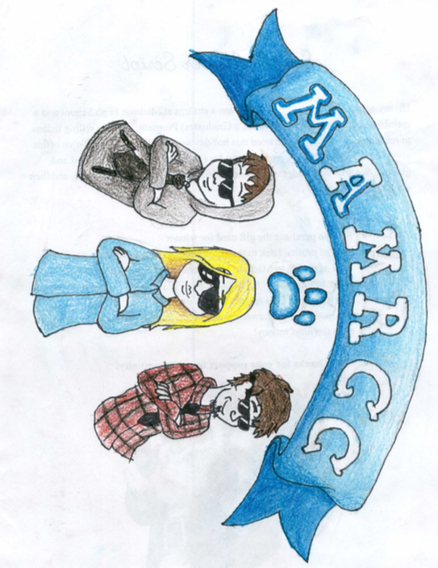
January 8th, 2019

Executive Summary

Madison Area Memorial Recreational Community College (MAMRCC) is working to increase the percentage of community members with post secondary education by providing local affordable hands on college courses, including two-year and four-year degrees, for those looking to improve their career or start a new career path. Also we offer a wider variety of recreational activities and dining options to our members to encourage healthy living styles. Our targeted community members will be from Carrabec, Skowhegan, and Madison.

Market Research

In our community we lack opportunities for education. In Maine 30% of the population has a bachelor's degree or higher BUT in some of Somerset County, only 16% of the population has a bachelor’s degree, according to the US Census. At MAMRCC we believe we can increase this percentage by providing a local option.
Our biggest competitor is Kennebec Valley Community College (KVCC) which is located in Fairfield, ME and is approximately 20.2 miles away, totaling about a thirty minute drive from Madison. Kennebec Valley Community College costs $94 per credit hour for Maine residents whereas ours would only cost $125 per semester class/$150 per 2 semester class and an extra $80 per month to use any recreational activities. Our closer, much more affordable option will save time, money for fuel, and makes education a possibility to those without transportation.
In Maine, only 77.7% of the population have internet at home and only 87% have computers, but in Somerset County only 70.2% have internet in their homes and only 81.2% have computers. Having access to computers and internet is important in our day in age because so many jobs are based around technology. More than 51% of today’s jobs require some degree of technology skills and will increase to about 77% in the next decade. MAMRCC will provide a small but effective computer lab for students to access computers for their courses, along with other educational uses. The college will also provide internet throughout the campus for students to use freely for educational purposes.

Marketing Strategy

We like to welcome everyone at MAMRCC. Our strategy to introduce new people to our recreational community college is to spread the word through advertisements that shows viewers MAMRCC is the place for them. This would include posting flyers and pamphlets at local grocery stores, recreational stores, and guidance offices of surrounding schools. We would promote our school as an affordable local option. Students can register at MAMRCC’s student service center or online at www.MAMRCC.com. We are always available and students can contact us through email, the contact page on our website, and in -person at the student service center. Our website would showcase our variety of courses from astronomy to the medical field, and our range of recreational activities including skate parks, weightlifting gyms, tennis, badminton, and basketball courts.

Financial Plan

After lots of collaborating we have decided that to make money we will fundraise, find investors for our business, charge memberships/class fees, and partner with sponsors to help pay for equipment and etc. Memberships will cost $80 per month to use recreational resources and each class will cost $150 per class that lasts a full semester. Depending on family income, you can qualify for financial aid and or scholarships. We will have land on the Reed, Rd Madison, ME 04950 with a retail price of $125,900 for 153.76 acres. This will be paid through fundraisers and investors. As there is no building attached to this lot of land we will have to build it from scratch which will be a very long process. Our business will most likely take a few years to build up which will give us extra time to come up with ideas to make the business better.

Type of Fee | Cost
Monthly Membership for Recreational Activities | $80
Payment Per Semester Class | $125
Payment Per 2 Semester Class | $150
Monthly Dining Card | $50

