

2020-21 Flex PBL
PBL Title: | Professional Communication | By: LinkedIn Learning | and Microsoft Learn
Duration: | 4 weeks | Release Date: | October 15, 2020
HELP? | e-mail jenn.beal@jag.org | Pages: | 8
Project Summary
This Flex PBL is intended to be implemented during the month of November for the 2020-2021 academic year. The content within this project aligns with various simultaneous projects and events taking place throughout the JAG National Network; for example, the L.O.V.E. Project, early stages in the Career Association, and prep for the Virtual National Student Leadership Academy.
Utilizing another incredible, virtual, and FREE* resource—this project captures the materials made available through LinkedIn Learning. LinkedIn Learning provides relevant skill training paths in connection with Microsoft Learn that prepares individuals for in-demand jobs. Here is the link to the materials: https://opportunity.linkedin.com/skills-for-in-demand-jobs
*This FREE offer is available until March 31, 2021.
If you scroll past the in-demand job section, you will see a “Master critical soft skills” section. By clicking on the blue rectangle, you can access the courses. Here is the direct link to the overall “Master In-Demand Professional Soft Skills” course: https://www.linkedin.com/learning/paths/master-in-demand-professional-soft-skills?trk=li-jobsindemand-softskills-en&src=direct%2Fnone&veh=direct%2Fnone%7Cdirect%2Fnone
One of the eleven courses within this master course is “Communication Foundations” and will be the focus of this project. Here is the direct link to the content being used in this Flex PBL: https://www.linkedin.com/learning/communication-foundations-2?trk=learning-path&upsellOrderOrigin=li-jobsindemand-softskills-en
Competency Attainment Below are suggested JAG Competencies

Level 1: G.51-Demonstrate politeness and civility, G.52-Demonstrate an ability to adapt to people and situations, G.53-Exhibit work ethics and behaviors essential to success,
G.55-Apply the problem solving process to complex problems, H.66-Demonstrate an ability to follow and give directions

Level 2: D.21-Comprehend verbal communications, D.22-Comprehend written communications, G.50-Negotiate solutions to conflicts, G.58-Identify ways to build mutual trust and respect, H.62-Demonstrate how to work effectively with others

Level 3: D.23-Communicate in writing, D.24-Communicate verbally, G.46-Describe how to work and communicate with diverse people at work and in the community to satisfy their expectations, H.64-Demonstrate an ability to communicate and work with customers to satisfy their expectations, H.65- Demonstrate listening skills which result in gaining a clear understanding of information being conveyed

Notes for Specialist
- Flex PBL are designed with two intended purposes:
  - to meet the ever-changing instructional needs of JAG Specialists across the JAG National network and
  - to provide relief with competency attainment and project design to allow Specialists the space to devote a majority of their time in meeting the immediate needs of students.

- A Flex PBL can be administered in a variety of instructional modalities. Here are three of the most common options:
  - Traditional; full time, in-person instruction – walk through the steps in showing videos and leading discussions as a typical class unit.
  - Hybrid, blended or a flipped classroom – identify and pull out the pieces that can be asked of students to perform outside of in-person class time (i.e. to watch videos, journal, etc.) and reserve team building, discussions and/or problem solving for in-person opportunities.
  - Completely online model – this Flex PBL can also be administered in a completely online format, by using any means of delivery that is being directed or offered by your school district.
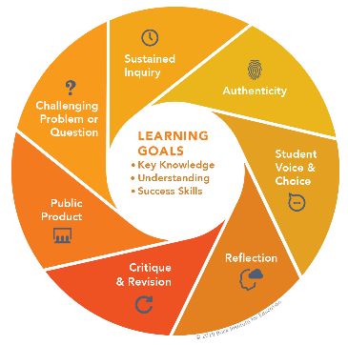
- The format of this Flex PBL was aimed to be easily manipulated for Specialists to deliver the project within a classroom. They can print, copy and paste into an e-mail, text, social media or a learning management system (i.e. Google Classroom, Canvas, etc).
- The intentional design of this Flex PBL is to allow a logical and manageable flow for students to work in a self-guided way.
- When making adjustments to this Flex PBL to meet the needs of your students, please remember to maintain the core elements that make this project a true project-based learning experience following the Buck Institute for Education standards.
- In addition to Genius resources, the JAG National Staff is available for steps on the practical application of this Flex PBL.
- The yellow highlighted sections need Specialist attention, as they are notes that require an action of the Specialist.
- Remember that each student responsibility can be adjusted to fit the needs of your students, especially when it comes to the expected time spent on this project. You are encouraged to add, remove or change out any elements within this Flex PBL to make this project suitable for your JAG students. Just remembering that a strong PBL (regardless of delivery method) has seven essential gold standard elements.
- Please complete this JAG Specialist survey at the completion of the project: https://forms.gle/ZSBpsgGKKKtSesq38
- Finally, Specialists are responsible for how grading/allocation of points are determined based on your program expectations.

Flex PBL – Professional Communication

Driving Question
How can I improve my professional communications skills and effectively communicate how these skills can enhance my current and future life at school, work and home?
Entry Event
CTE Online hosts a website with various PBLs. One of the CTE Online projects aligns perfectly with this Flex PBL topic of Professional Communication. By visiting the following link, Specialists will have access to four complete lessons. Each of these lessons would be an incredible way to provide entry into this Flex PBL.
https://www.cteonline.org/projects/jdawxg/communication-skills-pbl-project
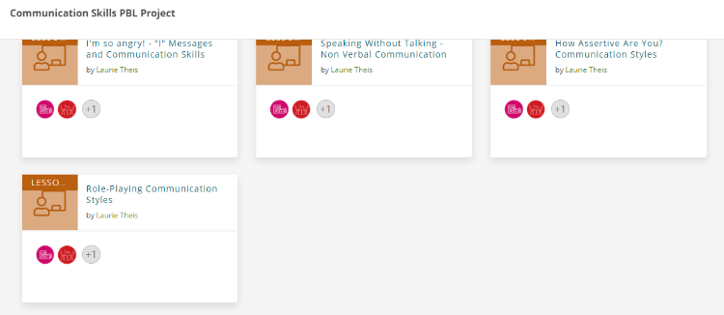
Here is what the menu looks like for the lessons and these are the three topics to pick from as a possible Entry Event:
- I’m so angry! – “I” Messages and Communication Skills
- Speaking without Talking – Non-Verbal Communication
- How Assertive are you?
When you click into a lesson, you will see an introduction, objectives, activities, resources, and a summative assessment. Browse and identify which Entry Event you’d like to perform with your students.

Public Product
Going back to the CTE Online materials used for the Entry Event, this Flex PBL revisits that site for a completely developed lesson that could be a wonderful way to capture the Public Product for this Flex PBL.
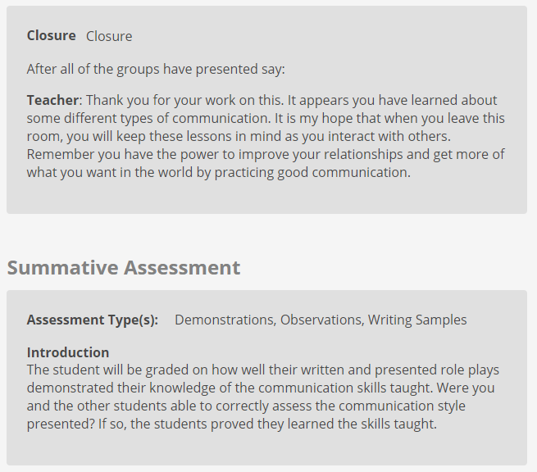
- Role-Playing Communication Styles
This activity incorporates individual and group role playing materials and resources. This activity includes a student feedback worksheet for this closing lesson. Rubrics for this Public Product can be found within the CTE Online lesson or you may use your own rubric from previous professional presentations.
Students will be asked to role-play, but also ultimately communicate how these new skills will enhance their current and future life at school, work and home—the driving question for this project.

Week 1 of 4
JAG Student Week One Responsibilities
- Specialist will record and share a link here or do an in-person overview of this project by explaining the online resource being used and pulling information from the course description. (Approx. 5 minutes)
The Communications Foundations for beginners course overview is:
Learn how to communicate more effectively. Your communication skills affect your career prospects, the value you bring to your company, and the likelihood of your promotion. This course helps you communicate better in a variety of professional situations, including meetings, email messages, pitches, and presentations. Instructors Tatiana Kolovou and Brenda Bailey-Hughes introduce the four building blocks of communication—people, message, context, and listening—and show how they apply in different circumstances. Through the use of vignettes and applied tools, the course shows how to build this core competency and communicate in a way that effectively and professionally conveys your message.
- Specialist will insert the details of the Entry Event here.

- Visit and explore the website for this project: (5 minutes)
https://www.linkedin.com/learning/communication-foundations-2?trk=learning-path&upsellOrderOrigin=li-jobsindemand-softskills-en
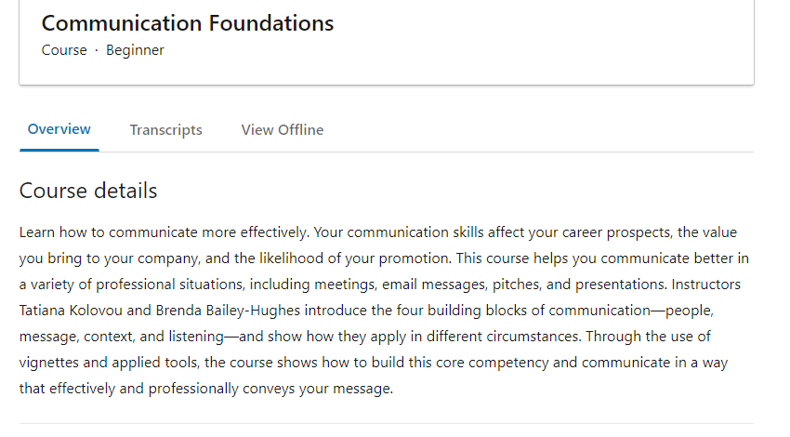
Be sure to check out the following elements of this site:

  - Course details
  - Instructor information
  - Ability to access transcripts of the content, if you wish
  - How to view materials offline
NOTE: You do not need to sign-in to access this content. If you wish to create an account, this will allow you to log-in and pick-up where you left off each time; however, you can also make notes of where you left and click into the section you are moving to next.
- When you are ready to begin the course, click on the down arrow next to the Introduction, seen below.
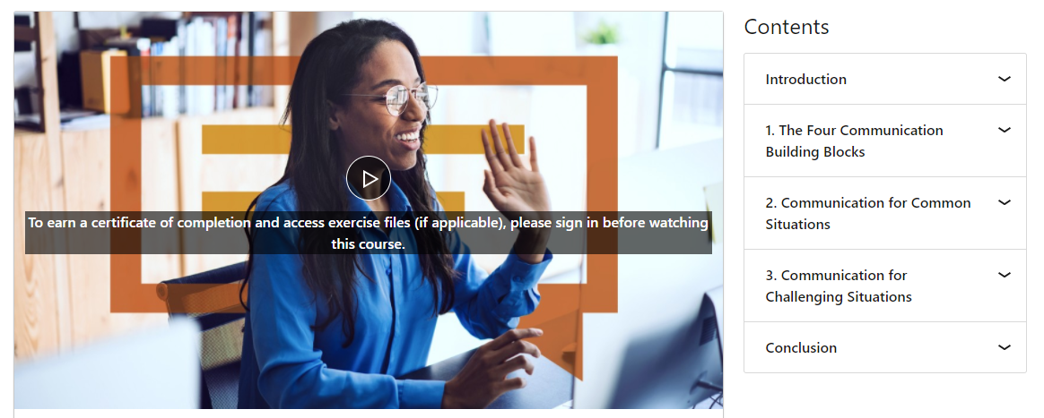

- There are two short videos in the introduction. (5 minutes)
  - Welcome - 1 minute, 6 seconds
  - Getting the most from this course – 2 minutes, 22 seconds
- Journal about the things presented to you from these two short videos. Consider the communication skills you believe you are already strong at and the areas you could improve. Think about the areas in your life (school, work, home) that you wish you could communicate more effectively. (10 minutes)
- Take this self-assessment on how your current communication skills are: (5 minutes) https://www.mindtools.com/pages/article/newCS_99.htm
- Got back to the LinkedIn Learning/Microsoft Learn website to begin the first unit.
  - 1. The Four Communication Building Blocks
    - The four building blocks: People – 4 minutes, 19 seconds
    - The four building blocks: Message – 4 minutes, 6 seconds
    - The four building blocks: Context – 2 minutes, 18 seconds
    - The four building blocks: Listening – 4 minutes, 12 seconds
- Check-in with your Specialist. The indicator word is Building Blocks. Share with your Specialist what you thought of the first unit of this online course. (5 minutes)
- Read this article on epic marketing failures in communication. (10 minutes) https://grasshopper.com/blog/8-epic-failures-of-communication/
- Complete the table below with a personal example of how you have either made a mistake or had someone else make a mistake with you for each of the four topics. (15 minutes)
Building Block Topic | Personal Example
People
Message
Context
Listening

Week 2 of 4
JAG Student Week Two Responsibilities
- Specialist will set-up this week’s unit focused on Communication for Common Situations. It will be important for the Specialist to help participants find value in the lessons even when they may not currently communicate a lot via e-mail or may not see themselves in the traditional meeting setting as explained in the videos. Let them know that these lessons are intended to not only provide insight into how a future career may operate for them, but how they may use these skills now with their JAG Career Association, other classes, at home and/or in a current job. (5 minutes)
- Go to the LinkedIn Learning/Microsoft Learn website to begin the second unit.
  - 2. Communication for Common Situations
    - When you socialize in professional settings – 2 minutes, 28 seconds
    - Toolkit: Social settings – 2 minutes, 32 seconds
    - When you run meetings – 4 minutes, 49 seconds
    - Toolkit: Meetings – 2 minutes, 36 seconds
    - When you send emails – 4 minutes, 40 seconds
    - Toolkit: Email – 1 minute, 37 seconds
    - When you’re explaining – 4 minutes, 42 seconds
    - Toolkit: Explanations – 2 minutes, 30 seconds
    - Optional, When you’re advising senior staff – 4 minutes, 41 seconds
    - Optional, Toolkit: Advise, 1 minute, 14 seconds
NOTE: You do not need to complete all of these videos in one setting. Feel free to take breaks as you work your way through the material.
- Check-in with your Specialist. The indicator word is Toolkit. Share with your Specialist what you learned through the videos and toolkit lessons. (5 minutes)
- Read this article on the 10 Common Communication Mistakes. See how what you learned from the LinkedIn Learning course compares or contrasts from the information in the article. https://www.mindtools.com/pages/article/common-communication-mistakes.htm(10 minutes)
- Watch as many video clips from the Poor Communication Skills YouTube playlist as you like. These various examples showcase the everyday communication challenges, but with a humorous spin—ENJOY! (5-10 minutes)
https://www.youtube.com/playlist?list=PLkRaBK25GgmHXtl5Set4b9jQ4Xfv-0_YW

Week 3 of 4
JAG Student Week Three Responsibilities
- Specialist will set-up this week’s unit focused on Communication for Challenging Situations. Perhaps share some recent challenging conversations that have been happening with your JAG classroom, school and/or community to set the table for the type of situations this next unit will be covering. (5 minutes)
- Go to the LinkedIn Learning/Microsoft Learn website to begin the third unit.
  - 3. Communication for Challenging Situations (Total of approximately 33 minutes)
  - Conclusion (37 seconds)
NOTE: You do not need to complete all of these videos in one setting. Feel free to take breaks as you work your way through the material.
- Journal
  - The top three things you learned about from the LinkedIn Learning/Microsoft Learn Communications course
  - Your communication strengths
  - Your communication shortcomings or areas to improve
  - How you appreciate being communicated with
- Google the following phrase “Communications in a ________________ career.” Fill in the blank with the career you wish to have in the future. If you wish, you may do multiple searches for more than one career. Read articles and/or watch videos of how communication looks in the career or careers you are interested in. (15 minutes)
- Check-in with your Specialist. The indicator word is Conclusion. Share with your Specialist what you learned through the videos and toolkit lessons from unit three. (5 minutes)

Week 4 of 4
JAG Student Week Four Responsibilities
- Specialist will start this week with introducing the closing activity that leads to this project’s Public Product. Revisit the Public Product section at the beginning of this Flex PBL for a link to the role-playing activity provided by CTE Online.
- This week is completely dedicated to working on your Public Product for this project. As a reminder, here is an overview of the Public Product details: (?? minutes)
  - Insert the details of this Public Product for students.
  - Students can demonstrate their role play from the activity earlier in the week or they can select to do a “how-to” example through video, handout or any other means of conveying the information.
- Review the rubric to help guide your work on this Flex PBLs Public Product: (insert link, picture or attachment) (5 minutes)
- Check-in with your Specialist. The indicator word/phrase is My Professional Communication. Use this time to ask questions of your Specialists before you dive into creating your Public Product for this project. (5 minutes)
- Create your Public Product: (Times will vary)
  - Insert the breakdown of tasks for students to work through as they complete their Public Product.

- As you wait for peers to review and offer feedback on your video, go check out a minimum of three other videos from your classmates. Comment on their video using this framework:

  - I like…
  - I wonder…
  - Have you thought about...

Remember the Driving Question for this Flex PBL: How can I improve my professional communications skills and effectively communicate how these skills can enhance my current and future life at school, work and home?
- Wrap up this project by doing these three things:
  - If you believe you have adequately answered this question and feel confident in the final Public Product you have—consider sharing on your Tallo profile, LinkedIn, other social media sites and/or including it in your digital application packet!
  - Share with your Specialist how you used your video from this project in other ways.

  - Complete this JAG National student survey to gather feedback about this Flex PBL: https://forms.gle/ZBqseUi1qKMs6xMd6

