
2020-21 Flex PBL
PBL Title: | Make it to the Top!
Duration: | 3 weeks | Release Date: | March 21, 2021
HELP? | e-mail jenn.beal@jag.org | Pages: | 6, plus attachment
Project Summary
This Flex PBL is intended for students to expand their workplace skills in order to be successful in their future careers.
Students will perform individual work from a Learning Choice Menu attachment as well as complete a small group Public Product, either virtually or in person. This project is intended to develop the JAG H Competencies and have students demonstrates the right way and the wrong way to perform well in your future career by portraying both how to get fired and also how to get promoted in the workplace.


Competency Attainment

Level 1: C.15-Understand what employers expect of employees, C.16-Identify problems of new employees, C.17-Demonstrate time management, C.18-Follow directions, D.21-Comprehend verbal communications, D.24-Communicate verbally, G.40-Conduct a job analysis, G.42-Demonstrate effective study skills, G.45-Understand the essential elements of high performing work teams.
Level 2: D. 22-Comprehend written communications, E.28-Deliver presentations to a group, G.53-Exhibit work ethics and behaviors essential to success.
Level 3: H.60 through H.80.
JAG Competencies should be set based on the Specialists discretion.
The above stated are merely suggestions based on the project structure.

Notes for Specialist

- Flex PBL are designed with two intended purposes:
  - to meet the ever-changing instructional needs of JAG Specialists across the JAG National network and
  - to provide relief with competency attainment and project design to allow Specialists the space to devote a majority of their time in meeting the immediate needs of students.

- A Flex PBL can be administered in a variety of instructional modalities. Here are three of the most common options:
  - Traditional; full time, in-person instruction – walk through the steps in showing videos and leading discussions as a typical class unit.
  - Hybrid, blended or a flipped classroom – identify and pull out the pieces that can be asked of students to perform outside of in-person class time (i.e. to watch videos, journal, etc.) and reserve team building, discussions and/or problem solving for in-person opportunities.
  - Completely online model – this Flex PBL can also be administered in a completely online format, by using any means of delivery that is being directed or offered by your school district.
- The format of this Flex PBL was aimed to be easily manipulated for Specialists to deliver the project within a classroom. They can print, copy and paste into an e-mail, text, social media or a learning management system (i.e. Google Classroom, Canvas, etc).
- The intentional design of this Flex PBL is to allow a logical and manageable flow for students to work in a self-guided way.
- A series of webinars are available on the Genius for each of these three options. The topic area shifts from week to week, but the three group offerings remain consistent to accommodate your needs as they may change throughout the 2020-2021 academic year.
- In addition to Genius resources, the JAG National Staff is available for steps on the practical application of this Flex PBL.
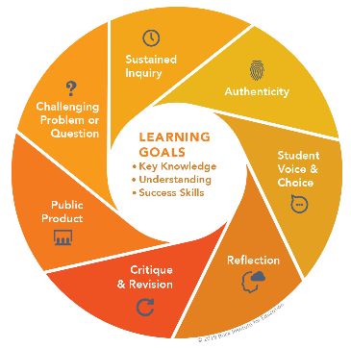
- The yellow highlighted sections need Specialist attention, as they are notes that require an action of the Specialist.
- Remember that each student responsibility can be adjusted to fit the needs of your students, especially when it comes to the expected time spent on this project. You are encouraged to add, remove or change out any elements within this Flex PBL to make this project suitable for your JAG students. Just remembering that a strong PBL (regardless of delivery method) has seven essential gold standard elements.
- Please complete this JAG Specialist survey at the completion of the project: https://forms.gle/FoJTtSiNM62wuXvh6
- Finally, Specialists are responsible for how grading/allocation of points are determined based on your program expectations.

Flex PBL – Make it to the Top!

Driving Question
What skills do I need to advance and be successful in my future career?
Entry Event

Watch this video: Oprah Winfrey Top 10 Rules for Success (15 minutes)

https://www.youtube.com/watch?v=Cf3y2dkOas&list=PLiZjIk9MmM0VWRGYCfuUCdyhKfU733WX

Then, answer the following question: (5 minutes)
What 3 rules of success from Oprah do you most relate to and agree with? Why?

Public Product
Students will work in small groups, either virtually or in person, to create a project that demonstrates the right way and the wrong way to perform well in your future career by portraying both how to get fired and also how to get promoted in the workplace.
Students will include at least 10 of the following H JAG Competencies in their public product:

H.60 Demonstrate punctuality and good attendance practices.
H.61 Demonstrate initiative and proactivity.
H.62 Demonstrate how to work effectively with others.
H.63 Demonstrate an attitude that attracts the attention of management.
H.64 Demonstrate an ability to communicate and work with customers to satisfy their
expectations.
H.65 Demonstrate listening skills which result in gaining a clear understanding of
information being conveyed.
H.66 Demonstrate an ability to follow and give directions.
H.67 Demonstrate good reasoning skills which results in thinking first, then taking action.
H.68 Demonstrate integrity and honesty in dealings with internal and external customers.
H.69 Demonstrate a willingness to accept responsibility for one’s own actions.
H.72 Demonstrate an ability to prioritize and manage time effectively in the workplace.
H.73 Demonstrate enthusiasm for work.
H.74 Demonstrate an eagerness to learn new responsibilities or improve current
responsibilities.
H.77 Demonstrate ability to self-evaluate and develop a continuous improvement (career
development) plan.
H.79 Demonstrate an ability to learn from past experiences and others.
H.80 Demonstrate an ability to send, receive and organize e-mail messages.
Scaffolding activities include competency-specific tasks from the H competencies that students can select from a Learning Choice Menu. Students will complete four selections each week.
Specialist can adjust to have students complete less activities or all 15 based on the available time for this project’s completion.

Week 1 of 3
JAG Student Week One Responsibilities

- Perform Entry Event Activities (20 minutes)

- Review Driving Question for this project. (5 minutes)

- Determine your group for this project’s public product and review the expectations.

- Individually select 12 tasks from the list of 15 on the Learning Choice Menu attachment.

The goal is to complete at least four selected tasks each week of this three week project. These are to be completed on your own, separate from your group members.

These tasks will help you understand JAG Competencies that will help you be successful in the workplace while you are developing your final product. As you complete each task, submit them to your specialist. Each task will vary from 20-40 minutes.

- Complete Learning Choice Menu #1 - _____________________________________.

- Complete Learning Choice Menu #2 - _____________________________________.

- Complete Learning Choice Menu #3 - _____________________________________.

- Complete Learning Choice Menu #4 - _____________________________________.

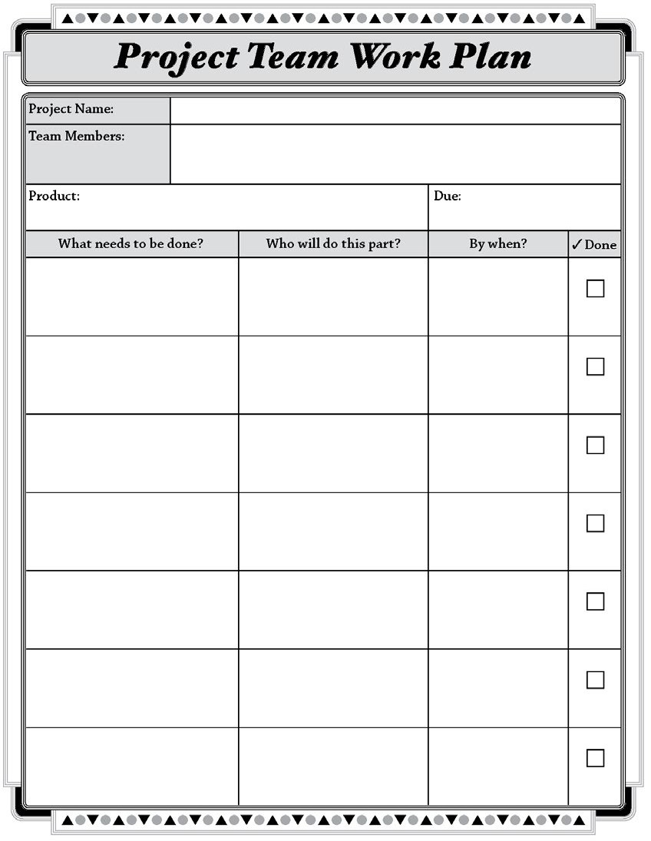
- Begin researching and planning your project. With your group, complete the project plan on page 13 and submit it to your specialist for feedback.

(30 minutes)

You may use this template to organize your team work for this project’s Public Product.

Week 2 of 3
JAG Student Week Two Responsibilities
- Complete Learning Choice Menu #5 - _____________________________________.

- Complete Learning Choice Menu #6 - _____________________________________.

- Complete Learning Choice Menu #7 - _____________________________________.

- Complete Learning Choice Menu #8 - _____________________________________.

- Review the Rubric for this project’s Public Product. (10 minutes)

CATEGORY | (4) Excellent | (3) Good | (2) Almost | (1) Not Yet
Presentation Design/Appearance | Presentation design is professional, attention-grabbing, and informational | Appearance is appealing and informational | Presentation appeal is fair | Presentation appeal needs improvement
Content/Plan | Plan for success in the workplace described in detail, with both sides of the issue presented | Outline of plan for success in the workplace is complete, with both sides of the issue presented | Fair outline of plan for success in the workplace, but one of both sides of the issue is incomplete | Poor outline of plan for success in the workplace and/or lacks a portrayal of both sides of the issue
Mechanics and Grammar | No errors in grammar, usage, or mechanics | 1-2 errors that do not detract from the presentation | There are noticeable errors in that may detract from the presentation | Multiple errors in mechanics, usage, and/or grammar
Organization | Exceptional organization with logical sequencing and easy for audience to follow | Competent organization with logical sequencing and easy for audience to follow | Fair organization with mostly logical sequencing | Poor organization with difficult to follow sequencing
Use of 10 competencies | Use of ten or more competencies, Detailed and factual information is presented | Use of ten competencies, factual information is presented | Use of 8-9 competencies, factual information is presented | Not enough competencies presented

- Continue working on the group portion of this project. (time will vary)

- Check-in with your Specialist to discuss this week’s progress and any questions. (10 minutes)

Week 3 of 3
JAG Student Week Three Responsibilities
- Complete Learning Choice Menu #9 - _____________________________________.

- Complete Learning Choice Menu #10 - _____________________________________.

- Complete Learning Choice Menu #11 - _____________________________________.

- Complete Learning Choice Menu #12 - _____________________________________.

- When your individual 12 earning menu items are complete, spend the rest of this week working on your Public Product for this project. (time will vary)

- Check-in with your Specialist to discuss this week’s progress and any questions. (10 minutes)
- Consult with at least one other group for feedback on your project. Ask them to use the following framework: (20 minutes)
  - I like…
  - I wonder…
  - Have you thought about...

- Wrap up this project by doing these three things:

  - Submit your Public Product for this project.

  - Complete the Self Reflection questions below and give to your JAG Specialist:

    - What did you learn from doing this project?
    - Were you satisfied with your final product?
    - What, if anything, would you change?
    - Did this project increase your knowledge of careers? Why or why not?
    - Did this project help you with goal setting? Why or why not?

  - Complete this JAG National student survey to gather feedback about this Flex PBL: https://forms.gle/hN5R1t5qtu3KBtWP8



