
2020-21 Flex PBL
PBL Title: | Financial Literacy (for High School) | with Hands on Banking | by Wells Fargo
Duration: | 3 weeks | Release Date: | January 8, 2021
HELP? | e-mail jenn.beal@jag.org | Pages: | 8
Project Summary
Working alone or with a partner, students will explore various online modules related to financial literacy. Ultimately, this project will conclude with an outline of financial goals for now and the future as well as a plan for how to achieve those goals.
This Flex PBL introduces financial literacy lessons through Hands on Banking that is provided as a public service by Wells Fargo.
Student can learn about creating a spending plan, building credit, school loans and how continuing education after high school could fit into your financial future. Start your financial life strong by taking the courses below. When you finish, take the assessment to check your knowledge and earn your Hands on Banking certificate.
High School courses:

- Getting Started
- Earning Money
- Spending Smart
- Save, Invest, and Build Wealth
- All About Credit
- School and Money
- Assessment

Here is a teacher’s guide for assistance with these courses: https://youth.handsonbanking.org/wp-content/uploads/2019/08/InstructorGuide_HighSchool.pdf This guide also includes a glossary that you may wish to share with students. It also contains learning objectives for all of the included lessons. The lessons include a Spanish version as well.
NOTE: For support on the Hands on Banking courses, join the live webinar provided by Wells Fargo on Wednesday, January 13, 2021 at 3:00 p.m. CST or watch the recording on the Genius.
Competency Attainment
Level 1: A.3-Identify desired life style and relate to selected occupations, C.18-Follow directions, D.22-Comprehend written communications, D.23-Communicate in writing, D.24-Communicate verbally, G.55-Apply the problem solving process to complex problems, H.61-Demonstrate initiative and proactivity, H.69-Demonstrate a willingness to accept responsibility for one’s own actions, H.70-Demonstrate a commitment in completing work assignments accurately and in a timely fashion, H.71-Demonstrate an ability to satisfy the purposes of a delegated task, H.77-Demonstrate ability to self-evaluate and develop a continuous improvement plan, H.78-Demonstrate basic computer operation skills, H.79-Demonstrate an ability to learn from past experiences and others.
Level 2: E.28-Deliver presentations to a group, F.32-Identify a self-value system and how it affects life, F.34-Identify process of decision-making, F.35-Demonstrate ability to assume responsibility for actions and decisions, G.53-Exhibit work ethics and behaviors essential to success, G.54-Set and prioritize goals and establish a timeline for achieving them, H.67-Demonstrate good reasoning skills which results in thinking first, then taking action.

Level 3: D.25-Perform mathematical calculations, F.33-Base decisions on values and goals, G.59-Prepare a short- and long-term personal budget.
JAG Competencies should be set based on the Specialists discretion.
The above stated are merely suggestions based on the project structure.
Notes for Specialist
- Flex PBL are designed with two intended purposes:
  - to meet the ever-changing instructional needs of JAG Specialists across the JAG National network and
  - to provide relief with competency attainment and project design to allow Specialists the space to devote a majority of their time in meeting the immediate needs of students.

- A Flex PBL can be administered in a variety of instructional modalities. Here are three of the most common options:
  - Traditional; full time, in-person instruction – walk through the steps in showing videos and leading discussions as a typical class unit.
  - Hybrid, blended or a flipped classroom – identify and pull out the pieces that can be asked of students to perform outside of in-person class time (i.e. to watch videos, journal, etc.) and reserve team building, discussions and/or problem solving for in-person opportunities.
  - Completely online model – this Flex PBL can also be administered in a completely online format, by using any means of delivery that is being directed or offered by your school district.
- The format of this Flex PBL was aimed to be easily manipulated for Specialists to deliver the project within a classroom. They can print, copy and paste into an e-mail, text, social media or a learning management system (i.e. Google Classroom, Canvas, etc).
- The intentional design of this Flex PBL is to allow a logical and manageable flow for students to work in a self-guided way.
- A series of webinars are available on the Genius for each of these three options. The topic area shifts from week to week, but the three group offerings remain consistent to accommodate your needs as they may change throughout the 2020-2021 academic year.
- In addition to Genius resources, the JAG National Staff is available for steps on the practical application of this Flex PBL.
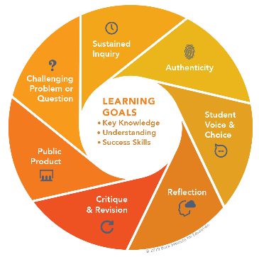
- The yellow highlighted sections need Specialist attention, as they are notes that require an action of the Specialist.
- Remember that each student responsibility can be adjusted to fit the needs of your students, especially when it comes to the expected time spent on this project. You are encouraged to add, remove or change out any elements within this Flex PBL to make this project suitable for your JAG students. Just remembering that a strong PBL (regardless of delivery method) has seven essential gold standard elements.
- Please complete this JAG Specialist survey at the completion of the project: https://forms.gle/gnn32dc3VPBhTVzk6
- Finally, Specialists are responsible for how grading/allocation of points are determined based on your program expectations.

Flex PBL – High School Financial Literacy

Driving Question
What steps must I take to ensure financial independence in the future?
Entry Event
Perform the Hands on Banking Experience. (60 minutes)
Here is the link to the Activity: https://handsonbanking.org/handsonbankingexperience/
“The Hands on Banking® Experience is a “real-world” money management simulation, designed for high school students and young adults, that helps teach important financial education concepts such as budgeting, comparison shopping, and evaluating needs, wants, and trade offs in a relevant and engaging way. During the activity, each student will be assigned a profile detailing their career, income, and family information. They will then interact with 13 stations that mimic real life expenses such as clothing, groceries, housing, transportation, and more.”
Specialists: the link above provides you with the necessary PDF files to facilitate this activity/experience, include an implementation guide, student profiles, budgeting tips, the PowerPoint presentation, scripts, and a course evaluation.
NOTE: For support on implementing the Hands on Banking Experience, join the live webinar provided by Wells Fargo on Wednesday, January 20, 2021 at 3:00 p.m. CST or watch the recording on the Genius.

Public Product
Students will create a project that outlines their financial goals now and for the future as well as how they plan to achieve those goals.
By finishing the Hands on Banking modules and successfully completing the assessment, students are awarded a certificate!



NOTE: For support on assessing student performance and behavior change from the Hands on Banking materials, join the live webinar provided on Tuesday, January 26, 2021 at 3:00 p.m. CST or watch the recording on the Genius.
Week 1 of 3
JAG Student Week One Responsibilities

- Review this project’s Driving Question: What steps must I take to ensure financial independence in the future?
- Perform the Entry Events (60 minutes)
Example of a possible profile:
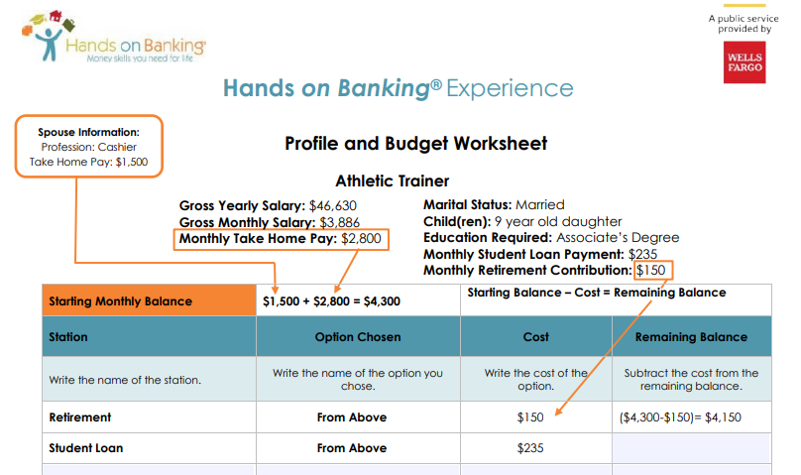
- Watch this video - https://www.youtube.com/watch?v=4j2emMn7UaI (16 minutes)
- Individually answer the following questions: (5 minutes)
  - What are your goals for your financial future?
    - What steps are you taking now to help you achieve those goals?
    - Does your future career choice support your financial goals? Why or why not?

- Begin the first course in the Hands on Banking online modules. (Approximately 1 hour)

Here is the direct link: https://youth.handsonbanking.org/courses/high-school-getting-started/ You are in the right place if you see this image on your screen after clicking the link.

This course has 8 lessons:

  - You and Money
  - So What do you Want?
  - How Money Works
  - Your Money Toolkit
  - Learn How To
  - Keep Track
  - Stay Safe
  - Your Next Steps

Once you get started, your screen will look like what is shown below. You can scroll through the content and engaged with videos and resources. See your progress towards completion in a percentage in the top left-hand corner.
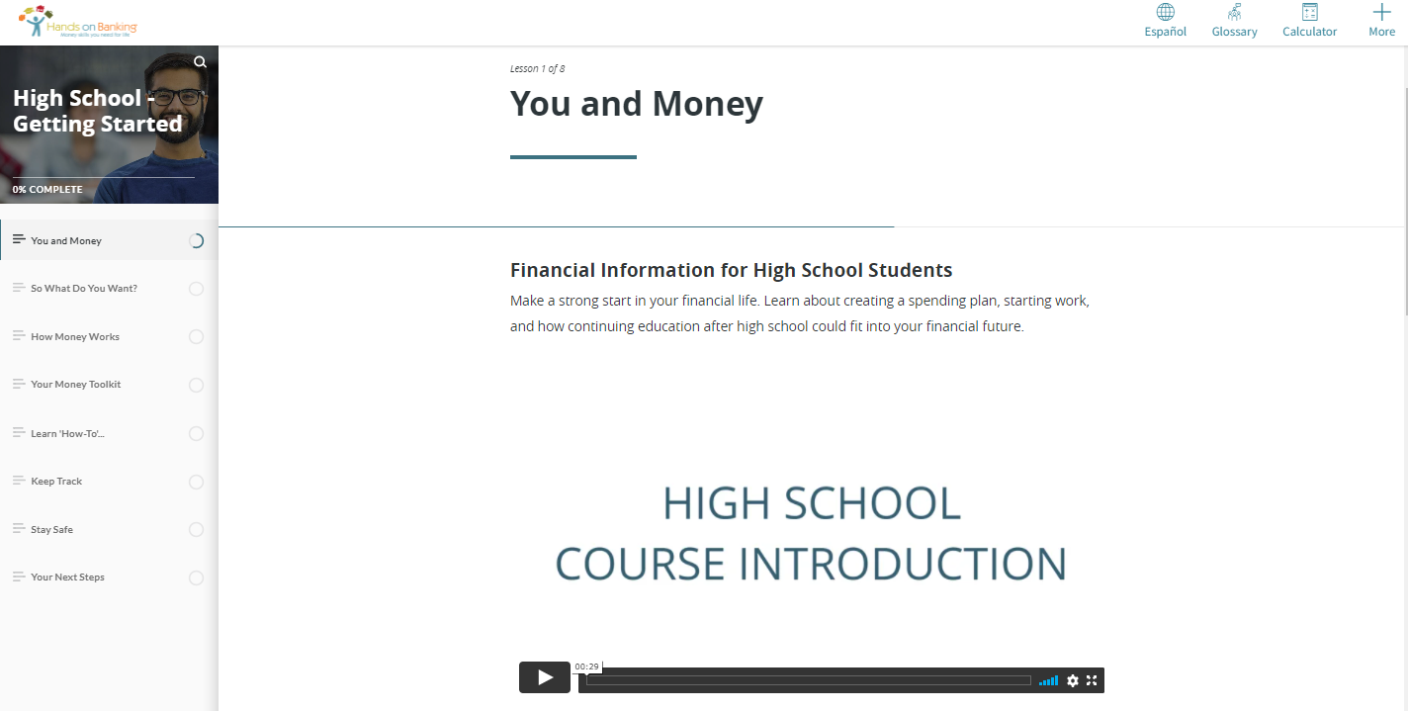

- Check-in with your Specialist. Share how you performed on the six multiple-choice topic assessment questions. Express any lingering questions or comments you have regarding the first course of Hands on Banking. (5 minutes)

- Engage in Course #2 “Earning Money”. (Approximately 40 minutes)

Here is the direct link: https://youth.handsonbanking.org/courses/high-school-earning-money/

This course has 5 lessons:

  - Making Your Own Way
  - Finding Employment
  - On the Job
  - Consider Entrepreneurship
  - Your Next Steps

- Complete Course #3 “Spending Smart”. (Approximately 45 minutes)

Here is the direct link: https://youth.handsonbanking.org/courses/high-school-spending-smart/

This course has 6 lessons:

  - The Value of Money
  - Have a Plan?
  - Be a Savvy Shopper
  - Smart Car Buying
  - Renting an Apartment
  - Your Next Steps

- Check-in with your Specialist and let them know when you have completed the first three courses. Share the biggest piece of advice you gained from the courses. (5 minutes)
- Begin thinking about your public product for this project. Consider journaling the important pieces you gained from the first three courses, so you can have that information handy when you begin putting together your personal financial goals for now and in the future, as well as your steps for successfully completing those goals.

Week 2 of 3
JAG Student Week Two Responsibilities

- Course #4 “Save, Invest, and Build Wealth”. (Approximately 45 minutes)
Here is the direct link: https://youth.handsonbanking.org/courses/high-school-save-invest-and-build-wealth/
This course has 6 lessons:

  - Getting Ahead
  - Reward Yourself by Saving
  - Investing Basics
  - Get Started with Investing
  - How to Build Wealth
  - Your Next Steps

- Course #5 “All About Credit”. (Approximately 60 minutes)
Here is the direct link: https://youth.handsonbanking.org/courses/high-school-all-about-credit/
This course has 8 lessons:

  - Before you Borrow
  - Credit Basics
  - Your Credit Score
  - Your Credit Report
  - Credit Cards
  - Loans
  - Dealing with Debt
  - Your Next Steps

- Course #6 “School and Money”. (Approximately 45 minutes)
Here is the direct link: https://youth.handsonbanking.org/courses/high-school-school-and-money/
This course has 6 lessons:

  - Investing in Yourself
  - Education and Earning Power
  - The Money You’ll Need and Where to Find it
  - Making it Happen- Your Action Plan
  - Managing Money in School and After
  - Your Next Steps

- Check-in with your Specialist to ask any questions you may have after completing the six online courses. Use this time to prepare for the final assessment, so you can successfully complete and receive the certification. (10 minutes)
- Perform Hands on Banking Assessment - https://youth.handsonbanking.org/courses/high-school-assessment/ (10 minutes)
- Once you have completed the assessment successfully, save your certificate. CONGRATS! Send a message to your Specialist with a picture of your awarded certificate.

Week 3 of 3
JAG Student Week Three Responsibilities

- This week is primarily dedicated to working on your Public Product for this project. The way to demonstrate your understanding of this project’s content can be done by creating an outline of your financial goals for now and in the future as well as how you plan to achieve those goals. (time will vary)
- Review the Financial Literacy Project Rubric found attached. (5 minutes)
- Continue working on what you have started from the previous two weeks of this project.(vary)
- Consult with at least two peers for feedback on your project. Ask them to use the following framework: (20 minutes)
  - I like…
  - I wonder…
  - Have you thought about...

- Wrap up this project by doing these three things:
  - Present your public product. Specialist: add in your specific details here for how and/or when you’d like students to conduct their presentations. (time will vary)
  - Individually complete a self reflection of your work on this project. (5 minutes)

What did you learn from doing this project?

Were you satisfied with your final product?

What, if anything, would you change?

Do you plan to begin working on your financial goals and if so, how?

What resources will help you reach your goals?

  - Complete this JAG National student survey to gather feedback about this Flex PBL: https://forms.gle/CABTzDKDKBfmJQs97

Financial Literacy Project Rubric
SCORE | CONTENT/ DEVELOPMENT | ORGANIZATION/ MECHANICS | VOICE/ PERSUASION | FOCUS/ ORIGINALITY | PRESENTATION
4 | Presents a well-researched issue that is clearly defined and includes abundant information.  Fully develops the central idea with specific, relevant details | All facets of the project are well-organized and appealing. Correct grammar and mechanics are used, adding credibility | The force of language, imagery, and argument is powerful, and invokes the emotions of the audience, making them want to take action. Strongly aware of audience and task; tone is consistent and appropriate | The project creatively presents financial literacy goals in a manner that is attention grabbing and gets the point across, while sustaining focus on central idea throughout the project | Innovative and professional presentation that portrays financial literacy goals with maximum integrity and reliability
3 | Presents a well-researched issue that is clearly defined and includes adequate information.  Fully develops the central idea with specific, relevant details | Most facets of the project are well-organized and appealing, with minimal errors in grammar and mechanics | The force of language, imagery, and argument would adequately move the audience to take action. Sufficiently aware of audience and task; tone is consistent and appropriate | The project productively presents financial literacy goals in a manner that is gets the point across, while adequately sustaining focus on central idea throughout the project | Satisfactory and professional presentation that portrays financial literacy goals with adequate credibility
2 | Presents financial literacy goals, but has insufficient research to back it up with facts. The central idea lacks specific, relevant details | Some facets of the project are well-organized and appealing, with several errors in grammar and mechanics | The force of language, imagery, and argument is fair, but lacks the power to invoke the emotions of the audience. Somewhat aware of audience and task; tone may be inconsistent but is appropriate | The project mostly presents financial literacy goals in a manner that gets the point across, but the focus shifts throughout the project | Presentation lacks the high level of professionalism required to portray financial literacy goals with sufficient credibility
1 | Presents financial literacy goals in a haphazard manner, with no research to support the facts presented, and is missing the necessary information to support those goals | Few facets of the project are well-organized and appealing, with numerous errors in grammar and mechanics | The force of language, imagery, and argument is weak and would not move the audience to take action. Project lacks awareness of the audience and task; tone is inconsistent and/or inappropriate | The project presents financial literacy goals in an unoriginal or redundant matter that lacks focus and credibility | Presentation is unprofessional and lacks credibility
Raw Rubric Score/Total | Percentage
20 | 100%
19 | 97%
18 | 95%
17 | 92%
16 | 90%
15 | 87%
14 | 84%
13 | 82%
12 | 79%
11 | 77%
10 | 74%
9 | 71%
8 | 69%

Total Points:_____

