

2020-21 Flex PBL
PBL Title: | Skills to Succeed Academy: | Getting a Job
Duration: | 4 weeks | Release Date: | October 15, 2020
HELP? | e-mail jenn.beal@jag.org | Pages: | 22
Project Summary
This Flex PBL is intended to be in the third wave of projects student engage with as they return to school for the 2020-2021 academic year.

Using the free, highly interactive online training program provided by Skills to Succeed Academy (S2SA), this project focuses on one module per week with time allowed each week for working on this project’s Public Product. Each module helps learners build the skills and confidence needed to make smart career choices and find and succeed in employment. The four S2SA modules being used from the Getting a Job section are:
- Who Can Help You?
- Create Your Resumé
- The Application Form
- A Better Cover Letter

Skills to Succeed Academy is a proud sponsor of the JAG organization and strives to support JAG students in completing modules as a way to boost their employability skills. Each year S2SA seeks to connect youth with their valuable courses; however, this year their resources are needed more than ever. S2SA modules can be administered in variety of ways:
- Assigned for students to complete outside of school in an asynchronous manner
- Streamed to groups or classrooms of students via a video conferencing service
- Facilitated in-person through a classroom overhead projector

Competency Attainment
Level 1:, A.4-Develop a career path for a selected occupation, B.7-Construct a resume, C.14-Demonstrate appropriate appearance, D.21-Comprehend verbal communications, D.24-Communicate verbally, F.33-Base decisions on values and goals

Level 2: A.1-Identify occupational interest, aptitudes and abilities, A.2-Relate interests, aptitudes and abilities to appropriate occupations, A.3-Identify desired life style and relate to selected occupation, A.5-Select an immediate job goal, C.18-Follow directions, D. 22-Comprehend written communications

Level 3: B.7-Construct a resume, B.9 Develop a letter of application, B.11 Complete application forms, D.23 Communicate in writing

JAG Competencies should be set based on the Specialists discretion.
The above stated are merely suggestions based on the project structure.
Notes for Specialist
- This Flex PBL encourages Specialists to set-up a Flipgrid account and establish a classroom code to share with your students. You may use other video software if you prefer. If you choose to use Flipgrid, here is a helpful tutorial video: https://www.youtube.com/watch?v=aLzX13jw7bw

- Flex PBL are designed with two intended purposes:
  - to meet the ever-changing instructional needs of JAG Specialists across the JAG National network and
  - to provide relief with competency attainment and project design to allow Specialists the space to devote a majority of their time in meeting the immediate needs of students.

- A Flex PBL can be administered in a variety of instructional modalities. Here are three of the most common options:
  - Traditional; full time, in-person instruction – walk through the steps in showing videos and leading discussions as a typical class unit.
  - Hybrid, blended or a flipped classroom – identify and pull out the pieces that can be asked of students to perform outside of in-person class time (i.e. to watch videos, journal, etc.) and reserve team building, discussions and/or problem solving for in-person opportunities.
  - Completely online model – this Flex PBL can also be administered in a completely online format, by using any means of delivery that is being directed or offered by your school district.
- The format of this Flex PBL was aimed to be easily manipulated for Specialists to deliver the project within a classroom. They can print, copy and paste into an e-mail, text, social media or a learning management system (i.e. Google Classroom, Canvas, etc).
- The intentional design of this Flex PBL is to allow a logical and manageable flow for students to work in a self-guided way.
- A series of webinars are available on the Genius for each of these three options. The topic area shifts from week to week, but the three group offerings remain consistent to accommodate your needs as they may change throughout the 2020-2021 academic year.
- In addition to Genius resources, the JAG National Staff is available for steps on the practical application of this Flex PBL.
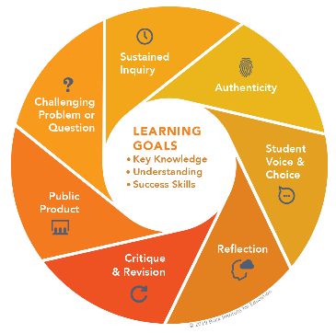
- The yellow highlighted sections need Specialist attention, as they are notes that require an action of the Specialist.
- Remember that each student responsibility can be adjusted to fit the needs of your students, especially when it comes to the expected time spent on this project. You are encouraged to add, remove or change out any elements within this Flex PBL to make this project suitable for your JAG students. Just remembering that a strong PBL (regardless of delivery method) has seven essential gold standard elements.
- Please complete this JAG Specialist survey at the completion of the project: https://forms.gle/y5eb9h6wgmY7MMSB6
- Finally, Specialists are responsible for how grading/allocation of points are determined based on your program expectations.

Flex PBL – S2SA: Getting a Job

Driving Question
What steps must I take to prepare for getting a job successfully?
Entry Event
Watch this video – (Linda Raynier) “How to Get a Job with No Experience” (5:47 minutes)
https://www.youtube.com/watch?v=OF8nx8Pt0tI
Discussion Questions – Students will answer the following questions: (10 minutes)

- What are some words you would use to describe yourself?
- Think of a celebrity and describe what you think their personal brand is (who they are and what they want to be known for)
- What perception do you give others about who you are?
Public Product
In a world where employers will likely Google you before deciding whether or not to interview you to work for them, it is important to manage your reputation both online and in person. Your reputation is your personal brand, and should portray who you are and what you want others to know you for. At the end of this project, students will create a video that portrays their personal brand in a positive and professional manner. They will include information from their resume and cover letter, and use pertinent descriptive words that would promote their personal brand to a potential employer. Students will post their video to Flipgrid for their classmates and Specialist to review and offer advice for improvements. The student can then update their video and share on their Tallo profile, LinkedIn as well as other social media sites. A video resume has become a popular way to get to know candidates, so students may also choose to use this video in a digital job application packet.
Create Flipgrid Account -- https://info.flipgrid.com/ (3 minutes)
What is Flipgrid? A simple, free and accessible video discussion experience for everyone!

Use this Join Code to have students get connected with each other ______________
Post a Video that portrays your personal brand in a positive and professional manner – within your Flipgrid account, find the Personal Brand Video assignment and post a short 60 second intro. Here is a video on how students can use Flipgrid: https://www.youtube.com/watch?v=C0QV3Yfv7UY
- This exercise will help you become familiar with the Flipgrid site, as this will be a tool used several times throughout this project.
- This video will also help your classmates get to know you a little better.
- Create a video that portrays your personal brand as though you are advertising yourself to an employer.

Rubric options are available throughout this Flex PBL.
Week 1 of 4
JAG Student Week One Responsibilities
- Specialist will record and share a link here or do an in-person overview of the Skills to Succeed Academy. A nice touch would be to share this video using Flipgrid if you are up for it! JAG Specialists can share information about how the Skills to Succeed Academy supports the overall JAG organization by providing their resources for free to JAG participants. Express how S2SA offers a variety of online modules focused on finding and maintaining employment. If you need additional information about the Skills to Succeed Academy, refer to their page on the JAGenius! (Approx. 5 minutes)

- Entry Event -- Implement the Entry Event activities found on page three of this Flex PBL.

  - Watch YouTube Video
  - Answer Discussion Questions
  - Create Flipgrid account

- Log into the Skills to Succeed Academy – http://s2sacademy.org (5 minutes)

Not registered yet?
- Go to http://s2sacademy.org
- Click on <Learner > Registration
- Fill in the registration form and use Access Code <fill in learner access code here. This information can be found on the JAGenius. >

- Take a moment to explore the site once you are logged into the Skills to Succeed Academy. You will notice a purple menu bar across the top that helps with: (5 minutes)


  - Search
  - Courses
  - Progress
  - Ref.Zone

- When you are familiar with the site and are ready to start your module/online lesson for this week, you may click on “Courses” in the purple menu bar at the top of the page. Then scroll down until you see three purple boxes with the title “Our courses”. Select the left-hand section called “Getting a Job”. When you open this page, you will see 20 modules. This week you will complete the option called “Who Can Help You?” which can be found by clicking on this link: https://s2sacademy.org/course/non_replay/usa/gaj_03/

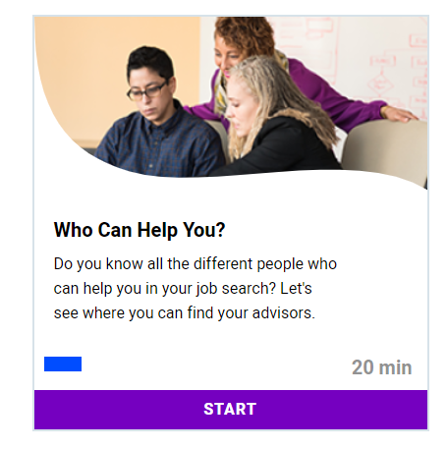
- You will see that this module is 20 minutes; however you will not need to complete this all in one setting. Click the purple bar that says “START” when you are ready to begin the course.
- When you are in the “Who Can Help You” module and ready to begin, on screen 1/19 you will click the play button on the small video. This is an introduction video to this module. Once the video intro is finished, you will be able to click the green arrow button in the bottom right-hand corner to advance to the next page. Remember, you can stop this module at any time and pick-up where you left off. Your progress is automatically saved, so when you log in next time—you can start on the page you last were on. (1 minute)

- On page 2 of 19, you will see what you’re going to do in this module, as well as what your intended targets are at the completion of this week’s course. See below.
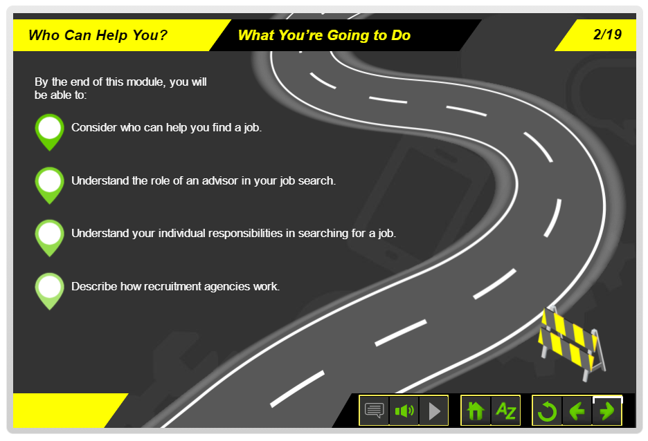
- After hearing about the goals of this module, click the green arrow to advance. Follow the directions that are spoken to you and that you are able to read on the screen. For example, on this screen (3/19) you will click the play button on the video to hear from Eric who is planning to see his advisor. (1 minute)

- Pause & Think -- What does a career mean to you? (2 minutes)
- Advance through the remainder of the module at your own pace; however, be aware of the goal to have this module completed before the start of next week. We have walked through the steps for the first few screens, so you should be familiar with how to interact with the S2SA platform. Remember, you can pause, stop and/or go back at any point in the module. (16 minutes)
- Screen 4/19 – Where can I find an advisor?
- Screen 5/19 – What can an advisor help with?
- Screen 6/19 – The advisor meeting
- Screen 7/19 – Prepare for the advisor meeting
- Screen 8/19 – Advisor meetings
- Screen 9/19 – What are your responsibilities?
- Screen 10/19 – What can your advisor help with?
- Screen 11/19 – Check your understanding
- Screen 12/19 – Who else can help?
- Screen 13/19 – Who can help Claire?
- Screen 14/19 – Who can help Angela?
- Screen 15/19 – Recruitment Agencies
- Screen 16/19 – Almost There
- Screen 17/19 – Quiz (Track your score, so you can share with your Specialist later!
- Screen 18/19 – Survey
- Screen 19/19 – Activity

- When you click on the green “Activity” button, you will be taken to a new window that has helpful activities for you to complete after having viewed this module. Browse this document and save for a later date.
- Check-in with your Specialist. Share with your Specialist that you have completed the “Who Can Help You?” module on the Skills to Succeed Academy. Your Specialist will work with you to identify sections within the activity pack that would be helpful for you to continue the important work focus on your career. (5 minutes)
- Complete the Networking Scavenger Hunt (worksheet provided). (15 minutes)
- Begin envisioning your project and complete the Project Plan (worksheet provided). (20 minutes)
Specialists: here is a direct link to the student activity pack, so you can review and identify sections that would be helpful for students to complete.
https://s2sacademy.org/cms/usa/activity_packs_files/GAJ%20Mod%203%20Who%20Can%20Help%20You.pdf


Networking Scavenger Hunt

Think of who you know and fill in the lines below.
Try not to use the same person twice.

- Who do you know that knows a military service member? _____________________
- Who do you know that knows an ambulance driver or EMT? ___________________
- Who do you know that knows an elected official? __________________________
- Who do you know that knows a mechanic? __________________________
- Who do you know that knows a truck driver? __________________________
- Who do you know that knows a doctor or nurse? __________________________
- Who do you know that knows a banker, teller, or loan officer? __________________
- Who do you know that knows an engineer? __________________________
- Who do you know that knows someone in the performing arts/entertainment industry? __________________________
- Who do you know that knows a business owner? ________________________
- Who do you know that knows a salesperson? __________________________
- Who do you know that knows a computer programmer or repairman? __________________________
- Who do you know who surfs the Internet? __________________________
- Who do you know that wants to work with animals or outside when they s school? __________________________
- Who do you know that has a family member in a job to do with health? ___________________
- Who do you know that has a family member in the food service industry? __________________________
- Who do you know that has a family member in the grocery industry? __________________________
- Who do you know that has a family member in the farming industry? ________________
- Who do you know that has a family member in the manufacturing industry? __________________________
- Who do you know that has a family member in the field of either childcare or education? __________________________

Project Plan

What my project is about: __________________________________________________
_______________________________________________________________________

Who is my audience?_____________________________________________________
_______________________________________________________________________

Describe your project: ____________________________________________________
______________________________________________________________________
______________________________________________________________________

How will I begin my project? _______________________________________________
______________________________________________________________________

______________________________________________________________________

How will my project demonstrate all of the required elements? ______________________________________________________________________
______________________________________________________________________

How will I end my project? ________________________________________________
_____________________________________________________________________

What will I show or do to make my project interesting? _________________________
_____________________________________________________________________

Week 2 of 4
JAG Student Week Two Responsibilities

- Specialist will pose a question to all students by making a video on Flipgrid or by posting a class discussion. Specialist will ask students to answer the question: What skills do you have?
- Log into your Skills to Succeed Academy and access the “Create Your Resumé” module. You may find the module by searching, checking under “Courses” or by clicking on this link: https://s2sacademy.org/course/non_replay/usa/gaj_06/ (2 minutes)
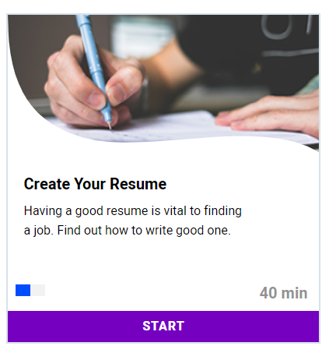
- Click on the play button on the video introduction and then advance through the screens by using the green arrow button in the bottom right-hand corner as you did on the previous module.
Remember: you can pause/stop the module at any time and resume where you left off at a later time.
As you review the slides, keep in mind that you will be creating a skills-based resumé at the close of this module.
There are 23 screens of this module and the estimated time to complete is 40 minutes.

- Complete Preparing for your Resumé (worksheet provided, two pages). (20 minutes)
- Check-in with your Specialist. Share with your Specialist how the second Skills to Succeed Academy module went. Specialist will work with you to identify sections within the activity pack that would be helpful for you to complete a rough draft of your resumé. (5 - 15 minutes)
Specialists: here is a direct link to the student activity pack, so you can review and identify sections that would be helpful for students to complete. https://s2sacademy.org/cms/usa/activity_packs_files/GAJ%20Mod%206%20Create%20Your%20Resume.pdf
- Using knowledge gained from the module, along with the previous worksheet and the Resume Rubric (worksheet provided); construct a rough draft of your resumé. (30 minutes)
- Meet with at least one peer and your JAG Specialist to get feedback on your resumé. (20 minutes)
- Using their feedback, along with the rubric, revise your resumé and submit your final draft to your Specialist. (30 minutes)
- Use any additional time to work on your public product.

Preparing for your Resume – Page One

When completing applications and/or resume writing, you must have the following information:

Name:__________________________________________________________________________
Address:________________________________________________________________________
Phone Numbers: (home)_________________________ (cell) _____________________________
Email:____________________________________________(make sure this is a professional email)
High school/vocational/colleges attended:___________________________________________
Expected graduation date:__________________
Special skills/classes:_______________________________________________________
Other places attended:______________________________________________________

Organizations you belong to/offices held/sports/hobbies/awards and achievements:
________________________________________________________________________________
________________________________________________________________________________
________________________________________________________________________________
________________________________________________________________________________

Experiences: (can be at home, work, volunteer, school – anywhere you learned special skills)
________________________________________________________________________________
________________________________________________________________________________
________________________________________________________________________________
________________________________________________________________________________
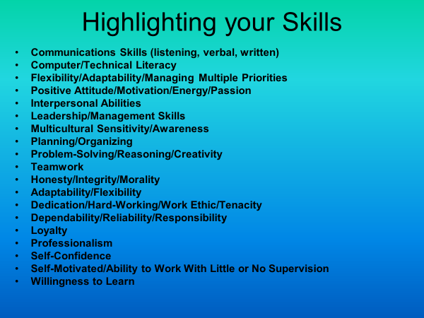
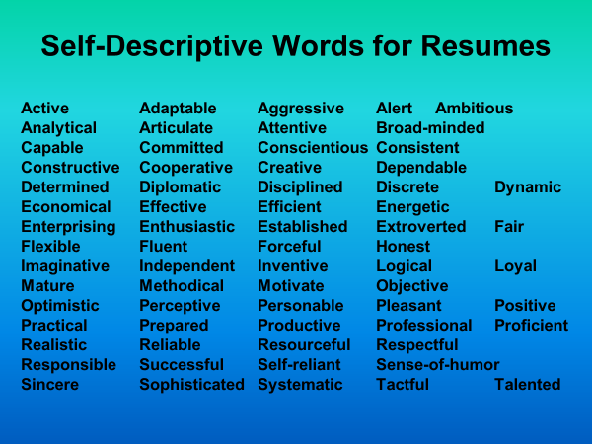

Preparing for your Resume – Page Two

8-10 words that sell you:___________________________________________________________
________________________________________________________________________________
________________________________________________________________________________

5-7 skills: _______________________________________________________________________
________________________________________________________________________________
________________________________________________________________________________
________________________________________________________________________________
________________________________________________________________________________

Summary Statement: ___________________________________________________________
________________________________________________________________________________
________________________________________________________________________________

Describe your Skills and Characteristics

1. ______________________________________________________________________________
________________________________________________________________________________

2. ______________________________________________________________________________
________________________________________________________________________________

3. ______________________________________________________________________________
________________________________________________________________________________

4. ______________________________________________________________________________
________________________________________________________________________________

5. ______________________________________________________________________________
________________________________________________________________________________

Resume Rubric

CATEGORY | (4) Excellent | (3) Good | (2) Almost | (1) Not Yet
Formatting & Organization  Consistent resume format arranged chronologically, by order of importance, or by skill. | The writer uses an attractive and organized resume format. The resume has identified sections, which are organized in a sensible way. | The writer uses an organized resume format. The resume has identified sections, which are organized in a sensible way. | The writer attempts to arrange the resume in an organized format.  The resume contains identified sections, but these may not be arranged in a logical way. | Demonstrates a lack of understanding of the correct form for a resume. It is disorganized and headings may be used inconsistently or missing entirely.
Content  Contact Info  Objective  Education  Qualifications  Successes | The resume has a clear objective with all of the required information in detail and with complete and accurate facts. | The resume has all required information with complete and accurate facts. | The resume has most of the required information, but some may be incomplete or inaccurate. | The resume lacks much of the required information and/or facts are inaccurate.
Writing – Mechanics:  Spelling  Grammar  Punctuation  Capitalization | There are no errors in mechanics, usage, grammar, or spelling. | There are some errors in mechanics, usage, grammar, or spelling, but they do not detract from the meaning. | There are noticeable errors in mechanics, usage, grammar, or spelling. Some of these may hinder comprehension. | The resume is hard to understand due to numerous errors in mechanics, usage, grammar, or spelling.
Elements of Business Writing | The resume fills a single page. It is written in brief, understandable phrases and contains relevant or standard facts. It does not contain the pronoun I. | The resume fills a single page. It is written in phrases and contains mostly relevant or standard facts. It does not contain the pronoun I. | The resume may not fill the page. It is written in words and phrases that contain assorted facts; these details may be incomplete or hard to understand. | The resume may not fill the page. Facts are incomplete and difficult to understand. Important details are omitted.
Language | The writer grabs the attention of the reader. The resume contains professional and descriptive language. | The writer gains the attention of the reader. The resume contains mostly professional and descriptive language. | The writer may not gain the attention of the reader. The language needs to be more professional and descriptive. | The writer does not gain the attention of the reader. The language is not professional and/or descriptive.

Raw Rubric Score/Total | Percentage
20 | 100%
19 | 97%
18 | 95%
17 | 92%
16 | 90%
15 | 87%
14 | 84%
13 | 82%
12 | 79%
11 | 77%
10 | 74%
9 | 71%
8 | 69%

Week 3 of 4
JAG Student Week Three Responsibilities
- Begin this week by completing the Practice Job Application (worksheet provided-two pages).
- Log into your Skills to Succeed Academy and access the “The Application Form” module. You may find the module by searching, checking under “Courses” or by clicking on this: https://s2sacademy.org/course/non_replay/usa/gaj_14/ (2 minutes)
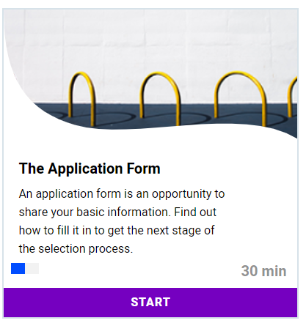
- Click on the play button on the video introduction and then advance through the pages by using the green arrow button in the bottom right-hand corner.
Remember: you can pause/stop the module at any time and resume where you left off at a later time.
There are 15 screens of this module and the estimated time to complete is 30 minutes.
As you go through this module, look over your practice application and make any necessary revisions. (10 minutes)
- Specialists: here is a direct link to the student activity pack, so you can review and identify sections that would be helpful for students to complete and then assign: https://s2sacademy.org/cms/usa/activity_packs_files/GAJ%20Mod%2014%20The%20Application%20Form.pdf You may want to have them complete the entire packet, or may opt to skip this if students performed well on the practice application.
- Complete the Emotional Intelligence Self-Evaluation for practice with employment tests (worksheet provided). Specialists—you will want to explain the language on this assessment and remind students that this is a tool to assist with taking assessments that may be part of an employment process. (10 minutes)
- Analyze your results from the previous assessment and develop a plan for areas that need improvement. (10 minutes)
- E-mail your progress on the Skills to Succeed Academy to your Specialist. You can view your progress page by logging into your S2SA profile and clicking on “Progress” in the purple bar at the top of the page. You may take a picture of this progress page or you may click on the “E-mail Progress” button and send the information to your Specialist this way. (5 minutes)
- Check-in with your Specialist. Share with your Specialist how confident you feel about completing job applications. The goal is to feel ready to complete one in the real world. (5 minutes)
- Spend the rest of your time this week working on your public product. Just one more week until showtime! Please be sure to use the rubric to assist you. Remember to reach out to your Specialist if you have questions or need assistance.
Practice Job Application – Page One
Name __________________________________________________________________________________
Present Address City ___ State ZIP ______
Phone ( ) - E-mail _________________________
Do you have reliable transportation for work? ◻ Yes ◻ No Do you have a valid driver’s license? ◻ Yes ◻ No
Are you at least 18 years of age? ◻ Yes ◻ No Desired wage_______________________
Availability: Sun______ Mon______ Tues______ Wed______ Thur______ Fri______ Sat______
Have you ever been convicted of a felony? ◻ Yes ◻ No
Education
Circle highest school year completed: 8 9 10 11 12 13 14 15 16 17 18 19 AA BA
High School:_________________________________Did you graduate? ◻ Yes ◻ No
Name of school beyond high school ________________________________________________________
Training Length Date Completed ________________________________
Major Vocational Training ______________________________
Are you a Veteran of Military Service? ◻ Yes ◻ No

Work Experience
Company Name Address
_______________________________________

Job Description (duties, skills, equipment used) ______________________________________________

_____________________________________________________________________________________

Date of Employment: Start / / End / / _____

Reason for leaving: ______________________________________________

Company Name Address
_______________________________________

Job Description (duties, skills, equipment used) ______________________________________________

_____________________________________________________________________________________

Date of Employment: Start / / End / / _____

Reason for leaving: ______________________________________________
Practice Job Application – Page Two

Additional Information
Volunteer Work:

Special Skills

Achievements/Awards:

Personal Summary:

References (names of persons not related to you):

Name Address Phone #
____________________

_______________________________ ____________________

____________________

Signature: Date: / /_____

Emotional Intelligence
Self-Evaluation

The purpose of this self-evaluation is to measure your tendencies and abilities within various areas of emotional intelligence. The Emotional Intelligence Self-Evaluation measures five areas of emotional intelligence including:
- Emotional Awareness
- Managing One’s Emotions
- Self-Motivation
- Empathy
- Coaching Others’ Emotions
This assessment has three total pages.

Part I: Rating. In the space provided next to each of the following statements, please write in the number which best describes your agreement with the item, using the scale immediately below.

1 = Disagree Very Much | 3 = Disagree Slightly | 5 = Agree Moderately
2 = Disagree Moderately | 4 = Agree Slightly | 6 = Agree Very Much

1 | I use both negative and positive emotions as a source of wisdom about how to navigate my life. | Top of Form  123456  Bottom of Form
2 | Negative feelings help me to address what I need to change in my life. | Top of Form  123456  Bottom of Form
3 | I am calm under pressure. | Top of Form  123456  Bottom of Form
4 | I have the ability to monitor my feelings from moment to moment. | Top of Form  123456  Bottom of Form
5 | When challenged, I am good at getting calm and focused to flow with life's demands. | Top of Form  123456  Bottom of Form
6 | When challenged, I am able to summon a wide range of positive emotions such as fun, joy, fighting spirit, and humor. | Top of Form  123456  Bottom of Form
7 | I am in charge of how I feel. | Top of Form  123456  Bottom of Form
8 | After something has upset me, I find it easy to regain my composure. | Top of Form  123456  Bottom of Form
9 | I am effective at listening to other people's problems. | Top of Form  123456  Bottom of Form
10 | I do not recycle and dwell on negative emotions. | Top of Form  123456  Bottom of Form
11 | I am sensitive to the emotional needs of others. | Top of Form  123456  Bottom of Form
12 | I have a calming influence on other people. | Top of Form  123456  Bottom of Form
13 | I am able to motivate myself to try and try again in the face of setbacks. | Top of Form  123456  Bottom of Form
14 | I try to be creative with life's challenges. | Top of Form  123456  Bottom of Form
15 | I respond appropriately to other people's moods, motivations, and desires. | Top of Form  123456  Bottom of Form
16 | I can easily enter into a "zone" state, or a state characterized by calmness, alertness, and focus. | Top of Form  123456  Bottom of Form
17 | When the time is right, I face my negative feelings and work through what the issue is. | Top of Form  123456  Bottom of Form
18 | I am capable of soothing myself after an upsetting event. | Top of Form  123456  Bottom of Form
19 | Knowing my true feelings is crucial to my well-being. | Top of Form  123456  Bottom of Form
20 | I am good at understanding the emotions of other people, even when the emotions are not directly expressed. | Top of Form  123456  Bottom of Form
21 | I am adept at reading people's feelings by their facial expressions. | Top of Form  123456  Bottom of Form
22 | I can easily set negative feelings aside when called upon to perform. | Top of Form  123456  Bottom of Form
23 | I am aware of subtle social signals that indicate what others need. | Top of Form  123456  Bottom of Form
24 | People view me as an effective coach for others' emotions. | Top of Form  123456  Bottom of Form
25 | People who are aware of their true feelings are better pilots of their lives. | Top of Form  123456  Bottom of Form
26 | I am often able to improve the moods of others. | Top of Form  123456  Bottom of Form
27 | I am a good person to come to for advice about handling relationships. | Top of Form  123456  Bottom of Form
28 | I am strongly attuned to others’ feelings. | Top of Form  123456  Bottom of Form
29 | I help others use their motivations to achieve their personal goals. | Top of Form  123456  Bottom of Form
30 | I can easily shake off negative feelings. | Top of Form  123456  Bottom of Form

Part II. Scoring. Add your score for the various areas of emotional intelligence according to the instructions below.

Emotional Competency | Item Numbers | Your Score
Emotional Awareness | Items: 1 + 2 + 4 + 17 + 19 + 25
Managing One’s Emotions | Items: 3 + 7 + 8 + 10 + 18 + 30
Self-Motivation | Items: 5 + 6 + 13 + 14 + 16 + 22
Empathy | Items: 9 + 11 + 20 + 21 + 23 + 28
Coaching Others’ Emotions | Items: 12 + 15 + 24 + 26 + 27 + 29

Part III. Interpreting Your Scores. Comparing your scores with the chart below will allow you to assess your current standing on the various emotional competencies relative to a cross-industry sampling of managers and other professionals.

Emotional Competency | Definite Strength | Needs Some Development | Needs Substantial Development
Emotional Awareness | 31 or above | 26 - 30 | 25 or below
Managing One’s Emotions | 32 or above | 27 - 31 | 26 or below
Self-Motivation | 31 or above | 27 - 30 | 26 or below
Empathy | 31 or above | 26 - 30 | 25 or below
Coaching Others’ Emotions | 30 or above | 25 - 29 | 24 or below

Each of the above competencies are important for being able to perform well in most managerial and professional jobs and are also important life skills in general. Therefore, you should consider creating a plan of improvement for areas in which your scores fell into the "needs substantial development" or "needs some development" range.

Week 4 of 4
JAG Student Week Four Responsibilities
- Specialists: Remind students this is the final week to work on their public product. For the final module, here is a direct link to the student activity pack, so you can review and identify sections that would be helpful for students to complete. This pack primarily contains sample cover letters and a checklist for writing cover letters. This may be particularly helpful to your students. https://s2sacademy.org/cms/usa/activity_packs_files/GAJ%20Mod%2015%20A%20Better%20Cover%20Letter.pdf
- Log into your Skills to Succeed Academy and access the “The Better Cover Letter” module. You may find the module by searching, checking under “Courses” or by clicking on this link: https://s2sacademy.org/course/non_replay/usa/gaj_15/ (2 minutes)
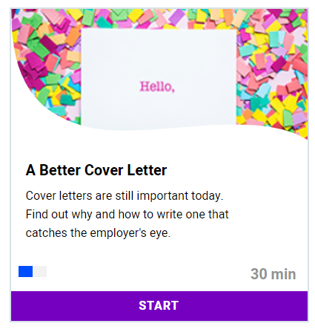
- Click on the play button on the video introduction and then advance through the screens by using the green arrow button in the bottom right-hand corner as you did on the previous module.
Remember: you can pause/stop the module at any time and resume where you left off at a later time.
As you review the slides, keep in mind that you will be creating a cover letter to go with your resumé at the close of this module.
There are 18 screens of this module and the estimated time to complete is 30 minutes.

- Once you have completed this module, draft your cover letter using the Cover Letter Rubric (included) to help guide you. 30 minutes)
- Get peer feedback from at least one other student before making the final draft. (15 minutes)
- Submit the final draft to your specialist. (5 minutes)
- This week is primarily dedicated to working on your Public Product for this project. As a reminder, here is an overview of the Public Product details:
Public Product
In a world where employers will likely Google you before deciding whether or not to interview you to work for them, it is important to manage your reputation both online and in person. Your reputation is your personal brand, and should portray who you are and what you want others to know you for. At the end of this project, students will create a video that portrays their personal brand in a positive and professional manner. They will include information from their resume and cover letter, and use pertinent descriptive words that would promote their personal brand to a potential employer. Students will post their video to Flipgrid for their classmates and Specialist to review and offer advice for improvements. The student can then update their video and share on their Tallo profile, LinkedIn as well as other social media sites. A video resume has become a popular way to get to know candidates, so students may also choose to use this video in a digital job application packet.

- Check-in with your Specialist and at least two other peers for feedback on your project. Then, revise and create your final product. Review the Personal Brand Video Rubric (provided) to help guide your work on this Flex PBLs Public Product. (Times will vary)
- Checklist for creating your Public Product:
  - Draft your script.
  - Make decisions about your attire, background, props, etc.
  - Practice.
  - Set-up your phone/camera or ask a friend to film.
  - Do a practice recording/dress rehearsal. Listen and watch for things you would like to improve.
  - Do your REAL video recording! Good luck!
  - When you are satisfied with your video intro, post it on Flipgrid under the Public Product assignment.

- As you wait for peers to review and offer feedback on your video, go check out a minimum of three other videos from your classmates. Comment on their video using this framework:

  - I like…
  - I wonder…
  - Have you thought about..

- Remember the Driving Question for this Flex PBL: What steps must I take to prepare for getting a job successfully?
- If you believe you have adequately answered this question and feel confident in the final Public Product you have—consider posting this video within your Tallo profile, LinkedIn, other social media sites and/or including it in your digital application packet!
- Wrap up this project by doing these three things:
  - E-mail your progress from Skills to Succeed Academy to your Specialist.
  - Share with your Specialist how you used your video from this project in other ways.
  - Complete this JAG National student survey to gather feedback about this Flex PBL: https://forms.gle/nkubGVV256sKEaf27

Cover Letter Rubric

CATEGORY | (4) Excellent | (3) Good | (2) Almost | (1) Not Yet
Attractiveness & Organization | The cover letter attractively includes  the six essential  parts: heading, inside address, salutation, body, closing, and signature. | The cover letter contains the six essential parts:  heading, inside address, salutation,  body, closing, and  signature | The writer approximates the correct form for a business letter. The cover letter may be missing one or two essential parts. | The writer demonstrates a lack of understanding of the correct form for a business letter. The letter may lack essential parts.
Content - Accuracy | The cover letter has all of the required information and some additional information. | The cover letter has all of the required information. | The cover letter has most of the required information. | The cover letter has little of the required information.
Writing – Mechanics:  Spelling  Sentence Form  Grammar  Punctuation  Capitalization | All of the writing is in complete sentences. Capitalization, punctuation and spelling are correct throughout. | There are some errors in mechanics, usage, grammar, or spelling, but they do not detract from the meaning. | There are noticeable errors in mechanics, usage, grammar, or spelling. Some of these may hinder comprehension. | The letter is hard to understand due to numerous errors in mechanics, usage, grammar, or spelling.
Elements of Business Writing | The letter explains its purpose, calls attention to the resume, and asks for an interview. The letter contains no extraneous details. | The letter identifies its purpose, calls attention to the resume, and asks for an interview. | The letter may not clearly identify what the writer wants, and some elements may be missing. | In the letter, the writer does not state the purpose for writing.
Language | The letter uses formal and consistent language. It sparks the interest of the reader. | The letter uses formal language, but the level of language may be inconsistent. | The letter does not include the use of formal language. | The level of language is inconsistent or inappropriate.

Raw Rubric Score/Total | Percentage
20 | 100%
19 | 97%
18 | 95%
17 | 92%
16 | 90%
15 | 87%
14 | 84%
13 | 82%
12 | 79%
11 | 77%
10 | 74%
9 | 71%
8 | 69%

Personal Brand Video Rubric

CATEGORY | (4) Excellent | (3) Good | (2) Almost | (1) Not Yet
Professional Appearance | Appearance is professional and impressive | Appearance is neat and professional | Neat in appearance | Appearance needs improvement
Content | Personal brand is described in detail | Personal brand description is competent | Personal brand description is fair | Personal brand description needs improvement
Mechanics and Grammar | No errors in grammar, usage, or mechanics | 1-2 errors that do not detract from the presentation | There are noticeable errors in that may detract from the presentation | Multiple errors in mechanics, usage, and/or grammar
Vocabulary | Includes several keywords that describe your essential qualities | Includes some keywords that describe your essential qualities | Includes few keywords that describe your essential qualities | Includes no keywords that describe your essential qualities
References to required components:  Resume  Cover Letter  Application  References | Includes several descriptive references to required project components | Includes some descriptive references to required project components | Includes few references to required project components | Does not include references to required project components

Raw Rubric Score/Total | Percentage
20 | 100%
19 | 97%
18 | 95%
17 | 92%
16 | 90%
15 | 87%
14 | 84%
13 | 82%
12 | 79%
11 | 77%
10 | 74%
9 | 71%
8 | 69%

